# What is a Binary Tree?

A binary tree is a tree data structure with a maximum of 2 children per node. We commonly refer to them as the left and right child as each element in a binary tree may only have two children.

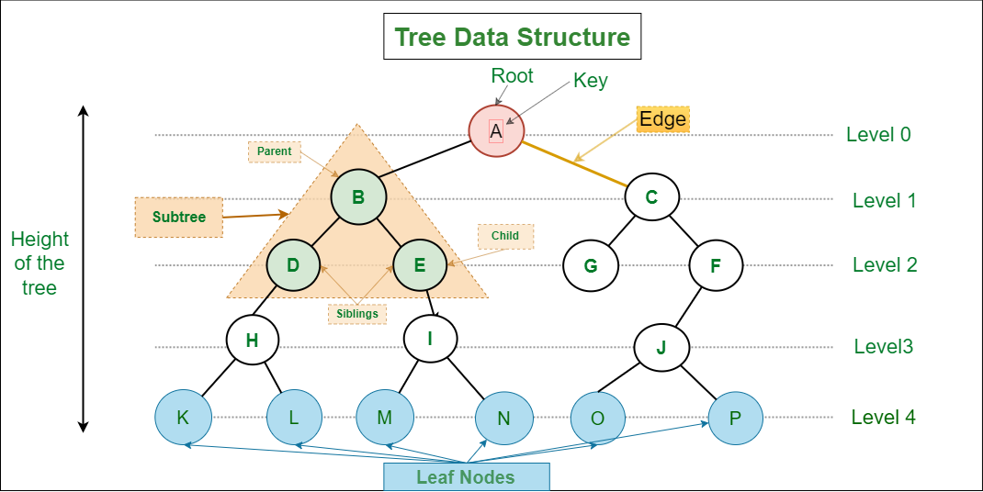

## What is a Full Binary Tree?

*A full binary tree is a binary tree with either zero or two child nodes for each node.*

A full binary tree, on the other hand, does not have any nodes that have only one child node.

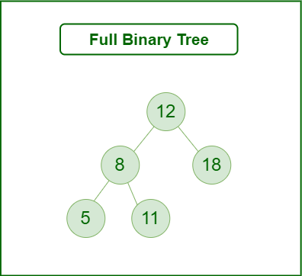

## **What is a Complete Binary Tree?**

A complete binary tree is a special type of binary tree where all the levels of the tree are filled completely except the lowest level nodes which are filled from as left as possible.

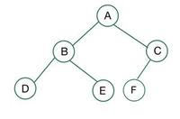

## What is a Perfect Binary Tree?

A **perfect binary tree** is a special type of binary tree in which all the leaf nodes are at the same depth, and all non-leaf nodes have two children. In simple terms, this means that all leaf nodes are at the maximum depth of the tree, and the tree is completely filled with no gaps.

The maximum number of nodes in a perfect binary tree is given by the formula**2^(d+1) – 1**, where d is the depth of the tree. This means that a perfect binary tree with a depth of n has **2^n** leaf nodes and a total of **2^(n+1) – 1** nodes.

**Perfect binary trees**have a number of useful properties that make them useful in various applications. For example, they are often used in the **implementation**of heap data structures, as well as in the **construction** of threaded binary trees. They are also used in the implementation of algorithms such as heapsort and merge sort.

In other words, it can be said that each level of the tree is completely filled by the nodes.

**Examples of Perfect Binary Tree:**

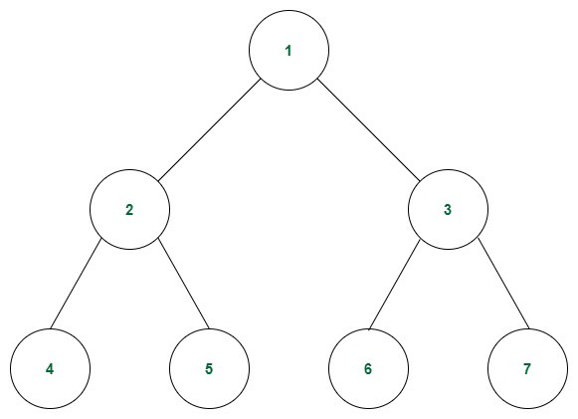

*Example of a Perfect Binary Tree*

A tree with only the root node is also a perfect binary tree.

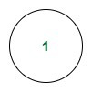

*Example-2*

The following tree is not a perfect binary tree because the last level of the tree is not completely filled.

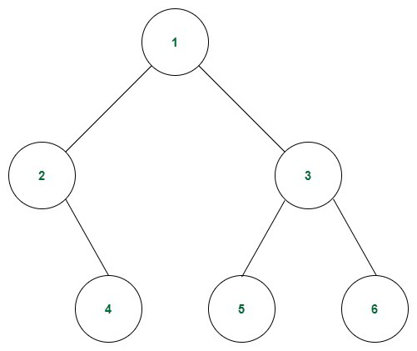

*Not a Perfect Binary Tree*

**Properties of a Perfect Binary Tree:**

* **Degree:** The degree of a node of a tree is defined as the number of children of that node. All the internal nodes have a degree of 2. The leaf nodes of a perfect binary tree have a degree of 0.
* **Number of leaf nodes:** If the height of the perfect binary tree is **h**, then the number of leaf nodes will be **2h** because the last level is completely filled.
* **Depth of a node:** Average depth of a node in a perfect binary tree is **Θ(ln(n))**.
* **Relation between leaf nodes and non-leaf nodes:** No. of leaf nodes = No. of non-leaf nodes +1.
* **Total number of nodes:** A tree of height **h** has total nodes = **2h+1 – 1**. Each node of the tree is filled. So total number of nodes can be calculated as 20 + 21 + . . . + 2h = 2h+1 – 1.
* **Height of the tree:** The height of a perfect binary tree with **N** number of nodes = **log(N + 1) – 1 = Θ(ln(n))**. This can be calculated using the relation shown while calculating the total number of nodes in a perfect binary tree.

**Check whether a tree is a Perfect Binary Tree or not:**

* Check the depth of the tree. A perfect binary tree is defined as a tree where all leaf nodes are at the same depth, and all non-leaf nodes have two children. To check whether a tree is a perfect binary tree, you can first calculate the depth of the tree.
* Check the number of nodes at each level: Once you have calculated the depth of the tree, you can then check the number of nodes at each level. In a perfect binary tree, the number of nodes at each level should be a power of 2 (e.g. 1, 2, 4, 8, etc.). If any level has a different number of nodes, the tree is not a perfect binary tree.

## [***height balanced binary tree***](https://www.geeksforgeeks.org/introduction-to-height-balanced-binary-tree/)

* *A*[***height balanced binary tree***](https://www.geeksforgeeks.org/introduction-to-height-balanced-binary-tree/)*is a binary tree in which the height of the left subtree and right subtree of any node does not differ by more than 1 and both the left and right subtree are also height balanced.*
* In this article, we will look into methods how to determine if given Binary trees are height-balanced
* Height of Tree is at max logN
* ***Examples:****The tree on the left is a height balanced binary tree. Whereas the tree on the right is not a height balanced tree. Because the left subtree of the root has a height which is 2 more than the height of the right subtree.*

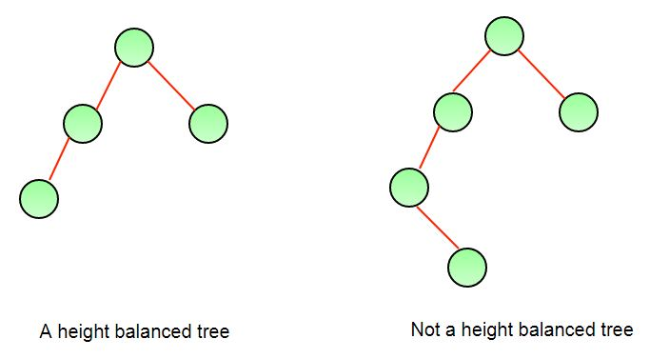

## What are BFS and DFS for Binary Tree?

A Tree is typically traversed in two ways:

* [Breadth First Traversal (Or Level Order Traversal)](https://www.geeksforgeeks.org/level-order-tree-traversal/)
* [Depth First Traversals](https://www.geeksforgeeks.org/618/)
  + Inorder Traversal (Left-Root-Right)
  + Preorder Traversal (Root-Left-Right)
  + Postorder Traversal (Left-Right-Root)

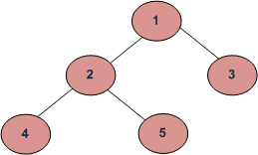

BFS and DFSs of above Tree

Breadth First Traversal : 1 2 3 4 5 or 1 2 3 5 4 or 1 3 2 4 5 or 1 3 2 5 4

Depth First Traversals:

Preorder Traversal : 1 2 4 5 3

Inorder Traversal : 4 2 5 1 3

Postorder Traversal : 4 5 2 3 1

# Preorder Traversal of Binary Tree

**Problem Statement:** Given a binary tree print the preorder traversal of binary tree.

**Example:**

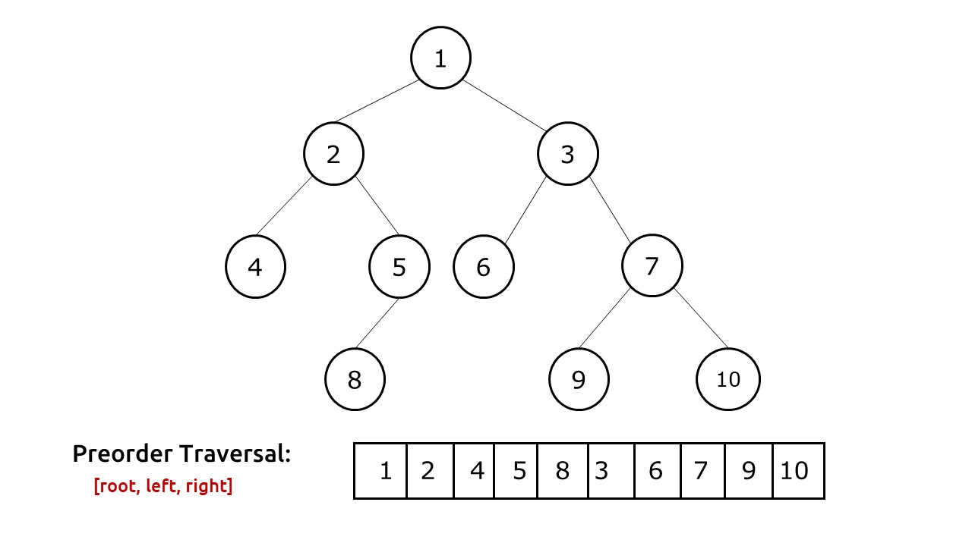

**Solution:**

**Disclaimer**: Don’t jump directly to the solution, try it out yourself first.

## **Solution 1: Iterative**

**Intuition:** In preorder traversal, the tree is traversed in this way: **root,**left, right. When we visit a node, we print its value, and then we want to visit the left child followed by the right child. The fundamental problem we face in this scenario is that there is no way that we can move from a child to a parent. To solve this problem, we use an explicit stack data structure. While traversing we can insert node values to the stack in such a way that we always get the next node value at the top of the stack.

**Approach:**

The algorithm approach can be stated as:

* We first take an explicit stack data structure and push the root node to it.(if the root node is not NULL).
* Then we use a while loop to iterate over the stack till the stack remains non-empty.
* In every iteration we first pop the stack’s top and print it.
* Then we first push the right child of this popped node and then push the left child, if they are not NULL. We do so because stack is a last-in-first-out(LIFO) data structure. We need to access the left child first, so we need to push it at the last.
* The execution continues and will stop when the stack becomes empty. In this process, we will get the preorder traversal of the tree.

**Dry Run:**In case you want to watch the dry run for this approach, please watch the video attached below.

**Code:**

import java.util.*;

class Node {

int data;

Node left, right;

Node(int data) {

this.data = data;

left = right = null;

}

}

public class TUF {

static ArrayList < Integer > preOrderTrav(Node curr) {

ArrayList < Integer > preOrder = new ArrayList < Integer > ();

if (curr == null)

return preOrder;

Stack < Node > s = new Stack < > ();

s.push(curr);

while (!s.isEmpty()) {

Node topNode = s.pop();

preOrder.add(topNode.data);

if (topNode.right != null)

s.push(topNode.right);

if (topNode.left != null)

s.push(topNode.left);

}

return preOrder;

}

public static void main(String args[]) {

Node root = new Node(1);

root.left = new Node(2);

root.right = new Node(3);

root.left.left = new Node(4);

root.left.right = new Node(5);

root.left.right.left = new Node(8);

root.right.left = new Node(6);

root.right.right = new Node(7);

root.right.right.left = new Node(9);

root.right.right.right = new Node(10);

ArrayList < Integer > preOrder = new ArrayList < > ();

preOrder = preOrderTrav(root);

System.out.print("The preOrder Traversal is : ");

for (int i = 0; i < preOrder.size(); i++) {

System.out.print(preOrder.get(i) + " ");

}

}

}

**Output:**

The preOrder Traversal is : 1 2 4 5 8 3 6 7 9 10

**Time Complexity: O(N)**.

Reason: We are traversing N nodes and every node is visited exactly once.

**Space Complexity: O(N)**

Reason: In the worst case, (a tree with every node having a single right child and left-subtree, follow the video attached below to see the illustration), the space complexity can be considered as O(N).

## **Solution 2:** **Recursive**

**Intuition:**In preorder traversal, the tree is traversed in this way: **root,**left, right. When we visit a node, we print its value, and then we want to visit the left child followed by the right child. The fundamental problem we face in this scenario is that there is no way that we can move from a child to a parent. To solve this problem, we use recursion and the recursive call stack to locate ourselves back to the parent node when execution at a child node is completed.

**Approach:**In preorder traversal, the tree is traversed in this way: **root, left, right**.

The algorithm approach can be stated as:

* We first visit the root node and before visiting its children we print its value.
* After this, we recursively visit its left child.
* Then we recursively visit the right child.
* If we encounter a node pointing to NULL, we simply return to its parent.

**Code:**

import java.util.*;

class Node {

int data;

Node left, right;

Node(int data) {

this.data = data;

left = null;

right = null;

}

Node() {

}

}

public class TUF {

static void preOrderTrav(Node curr, ArrayList < Integer > preOrder) {

if (curr == null)

return;

preOrder.add(curr.data);

preOrderTrav(curr.left, preOrder);

preOrderTrav(curr.right, preOrder);

}

public static void main(String args[]) {

Node root = new Node(1);

root.left = new Node(2);

root.right = new Node(3);

root.left.left = new Node(4);

root.left.right = new Node(5);

root.left.right.left = new Node(8);

root.right.left = new Node(6);

root.right.right = new Node(7);

root.right.right.left = new Node(9);

root.right.right.right = new Node(10);

ArrayList < Integer > preOrder = new ArrayList < > ();

preOrderTrav(root, preOrder);

System.out.print("The preOrder Traversal is : ");

for (int i = 0; i < preOrder.size(); i++) {

System.out.print(preOrder.get(i) + " ");

}

}

}

**Output:**

The preOrder Traversal is : 1 2 4 5 8 3 6 7 9 10

**Time Complexity: O(N)**.

Reason: We are traversing N nodes and every node is visited exactly once.

**Space Complexity: O(N)**

Reason: Space is needed for the recursion stack. In the worst case (skewed tree), space complexity can be O(N).

**Explanation:**It is very important to understand how recursion works behind the scenes to traverse the tree. For it we will see a simple case:

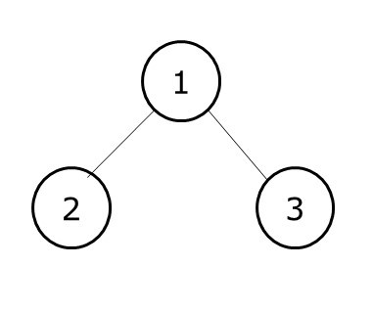

Preorder traversal of this tree: 1,2,3.

Initially, we pass the root node pointing to 1 to our traversal function. The algorithm steps are as follows:

* As we are doing a preorder traversal, the first thing we will do is to print the current node value, i.e 1.
* Then we need to move left but how do we do so? Remember that our nodes only have pointers to the children and not to the parent, therefore we can move only from parent to child and not from a child to the parent.
* The answer to this question is **recursion**. We call the same function with the current node pointing to the left child, i.e 2. This second function is then pushed to our call stack. We do our execution which is to visit node 2 print it and then again recursively call its both children. As both of them point to NULL, we will return from them and execution of the second function stops.
* This second function will then be removed from our call stack and we will return to the first function. Then we again recursively call the function for the right child and do the execution.

The call stack diagram will help to understand the recursion better.

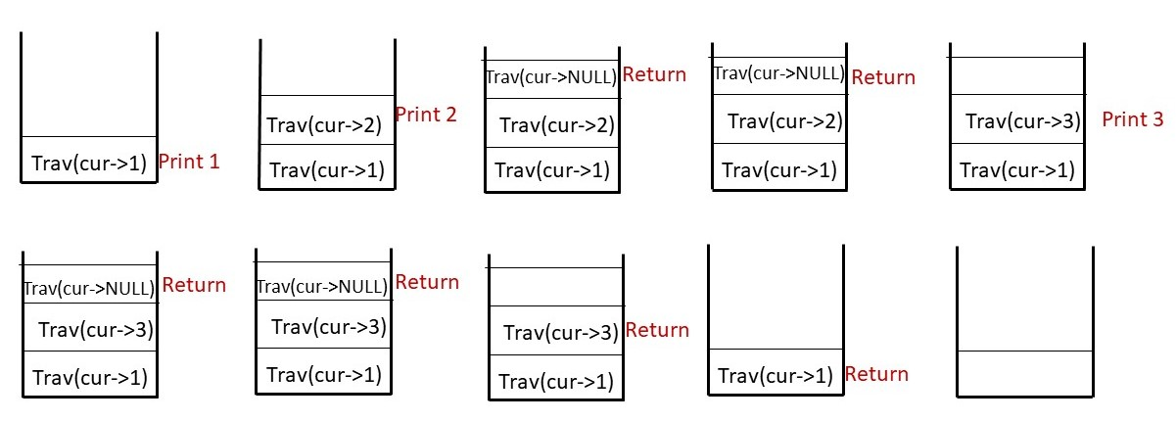

# Inorder Traversal of Binary Tree

**Problem Statement:** Given a Binary Tree. Find and print the inorder traversal of Binary Tree.

**Examples**:

**Input:**

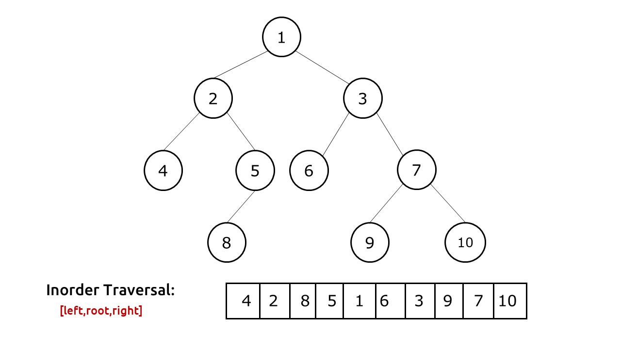

**Output:**  The inOrder Traversal is : 4 2 8 5 1 6 3 9 7 10

**Disclaimer**: Don’t jump directly to the solution, try it out yourself first.

## **Solution  [Iterative]:**

**Intuition:**In inorder traversal, the tree is traversed in this way: **root,**left, right. We first visit the left child, after returning from it we print the current node value, then we visit the right child. The fundamental problem we face in this scenario is that there is no way that we can move from a child to a parent. To solve this problem, we use an explicit stack data structure. While traversing we can insert node values to the stack in such a way that we always get the next node value at the top of the stack.

**Approach:**

The algorithm approach can be stated as:

* We first take an explicit stack data structure and set an infinite loop.
* In every iteration we check whether our current node is pointing to NULL or not.
* If it is not pointing to null, we simply push the current value to the stack and move the current node to its left child.
* If it is pointing to NULL, we first check whether the stack is empty or not. If the stack is empty, it means that we have traversed the tree and we break out of the loop.
* If the stack is not empty, we pop the top value of the stack, print it and move the current node to its right child.

Stack is a Last-In-First-Out (LIFO) data structure, therefore when we encounter a node, we simply push it to the stack and try to find nodes on its left. When the current node points to NULL, it means that there is nothing left to traverse and we should move to the parent. This parent is always placed at the top of the stack. If the stack is empty, then we had already traversed the whole tree and should stop the execution.

**Dry Run:**In case you want to watch the dry run for this approach, please watch the video attached below.

**Code:**

import java.util.*;

class Node {

int data;

Node left, right;

Node(int data) {

this.data = data;

left = null;

right = null;

}

}

class TUF {

static ArrayList < Integer > inOrderTrav(Node curr) {

ArrayList < Integer > inOrder = new ArrayList < > ();

Stack < Node > s = new Stack < > ();

while (true) {

if (curr != null) {

s.push(curr);

curr = curr.left;

} else {

if (s.isEmpty()) break;

curr = s.pop();

inOrder.add(curr.data);

curr = curr.right;

}

}

return inOrder;

}

public static void main(String args[]) {

Node root = new Node(1);

root.left = new Node(2);

root.right = new Node(3);

root.left.left = new Node(4);

root.left.right = new Node(5);

root.left.right.left = new Node(8);

root.right.left = new Node(6);

root.right.right = new Node(7);

root.right.right.left = new Node(9);

root.right.right.right = new Node(10);

ArrayList < Integer > inOrder;

inOrder = inOrderTrav(root);

System.out.println("The inOrder Traversal is : ");

for (int i = 0; i < inOrder.size(); i++) {

System.out.print(inOrder.get(i) + " ");

}

}

}

**Output:**

The inOrder Traversal is : 4 2 8 5 1 6 3 9 7 10

**Time Complexity: O(N)**.

Reason: We are traversing N nodes and every node is visited exactly once.

**Space Complexity: O(N)**

Reason: In the worst case (a tree with just left children), the space complexity will be O(N).

## **Solution 2 [Recursive]:**

**Approach:**In inorder traversal, the tree is traversed in this way: **left,**root, **right**.

The algorithm approach can be stated as:

* We first recursively visit the left child and go on till we find a leaf node.
* Then we print that node value.
* Then we recursively visit the right child.
* If we encounter a node pointing to NULL, we simply return to its parent.

**Explanation:**It is very important to understand how recursion works behind the scenes to traverse the tree. For it we will see a simple case:



Inorder traversal of this tree: 2,1,3

Initially, we pass the root node pointing to 1 to our traversal function. The algorithm steps are as follows:

* As we are doing an inorder traversal, the first thing we will do is to recursively visit the left child. We continue till the time we find a leaf node. At node 2, as there is no more left child, we print its value.
* Then we need to move back to node 1 but how do we do so? Remember that our nodes only have pointers to the children and not to the parent, therefore we can move only from parent to child and not from a child to the parent.
* The answer to this question is **recursion**. When we move to node 2, we call it recursively. This second function is then pushed to our call stack. We do our execution which is to visit the left child of node 2, return from it as it is NULL, print current node value and then again recursively call its right child.
* This second function will then be removed from our call stack and we will return to the first function. Then we again recursively call the function for the right child and do the execution, i.e print 1 and then visit its right child.

The call stack diagram will help to understand the recursion better.

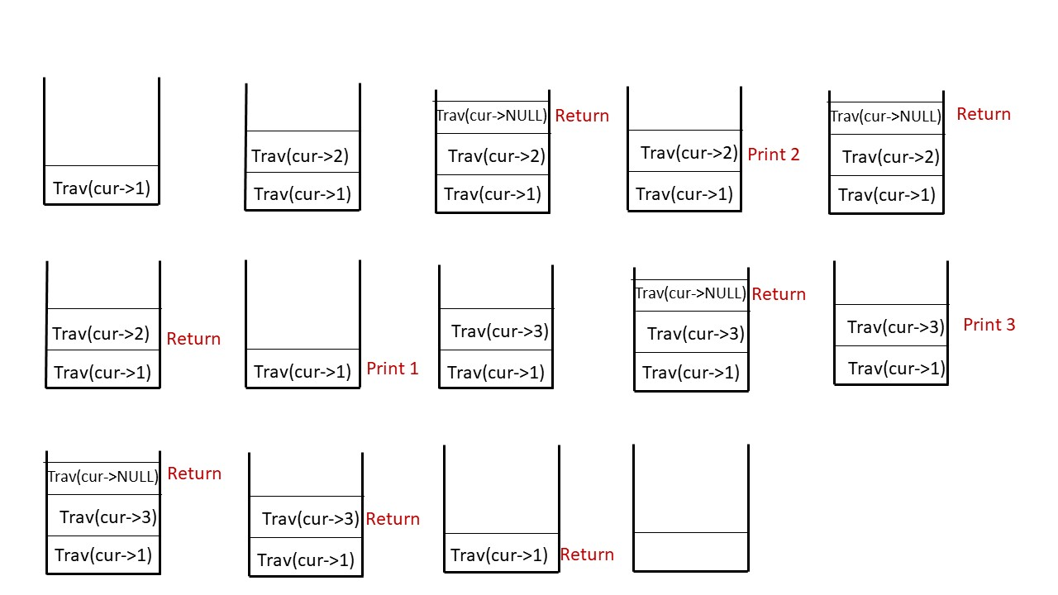

**Dry Run:**In case you want to watch the dry run for this approach, please watch the video attached below.

**Code:**

import java.util.*;

class Node {

int data;

Node left, right;

Node(int data) {

this.data = data;

left = null;

right = null;

}

}

class TUF {

static void inOrderTrav(Node curr, ArrayList < Integer > inOrder) {

if (curr == null)

return;

inOrderTrav(curr.left, inOrder);

inOrder.add(curr.data);

inOrderTrav(curr.right, inOrder);

}

public static void main(String args[]) {

Node root = new Node(1);

root.left = new Node(2);

root.right = new Node(3);

root.left.left = new Node(4);

root.left.right = new Node(5);

root.left.right.left = new Node(8);

root.right.left = new Node(6);

root.right.right = new Node(7);

root.right.right.left = new Node(9);

root.right.right.right = new Node(10);

ArrayList < Integer > inOrder = new ArrayList < > ();

inOrderTrav(root, inOrder);

System.out.println("The inOrder Traversal is : ");

for (int i = 0; i < inOrder.size(); i++) {

System.out.print(inOrder.get(i) + " ");

}

}

}

**Output:**

The inOrder Traversal is : 4 2 8 5 1 6 3 9 7 10

**Time Complexity: O(N)**.

Reason: We are traversing N nodes and every node is visited exactly once.

**Space Complexity: O(N)**

Reason: Space is needed for the recursion stack. In the worst case (skewed tree), space complexity can be O(N).

# Post-Order Traversal Of Binary Tree

**Problem Statement: Postorder Traversal of a binary tree**. Write a program for the postorder traversal of a binary tree.

**Example:**

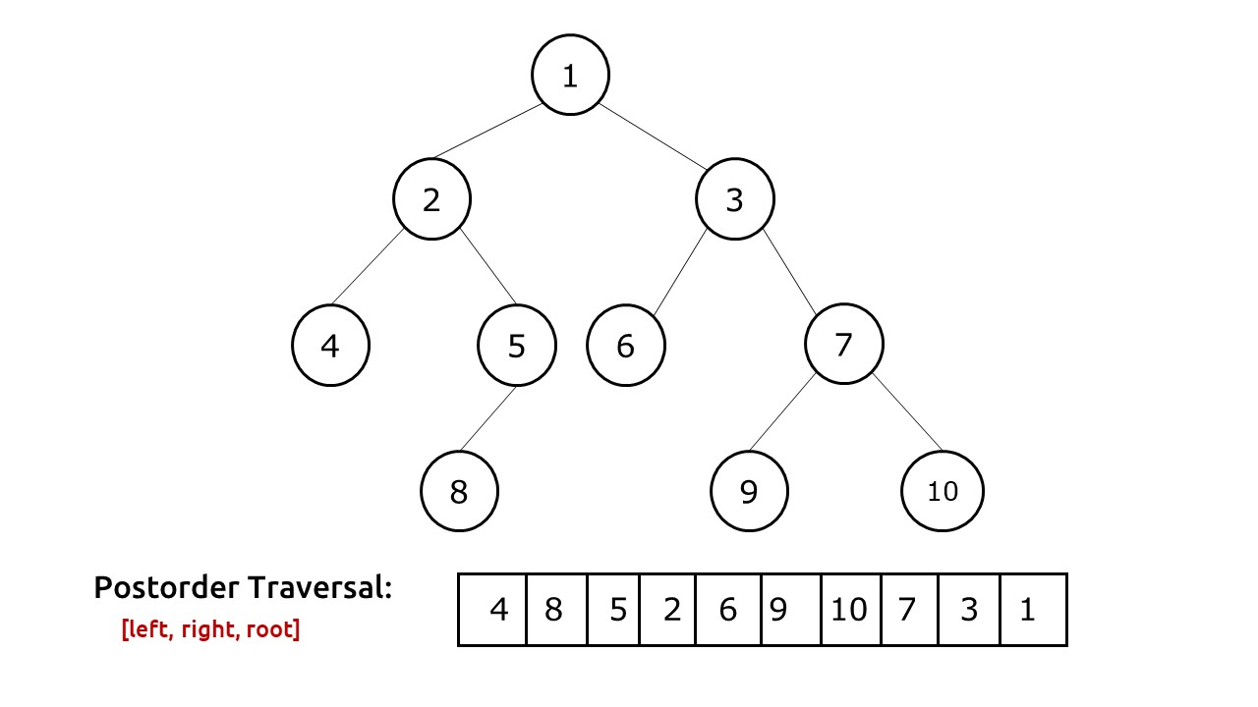

**Disclaimer**: Don’t jump directly to the solution, try it out yourself first.

## **Solution  [Recursive]:**

**Approach:**In postorder traversal, the tree is traversed in this way: **left, right**, **root**.

The algorithm approach can be stated as:

* We first recursively visit the left child and go on left till we find a node pointing to NULL.
* Then we return to its parent.
* Then we recursively visit the right child.
* After we have returned from the right child as well, only then will we print the  current node value.

**Explanation:**It is very important to understand how recursion works behind the scenes to traverse the tree. For it we will see a simple case:



Postorder traversal of this tree: 2,3,1

Initially, we pass the root node pointing to 1 to our traversal function. The algorithm steps are as follows:

* As we are doing a postorder traversal, the first thing we will do is to recursively visit the left child. We continue till the time we find a node pointing to NULL
* As we can’t move further left, we need to return back to node 2 but how do we do so? Remember that our nodes only have pointers to the children and not to the parent, therefore we can move only from parent to child and not from a child to the parent.
* The answer to this question is **recursion**. We recursively called the same function with the current node pointing to the NULL node.This second function was pushed to our call stack. We do our execution which is to return from that node(as the node is pointing to NULL).
* As the execution stops, we need to come back to the parent, we simply return to it as is present at the top of the recursion call stack.
* Similar execution is performed at all nodes.

The call stack diagram will help to understand the recursion better.

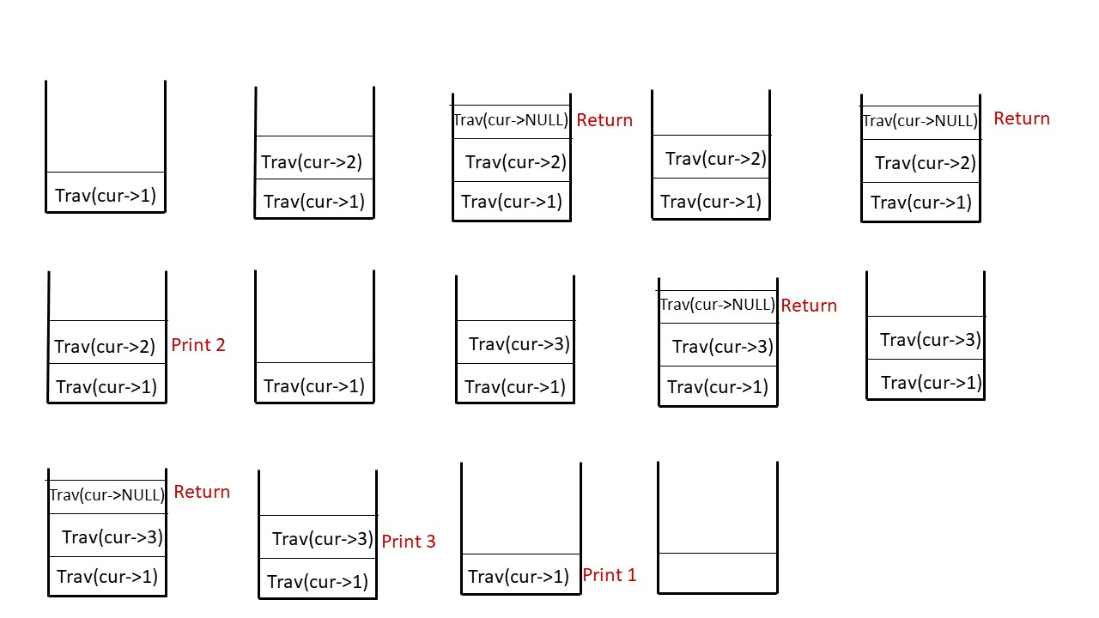

**Dry Run:**In case you want to watch the dry run for this approach, please watch the video attached below.

**Code:**

import java.util.*;

class Node {

int data;

Node left, right;

Node(int data) {

this.data = data;

left = null;

right = null;

}

}

public class TUF {

static void postOrderTrav(Node curr, ArrayList < Integer > postOrder) {

if (curr == null)

return;

postOrderTrav(curr.left, postOrder);

postOrderTrav(curr.right, postOrder);

postOrder.add(curr.data);

}

public static void main(String args[]) {

Node root = new Node(1);

root.left = new Node(2);

root.right = new Node(3);

root.left.left = new Node(4);

root.left.right = new Node(5);

root.left.right.left = new Node(8);

root.right.left = new Node(6);

root.right.right = new Node(7);

root.right.right.left = new Node(9);

root.right.right.right = new Node(10);

ArrayList < Integer > postOrder = new ArrayList < > ();

postOrderTrav(root, postOrder);

System.out.println("The postOrder Traversal is : ");

for (int i = 0; i < postOrder.size(); i++) {

System.out.print(postOrder.get(i) + " ");

}

}

}

**Output:**

The postOrder Traversal is : 4 8 5 2 6 9 10 7 3 1

**Time Complexity: O(N)**.

Reason: We are traversing N nodes and every node is visited exactly once.

**Space Complexity: O(N)**

Reason: Space is needed for the recursion stack. In the worst case (skewed tree), space complexity can be O(N).

**Iterative Solution**

**Prerequisite:**Recursive solution to preorder traversal.

**Intuition:**In postorder traversal, the tree is traversed in this way: **left,**right, root. We first visit the left child, after returning from it we visit the right child, and after returning from both of them, we print the value of the current node. The fundamental problem we face in this scenario is that there is no way that we can move from a child to the parent using as our node points to only children and not to the parent. To solve this problem, we use an explicit stack data structure. While traversing we can insert node values to the stack in such a way that we always get the next node value at the top of the stack.

## **Solution 1: Using two stacks**

**Approach:**

The algorithm approach can be stated as:

* We take two explicit stacks S1 and S2.
* We insert our node to S1(if it’s not pointing to NULL).
* We will set up a while loop to run till S1 is non-empty.
* In every iteration, we pop out the top of S1 and then push this popped node to S2. Moreover we will push the left child and right child of this popped node to S1.(If they are not pointing to NULL).
* Then we start the next iteration with the next node as top of S1.
* We stop the iteration when S1 becomes empty.
* At last we start popping at the top of S2 and print the node values, we will get the postorder traversal.

Stack is a Last-In-First-Out (LIFO) data structure. To understand the two-stack approach, we need to understand how we insert and remove nodes in both stacks.

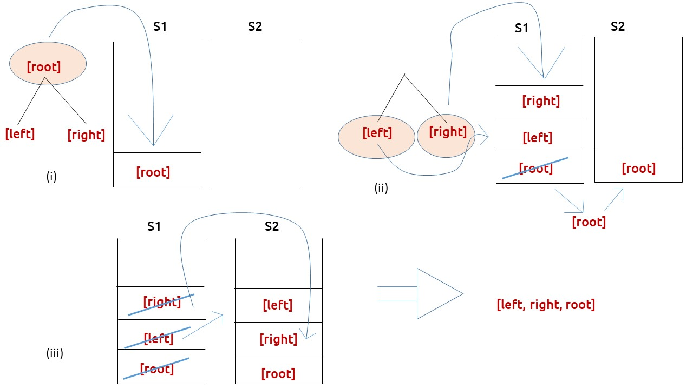

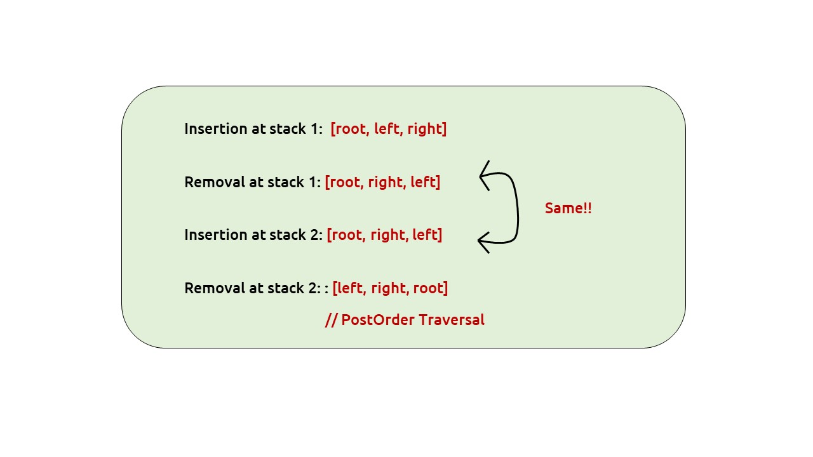

**Dry Run:**In case you want to watch the dry run for this approach, please watch the video attached below.

**Code:**

import java.util.*;

class Node {

int data;

Node left, right;

Node(int data) {

this.data = data;

left = null;

right = null;

}

}

public class TUF {

static ArrayList < Integer > postOrderTrav(Node curr) {

ArrayList < Integer > postOrder = new ArrayList < > ();

if (curr == null) return postOrder;

Stack < Node > s1 = new Stack < > ();

Stack < Node > s2 = new Stack < > ();

s1.push(curr);

while (!s1.isEmpty()) {

curr = s1.pop();

s2.push(curr);

if (curr.left != null)

s1.push(curr.left);

if (curr.right != null)

s1.push(curr.right);

}

while (!s2.isEmpty()) {

postOrder.add(s2.pop().data);

}

return postOrder;

}

public static void main(String args[]) {

Node root = new Node(1);

root.left = new Node(2);

root.right = new Node(3);

root.left.left = new Node(4);

root.left.right = new Node(5);

root.left.right.left = new Node(8);

root.right.left = new Node(6);

root.right.right = new Node(7);

root.right.right.left = new Node(9);

root.right.right.right = new Node(10);

ArrayList < Integer > postOrder = new ArrayList < > ();

postOrder = postOrderTrav(root);

System.out.println("The postOrder Traversal is : ");

for (int i = 0; i < postOrder.size(); i++) {

System.out.print(postOrder.get(i) + " ");

}

}

}

**Output**

The postOrder Traversal is : 4 8 5 2 6 9 10 7 3 1

**Time Complexity: O(N)**.

Reason: We are traversing N nodes and every node is visited exactly once.

**Space Complexity: O(N+N)**

## **Solution 2: Using a single stack:**

**Intuition:**First we need to understand what we do in a postorder traversal. We first explore the left side of the root node and keep on moving left until we encounter a node pointing to NULL. As now there is nothing more to traverse on the left, we move to the immediate parent(say node P) of that NULL node. Now we again start our left exploration from the right child of that node P. We will print a node’s value only when we have returned from its both children.

Approach:

The algorithm steps can be stated as:

* We take an explicit data structure and a cur pointer pointing to the root of the tree.
* We run a while loop till the time the cur is not pointing to NULL or the stack is non-empty.
* If cur is not pointing to NULL, it means then we simply push that value to the stack and move the cur pointer to its left child because we want to explore the left child before the root or the right child.
* If the cur is pointing to NULL, it means we can’t go further left, then we take a variable temp and set it to  cur’s parent’s right child (as we have visited the left child, now we want to visit the right child). We have node cur’s parent at the top of the stack.
* If node temp is not pointing to NULL, we simply initialise cur as node temp so that we can again start looking at the left of node temp from the next iteration.
* If node temp is pointing to NULL, then first of all we are sure that we have visited both children of temp’s parent, so it’s time to print it. Therefore we set temp to its parent( present at the top of stack), pop the stack and then print temp’s value. Additionally,  this new temp(parent of NULL-pointing node) can be the right child of the node present at the top of stack after popping.In that case the node at top of the stack is parent of temp and the next node to be printed. Therefore we run an additional while loop to check if that is the case, if true then again move temp to its parent and print its value.

**Dry Run:**In case you want to watch the dry run for this approach, please watch the video attached below.

**Code:**

import java.util.*;

class Node {

int data;

Node left, right;

Node(int data) {

this.data = data;

left = null;

right = null;

}

}

public class TUF {

static ArrayList < Integer > postOrderTrav(Node cur) {

ArrayList < Integer > postOrder = new ArrayList < > ();

if (cur == null) return postOrder;

Stack < Node > st = new Stack < > ();

while (cur != null || !st.isEmpty()) {

if (cur != null) {

st.push(cur);

cur = cur.left;

} else {

Node temp = st.peek().right;

if (temp == null) {

temp = st.pop();

postOrder.add(temp.data);

while (!st.isEmpty() && temp == st.peek().right) {

temp = st.pop();

postOrder.add(temp.data);

}

} else cur = temp;

}

}

return postOrder;

}

public static void main(String args[]) {

Node root = new Node(1);

root.left = new Node(2);

root.right = new Node(3);

root.left.left = new Node(4);

root.left.right = new Node(5);

root.left.right.left = new Node(8);

root.right.left = new Node(6);

root.right.right = new Node(7);

root.right.right.left = new Node(9);

root.right.right.right = new Node(10);

ArrayList < Integer > postOrder = new ArrayList < > ();

postOrder = postOrderTrav(root);

System.out.println("The postOrder Traversal is : ");

for (int i = 0; i < postOrder.size(); i++) {

System.out.print(postOrder.get(i) + " ");

}

}

}

**Output:**

The postOrder Traversal is : 4 8 5 2 6 9 10 7 3 1

**Time Complexity: O(N)**.

**Space Complexity: O(N)**

# Level Order Traversal of a Binary Tree

**Problem Statement:**Level order traversal of a binary tree. Given the root node of the tree and you have to print the value of the level of the node by level.

**Example 1:**

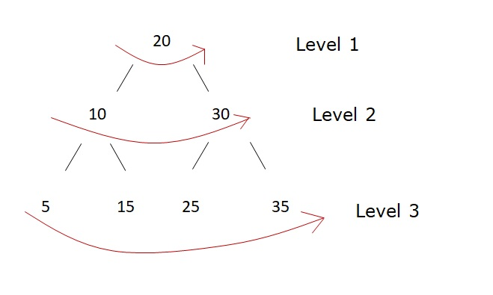

**Output**:

20 10 30 5 15 25 35

We will print the nodes of the first level (20), then we will print nodes of second level(10,30) and at last we will print nodes of the last level(5,15,25,35)

**Example 2:**

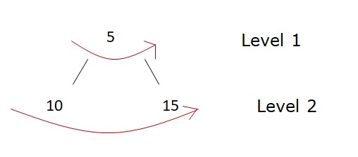

5 10 15

## **Solution:**

**Disclaimer**: Don’t jump directly to the solution, try it out yourself first.

Let us consider the example 1 given above.

We need to print a level by level traversal. Let us say, we store all the levels in a data structure named ‘ans’. We can use a vector<int> or List<int> to store our answer.

Now we need to store the first level to ‘ans’. In any given binary tree, the first level will always be the root node, so we can easily store it.

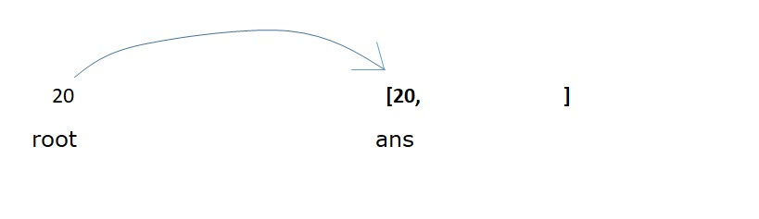

Next, we want to store the second level, this can be done by pushing the left child of root and then the right child of the root to our ‘ans’ data structure.

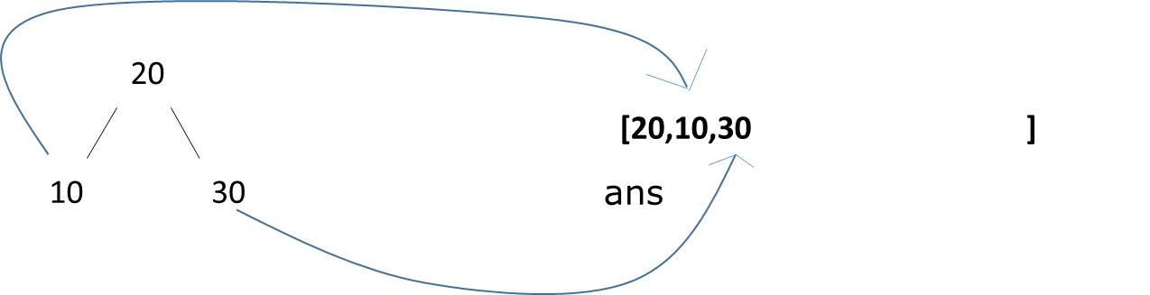

Now what about the next level? We just can’t keep writing root→left→left / root→left→right and so on to reach further levels. We need an additional data structure to store all the nodes of a level. When we are at level 1, we want its left child to be stored first, followed by the right child as the next level and store it in our data structure. Similarly at level 2, we want to access first the left child (which was added first to the data structure), to store the nodes of the next level.

As there is a first-in first-out (FIFO) operation, we will use the **queue** data structure.

**Approach:**

The algorithm steps are stated as:

* Take a queue data structure and push the root node to the queue.
* Set a while loop which will run till our queue is non-empty.
* In every iteration, pop out from the front of the queue and assign it to a variable (say temp).
* If temp has a left child, push it to the queue.
* If temp has a right child, push it to the queue.
* At last push the value of the temp node to our “ans” data structure.

**Dry Run:**

We will discuss example 1.

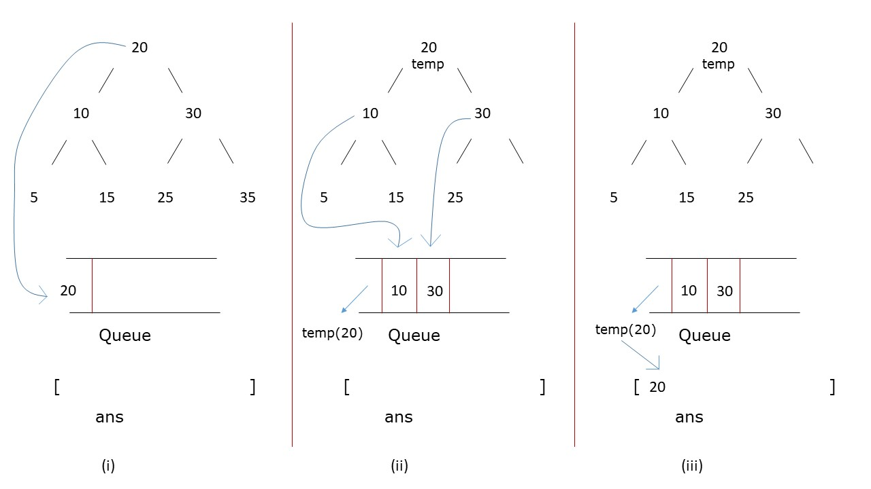

1. First we insert the root node to the queue.
2. We set our while loop and pop its front element as temp Then we inserted the left child followed by the right child of temp to the queue.
3. Then we push the temp value to our ans list.

Then we follow these steps for all nodes till the time our queue is non-empty, as shown in the figures below.

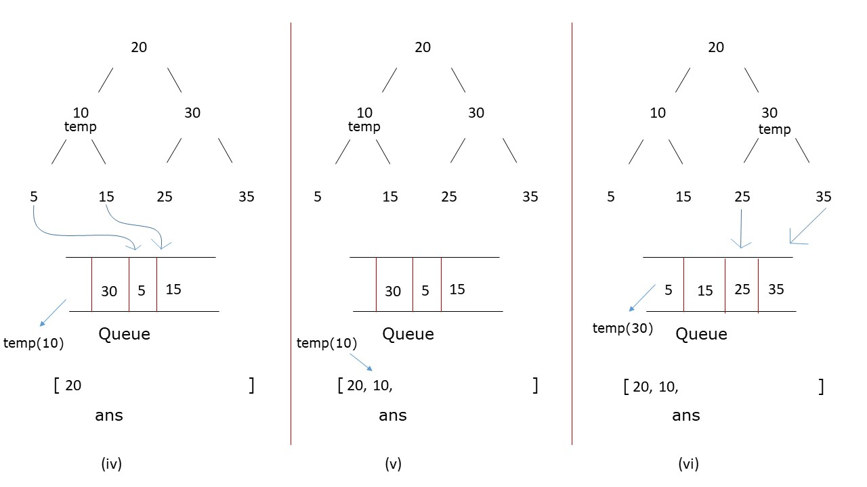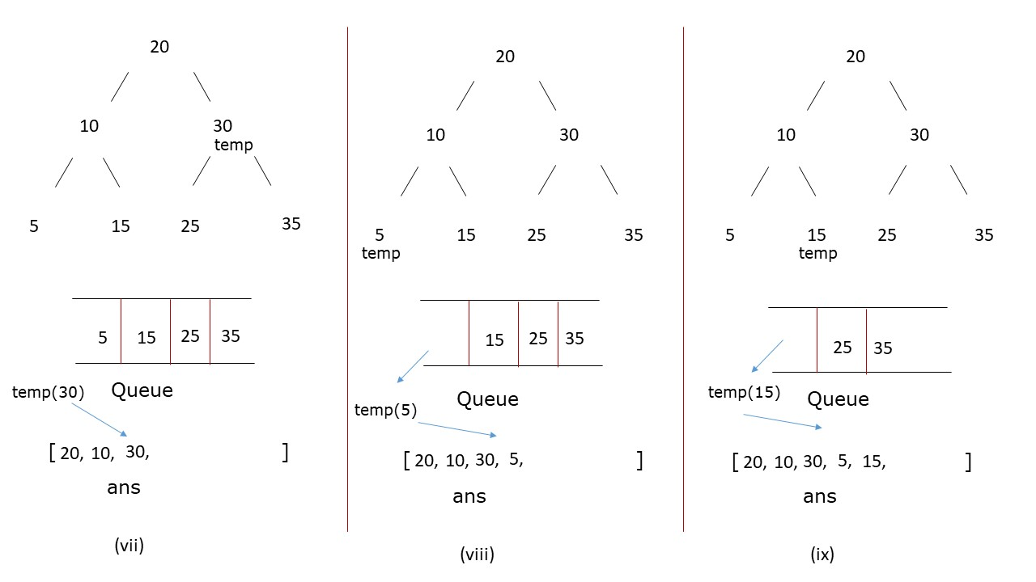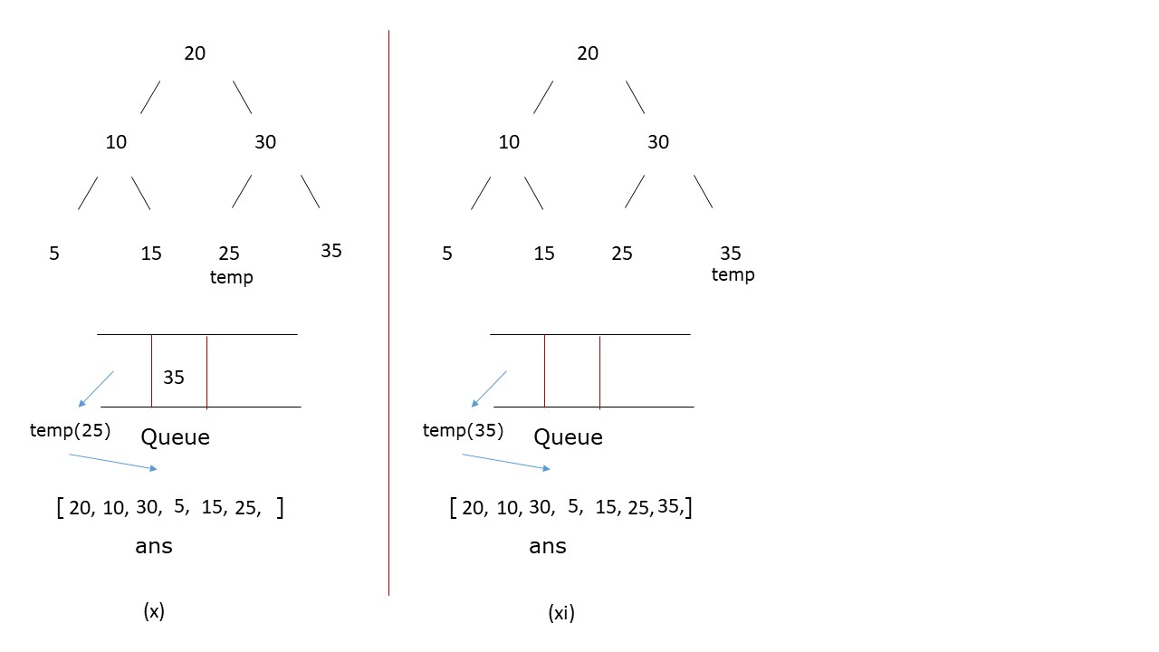

**Code:**

class Solution {

public List<Integer> levelOrder(TreeNode root) {

Queue<TreeNode> queue = new LinkedList<TreeNode>();

List<Integer> wrapList = new ArrayList<Integer>();

if(root == null) return wrapList;

queue.offer(root);

while(!queue.isEmpty()){

if(queue.peek().left != null)

queue.offer(queue.peek().left);

if(queue.peek().right != null)

queue.offer(queue.peek().right);

wrapList.add(queue.poll().val);

}

return wrapList;

}

}

**Time Complexity:**O(N)

**Space Complexity:**O(N)

**What if we have to print the level numbers as well?**

In the above approach we print the nodes level-wise but we can’t differentiate from our ans that whether two nodes are from the same level or not.

To store the level-order traversal along with individual levels stored together ( [[20],[10,30],[5,15,25,35]]), we need to make the following changes:

* First we need to declare a 2d array to store our answer( vector<vector<int>> in C++ and List<List<int>> in Java).
* Inside the while loop, first we declare a list to store nodes of a level (say level), then we need to set another for loop, which iterates for the size of the queue and inside this for loop we need to write the logic which we had discussed in the first approach
* The for loop ensures that all the nodes of a particular level are inserted together and when the iteration of the for loop ends, the queue contains the elements of only one level at a time.
* Inside the for loop we push the value of temp to ‘level’.
* After the for loop ends, we push ‘level’ to the answer.

**Note:**The inner for loop runs just for the size of the queue, for which the while loop would also have to run, therefore introducing the for loop doesn’t increase the time complexity of the program

# Preorder Inorder Postorder Traversals in One Traversal

**Problem Statement: Preorder Inorder Postorder Traversals in One Traversal**. Write a program to print Preorder, Inorder, and Postorder traversal of the tree in a single traversal.

**Example:**

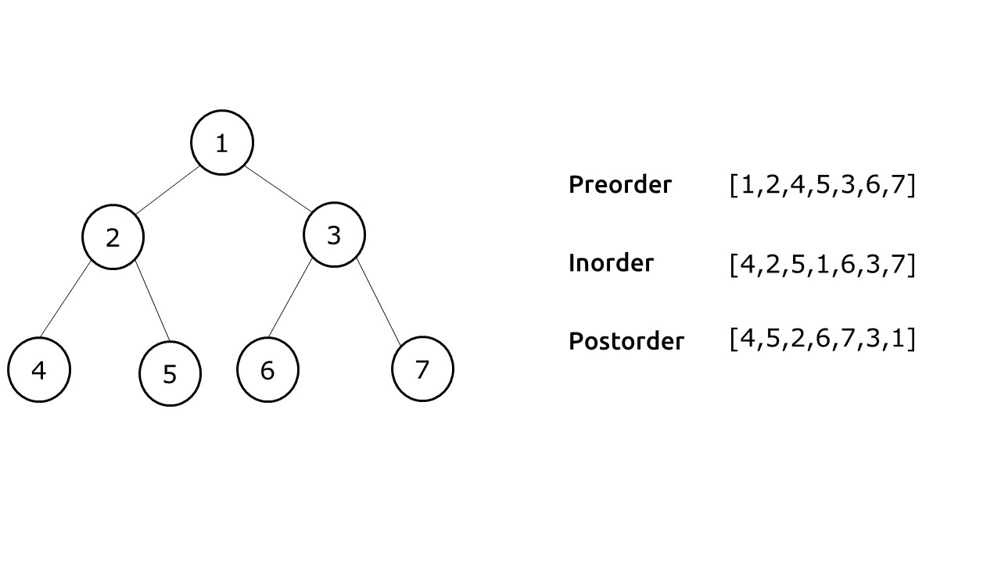

**Problem Description:**

We need to write a function allTraversals() which returns us three lists of a preorder, inorder and postorder traversals of the tree at the same time. We are not allowed to write separate codes for each traversal. We want all traversals in a single piece of code, in a single instance.

**Disclaimer**: Don’t jump directly to the solution, try it out yourself first.

**Pre-req**: Traversals Video, Stack Data Structure

### ****Solution :****

**Intuition:**If we study the preorder, inorder and postorder traversals, we will observe a pattern. To understand this pattern, we take a simple example:

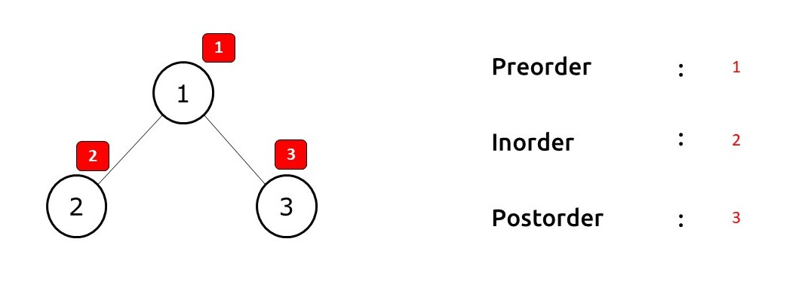

The number inside the red boxes is the visit when we print the node. In preorder traversal, we print a node at the first visit itself. Whereas, in inorder traversal at the first visit to a node, we simply traverse to the left child. It is only when we return from the left child and visit that node the second time, that we print it. Similarly, in postorder traversal, we print a node in its third visit after visiting both its children.

**Approach:**

The algorithm steps can be described as follows:

We take a stack data structure and push a pair<val, num> to it. Here Val is the value of the root node and num the visit to the node. Initially, the num is 1 as we are visiting the root node for the first time. We also create three separate lists for preorder, inorder and postorder traversals. Then we set an iterative loop to run till the time our stack is non-empty.

In every iteration, we pop the top of the stack (say, T). Then we check the second value(num) of T. Three cases can arise:

* **Case 1 : When num==1**

This means that we are visiting the node for the very first time, therefore we push the node value to our preorder list. Then we push the same node with num=2(for Case 2). After this, we want to visit the left child. Therefore we make a new pair Y(<val, num>) and push it to the stack (if there exists a left child). The val of Y is equal to the left child’s node value and num is equal to 1.

* **Case** **2 : When num==2**

This means that we are visiting the node for the second time, therefore on our second visit to the node, we push the node value to our inorder list. Then we push the same node with num=3( for Case 3). After this, we want to visit the right child. Therefore as in the first case, we check if there exists a right child or not. If there is, we push the right child and num value=1 as a pair to our stack.

* **Case 3 When num==3**

This means that we are visiting the node for the third time. Therefore we will push that node’s value to our postorder list. Next, we simply want to return to the parent so we will not push anything else to the stack.

**Dry Run:**In case you want to watch the dry run for this approach, please watch the video attached below.

**Code:**

import java.util.*;

class TreeNode {

int val;

TreeNode left;

TreeNode right;

TreeNode() {}

TreeNode(int val) {

this.val = val;

}

}

class Pair {

TreeNode node;

int num;

Pair(TreeNode _node, int _num) {

num = _num;

node = _node;

}

}

public class TUF {

public static void allTraversal(TreeNode root, List < Integer > pre, List < Integer > in , List < Integer > post) {

Stack < Pair > st = new Stack < Pair > ();

st.push(new Pair(root, 1));

if (root == null) return;

while (!st.isEmpty()) {

Pair it = st.pop();

// this is part of pre

// increment 1 to 2

// push the left side of the tree

if (it.num == 1) {

pre.add(it.node.val);

it.num++;

st.push(it);

if (it.node.left != null) {

st.push(new Pair(it.node.left, 1));

}

}

// this is a part of in

// increment 2 to 3

// push right

else if (it.num == 2) { in .add(it.node.val);

it.num++;

st.push(it);

if (it.node.right != null) {

st.push(new Pair(it.node.right, 1));

}

}

// don't push it back again

else {

post.add(it.node.val);

}

}

}

public static void main(String args[]) {

TreeNode root = new TreeNode(1);

root.left = new TreeNode(2);

root.left.left = new TreeNode(4);

root.left.right = new TreeNode(5);

root.right = new TreeNode(3);

root.right.left = new TreeNode(6);

root.right.right = new TreeNode(7);

List < Integer > pre = new ArrayList < > ();

List < Integer > in = new ArrayList < > ();

List < Integer > post = new ArrayList < > ();

allTraversal(root, pre, in , post);

System.out.println("The preorder Traversal is : ");

for (int nodeVal: pre) {

System.out.print(nodeVal + " ");

}

System.out.println();

System.out.println("The inorder Traversal is : ");

for (int nodeVal: in ) {

System.out.print(nodeVal + " ");

}

System.out.println();

System.out.println("The postorder Traversal is : ");

for (int nodeVal: post) {

System.out.print(nodeVal + " ");

}

System.out.println();

}

}

**Output:**

The preorder Traversal is :  
1 2 4 5 3 6 7  
The inorder Traversal is :  
4 2 5 1 6 3 7  
The postorder Traversal is :  
4 5 2 6 7 3 1

**Time Complexity: O(N)**

**Reason:** We are visiting every node thrice therefore time complexity will be O(3*N), which can be assumed as linear time complexity.

**Space Complexity: O(N)**

**Reason**: We are using three lists and a stack to store the nodes. The time complexity will be about O(4*N), which can be assumed as linear time complexity.

# Maximum depth of a Binary Tree

**Problem Statement:** Find the **Maximum Depth** of Binary Tree. Maximum Depth is the **count of nodes of the longest path**from theroot node to the leaf node.

**Examples**:

**Input Format**: Given the root of Binary Tree

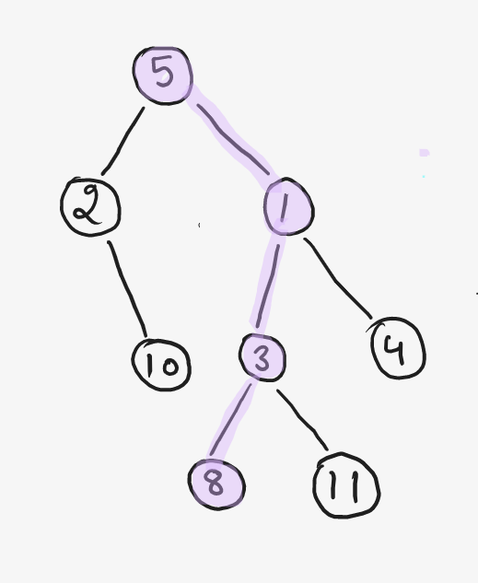

**Result**: 4

**Explanation**: Maximum Depth in this tree is 4 if we follow path 5 – 1 – 3 – 8 or 5 – 1 – 3 – 11

**Input Format:**  Given the root of Binary Tree

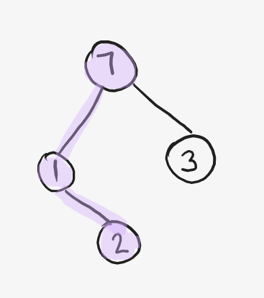

**Result**: 3

**Explanation**: Maximum Depth in this tree is 3 , if we follow path 7 – 1 – 2. If we follow 7 – 3 path then depth is 2 ( not optimal)

**Input Format:**  Given the root of Binary Tree



**Result**: 1

**Explanation**: Maximum Depth in this tree is 1 as there is only one node which is the root node.

**Note**: We are counting depth in terms of Node, if the question was given in terms of edges then the answer will be 0 in the above case.

**Solution**

**Disclaimer**: Don’t jump directly to the solution, try it out yourself first.

## **Solution 1:**

**Intuition + Approach:** **Using LEVEL ORDER TRAVERSAL**

If we observe carefully, the depth of the Binary Tree is the number of levels in the binary tree. So, if we simply do a level order traversal on the binary tree and keep a count of the number of levels, it will be our answer.

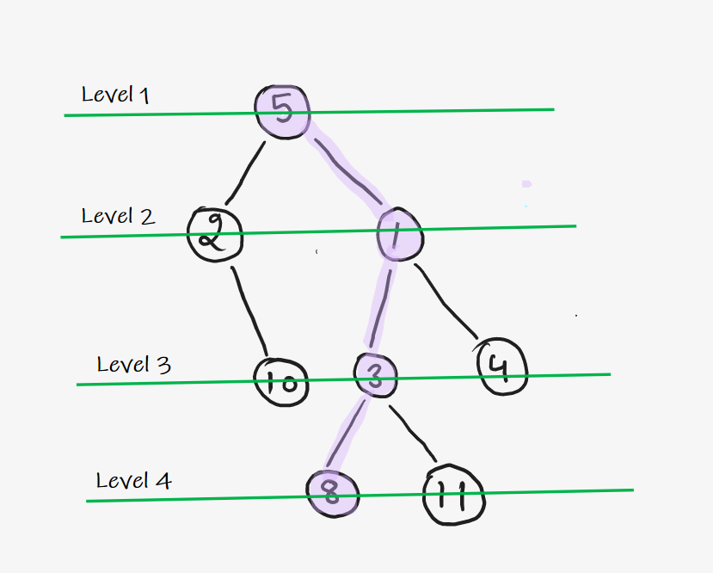

In this example, if we start traversing the tree level-wise, then we can reach at max Level 4, so our answer is 4. Because the maximum depth we can achieve is indicated by the last level at which we can travel.

**Code**:

public class tUf {

private static int levelOrder( TreeNode root ){

if( root == null ){

return 0;

}

LinkedList<TreeNode> queue = new LinkedList<>();

queue.addLast(root);

int level = 0;

while( queue.size() > 0 ){

int size = queue.size();

while( size-- > 0 ){

TreeNode remNode = queue.removeFirst();

if( remNode.left != null ){

queue.addLast( remNode.left );

}

if( remNode.right != null ){

queue.addLast( remNode.right );

}

}

level++;

}

return level;

}

}

**Time Complexity:**O(N)

**Space Complexity:**O(N)( Queue data structure is used )

## Solution 2**:**

**Intuition: Recursively ( Post Order Traversal )**

If we have to do it recursively, then what we can think of is, If I have Maximum Depth of Left subtree and Maximum Depth of Right subtree then what will be the height or depth of the tree?

Exactly,

**1 + max(depth of left subtree, depth of right subtree)**

So, to calculate the Maximum Depth, we can simply take the maximum of the depths of the left and right subtree and add 1 to it.

Why take Maximum?? Because we need maximum depth so if we know left & right children’s maximum depth then we’ll definitely get to the maximum depth of the entire tree.

**Approach :**

* We start to travel recursively and do our work in Post Order.
* Reason behind using Post Order comes from our intuition , that if we know the result of  left and right child then we can calculate the result using that.
* This is exactly an indication of PostOrder, because in PostOrder we already calculated results for left and right children than we do it for current node.
* So for every node post order, we do Max( left result , right result ) + 1 and return it to the previous call.
* Base Case is when root == null so we need to return 0;

**Dry Run :**

In Post Order, we start to travel on the example given in the below diagram

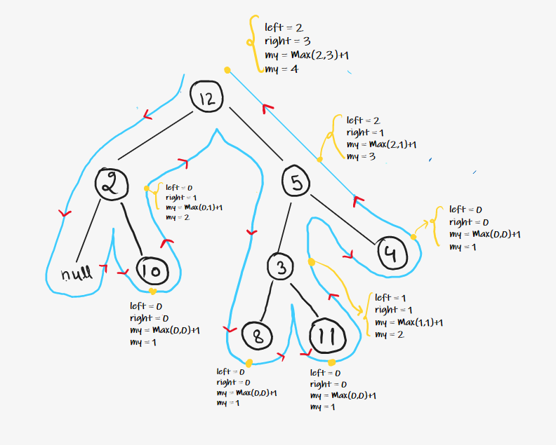

* Reach on **Node 10**, Left child = null so 0 , Right child = null so 0 & add 1 for node 10 so max depth till node 10 is max(0,0) + 1 = 1.
* Reach on **Node 2** , Left child = null so 0 , Right child = will give 1 & add 1 for node 2 so max depth till node 2 is max(0,1) + 1 = 2.
* Reach on **Node 8** , Left child = null so 0 , Right child = null so 0 & add 1 for node 8 so max depth till node 8 is max(0,0) + 1 = 1.
* Reach on **Node 11** , Left child = null so 0 , Right child = null so 0 & add 1 for node 11 so max depth till node 11 is max(0,0) + 1 = 1.
* Reach on **Node 3** , Left child will give 1 , Right child = will give 1 & add 1 for node 3 so max depth till node 3 is max(1,1) + 1 = 2.
* Reach on **Node 4** , Left child = null so 0 , Right child = null so 0 & add 1 for node 4 so max depth till node 4 is max(0,0) + 1 = 1.
* Reach on **Node 5** , Left child will give 2 , Right child = will give 1 & add 1 for node 5 so max depth till node 5 is max(2,1) + 1 = 3.
* Reach on **Node 12** , Left child will give 2 , Right child = will give 3 & add 1 for node 12 so max depth till node 12 is max(2,3) + 1 = 4.
* Hence 4 is our final ans.

**Code**:

class Solution {

public int maxDepth(TreeNode root) {

if(root == null) return 0;

int lh = maxDepth(root.left);

int rh = maxDepth(root.right);

return 1 + Math.max(lh, rh);

}

}

**Time Complexity:**O(N)

**Space Complexity:**O(1) Extra Space + O(H) Recursion Stack space, where **“H”** is the height of the binary tree.

# Check if the Binary Tree is Balanced Binary Tree

**Problem Statement:** Check whether the given Binary Tree is a **Balanced Binary Tree**or not. A binary tree is balanced if, for all nodes in the tree, the difference between left and right subtree height is not more than 1.

**Examples**:

**Input Format**: Given the root of Binary Tree

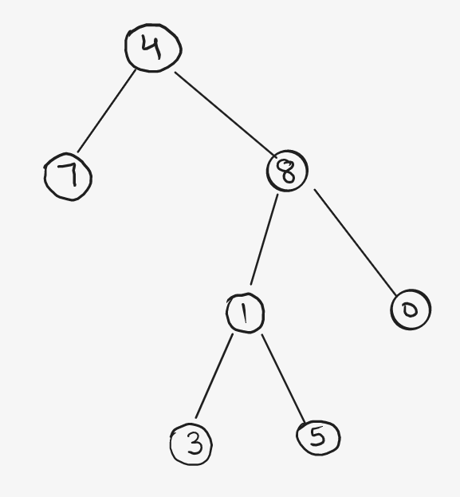Binary Tree

**Result**: False

**Explanation**: At Node 4, Left Height = 1 & Right Height = 3, Absolute Difference is 2 which is greater than 1, Hence, not a balanced tree.

**Input Format:**  Given the root of Binary Tree

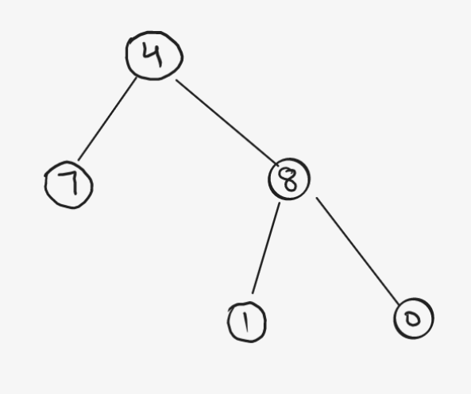

**Result**: True

**Explanation**: All Nodes in the tree have an Absolute Difference of Left Height & Right Height not more than 1.

**Solution**

**Disclaimer**: Don’t jump directly to the solution, try it out yourself first.

## **Solution 1: Naive approach**

**Intuition + Approach:**

For a Balanced Binary Tree, Check left subtree height and right subtree height for every node present in the tree. Hence, traverse the tree recursively and [calculate the height of left and right subtree](https://takeuforward.org/data-structure/maximum-depth-of-a-binary-tree/) from every node, and whenever the condition of Balanced tree violates, simply return false.

Condition for Balanced Binary Tree

**For all Nodes , Absolute( Left Subtree Height – Right Subtree Height ) <= 1**

**dry-run :**

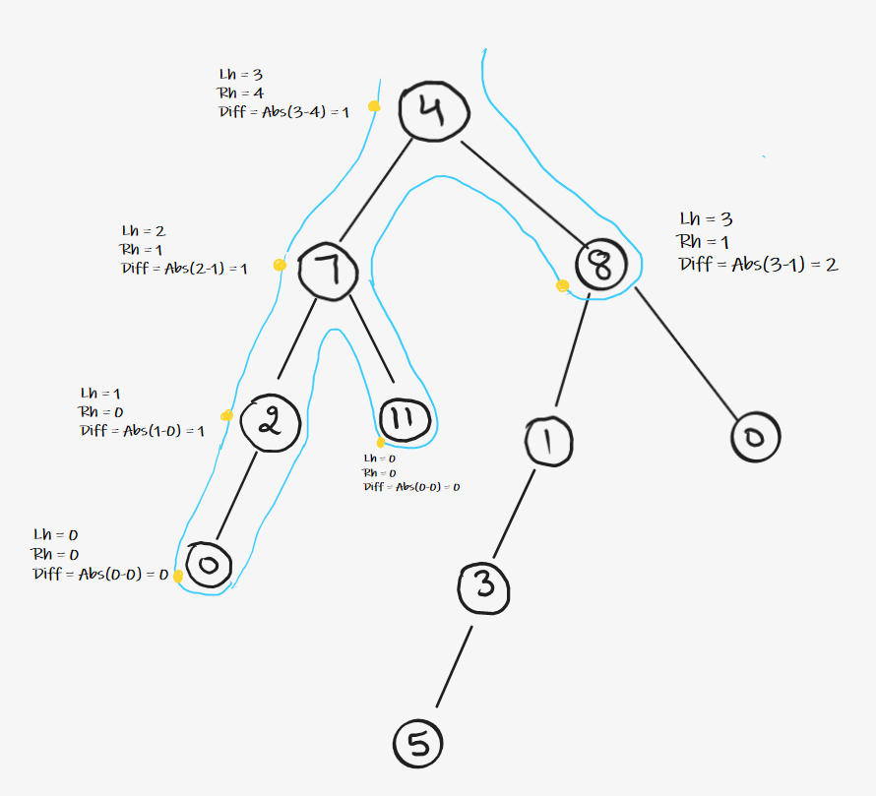

Start traversing the tree, the example given in above diagram:

* Reach on **Node 4**, call Height Function , Left height = 3 , Right height = 4 so Absolute Difference between two is Abs(3 – 4) = 1.
* Reach on **Node 7**, call Height Function , Left height = 2 , Right height = 1 so Absolute Difference between two is Abs(2 – 1) = 1.
* Reach on **Node 2**, call Height Function , Left height = 1 , Right height = 0 so Absolute Difference between two is Abs(1 – 0) = 1.
* Reach on **Node 0**, call Height Function , Left height = 0 , Right height = 0 so Absolute Difference between two is Abs(0 – 0) = 0.
* Now, on **PostOrder of Node 0,**the left subtree (null) gives true & right subtree (null) gives true , as both are true , return true.
* Now, on **PostOrder of Node 2,**the left subtree (0) gives true & right subtree (null) gives true , as both are true , return true.
* Reach on **Node 11**, call Height Function , Left height = 0 , Right height = 0 so Absolute Difference between two is Abs(0 – 0) = 0.
* Now , on **PostOrder of Node 11,**the left subtree (null) gives true & right subtree (null) gives true , as both are true , return true.
* Now ,on **PostOrder of Node 7,**the left subtree (2) gives true & right subtree (11) gives true , as both are true , return true.
* Reach on **Node 8**, call Height Function , Left height = 3 , Right height = 1 so Absolute Difference between two is Abs(3 – 1) = 2. Here Condition violates , simply return false, no need to call further
* Now , on **PostOrder of Node 4,**the left subtree (7) gives true & right subtree (8) gives false , so any one of subtree gives false , return false.

**Time Complexity: O(N*N)**( For every node, Height Function is called which takes O(N) Time. Hence for every node it becomes N*N )

**Space Complexity: O(1)**( Extra Space )**+ O(H)**( Recursive Stack Space where **“H”**is the height of tree )

## **Solution 2: Post Order Traversal**

**Intuition:** Can we optimize the above brute force solution? Which operation do you think can be skipped to optimize the time complexity?

Ain’t we traversing the subtrees again and again in the above example?

Yes, so can we skip the repeated traversals?

What if we can make use of post-order traversal?

So, the idea is to use post-order traversal. Since, in postorder traversal, we first traverse the left and right subtrees and then visit the parent node, similarly instead of calculating the height of the left subtree and right subtree every time at the root node, use post-order traversal, and keep calculating the heights of the left and right subtrees and perform the validation.

**Approach :**

* Start traversing the tree recursively and do work in Post Order.
* For each call, caculate the height of the root node, and return it to previous calls.
* Simultaneously, in the Post Order of every node , Check for condition of balance as information of left and right subtree height is available.
* If it is balanced , simply return height of current node and if not then return -1.
* Whenever the subtree result is -1 , simply keep on returning -1.

**Dry Run :**

In Post Order, Start traversing the tree on the example given in below diagram

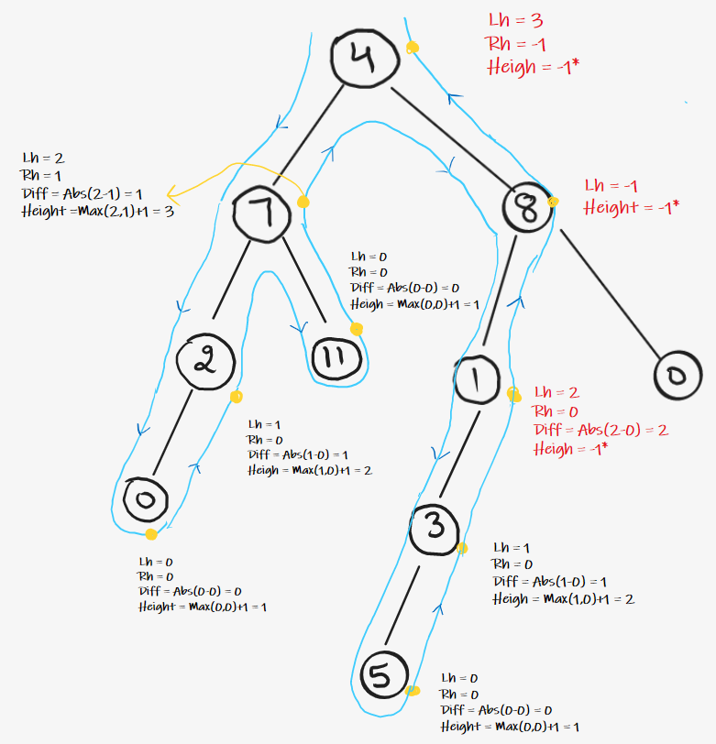

* Reach on **Node 0**, Left child = null so 0 Height , Right child = null so 0 Height , Difference is 0-0 = 0 , ( 0 <= 1 ) so return height , i.e. Max(0,0) + 1 = 1.
* Reach on **Node 2**, Left subtree height = 1 , Right subtree height =  0, Difference is 1-0 = 1 , ( 1 <= 1 ) so return height , i.e. Max(1,0) + 1 = 2.
* Reach on **Node 11**, Left child = null so 0 Height , Right child = null so 0 Height , Difference is 0-0 = 0 , ( 0 <= 1 ) so return height , i.e. Max(0,0) + 1 = 1.
* Reach on **Node 7**, Left subtree height = 2 , Right subtree height =  1, Difference is 2-1 = 1 , ( 1 <= 1 ) so return height , i.e. Max(2,1) + 1 = 3.
* Reach on **Node 5**, Left child = null so 0 Height , Right child = null so 0 Height , Difference is 0-0 = 0 , ( 0 <= 1 ) so return height , i.e. Max(0,0) + 1 = 1.
* Reach on **Node 3**, Left subtree height = 1 , Right subtree height =  0, Difference is 1-0 = 1 , ( 1 <= 1 ) so return height , i.e. Max(1,0) + 1 = 2.
* Reach on **Node 1**, Left subtree height = 2 , Right subtree height =  0, Difference is 2-0 = 2 , ( 2 > 1 ) i.e. Tree is **not Balanced**, so return -1.
* Reach on **Node 8**, Left subtree height = **-1** , indicates that tree is not balanced, simply return -1;
* Reach on **Node 4**, Left subtree height = 3 , Right subtree height =  **-1**, therefore indicates that tree is not balanced , simply return -1;
* In the Main function , If the final Height of tree is -1 return false as tree is not balanced , else return true.

**Code**:

class Solution {

public boolean isBalanced(TreeNode root) {

return dfsHeight (root) != -1;

}

int dfsHeight (TreeNode root) {

if (root == null) return 0;

int leftHeight = dfsHeight (root.left);

if (leftHeight == -1) return -1;

int rightHeight = dfsHeight (root.right);

if (rightHeight == -1) return -1;

if (Math.abs(leftHeight - rightHeight) > 1) return -1;

return Math.max(leftHeight, rightHeight) + 1;

}

}

**Time Complexity:**O(N)

**Space Complexity:**O(1) Extra Space + O(H) Recursion Stack space (Where “H”  is the height of binary tree)

# Calculate the Diameter of a Binary Tree

**Problem Statement:** Find the Diameter of a Binary Tree. **Diameter** is the length of the longest path between any 2 nodes in the tree and this path may or may not pass from the root.

**Example** 1:

**Input Format**: Given the root of Binary Tree

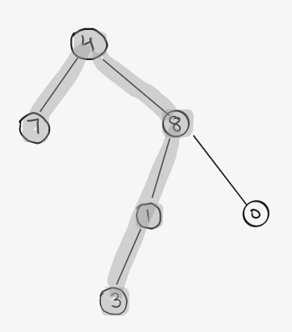Diameter of a Binary Tree

**Result**: 4

**Explanation**: Longest Path available is 7 – 4 – 8 – 1 – 3 of length 4

**Example 2:**

**Input Format:**  Given the root of Binary Tree

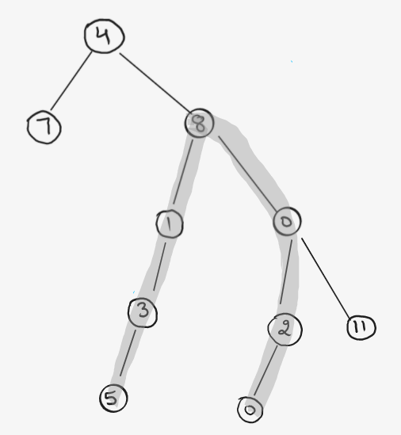

**Result**: 6

**Explanation**:  Longest Path available is 5 – 3 – 1 – 8 – 0 – 2 – 0 of length 6. ( Path is not Passing from root ).

## **Solution**s for Diameter of a Binary Tree

**Disclaimer**: Don’t jump directly to the solution, try it out yourself first.

## **Solution 1: Naive approach**

**Intuition :**

The idea is to consider every node as a Curving Point in diameter. For our understanding, we can define the curving point as the node on the diameter path which has the maximum height. In the above examples, the Curving Point is node **4** in Example 1 and node **8** in Example 2.

Now, if we observe carefully, we can see that diameter of the tree can be defined as left subtree height + right subtree height from the Curving Point.

So, the idea to find the Curving Point is, consider every node in the tree as a curving point and calculate the diameter for every curving point and return the maximum of all diameters.

Diameter at given Curving Point = Left Height + Right Height

**Approach :**

* Traverse the tree recursively.
* At every node, [calculate height of left and right subtrees.](https://takeuforward.org/data-structure/maximum-depth-of-a-binary-tree/)
* Calculate the diameter for every node using the above formula.
* Calculate the maximum of all diameters. This can be done simply using a variable passed by reference in the recursive calls or a global static variable.

**dry-run :**

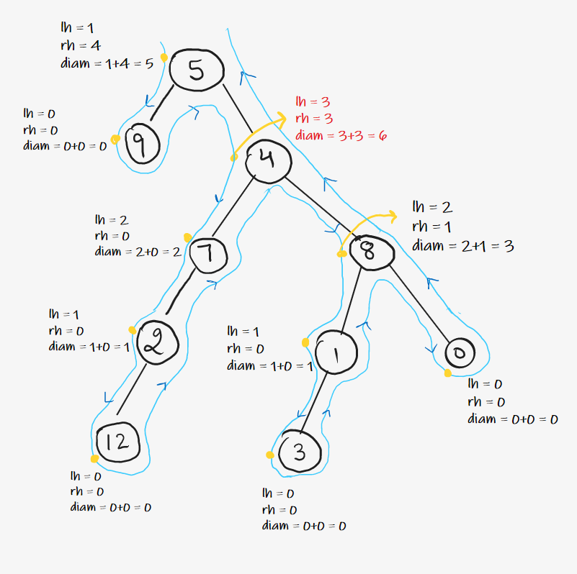

Start traversing the tree.

* Initialize Maximum Diameter variable with Integer.MIN_VALUE.
* Reach on **Node 5**, call Height Function , Left height = 1 , Right height = 4 so Diameter is (1 + 4) = 5. Hence , Maximum Diameter = Max( Integer.MIN_VALUE , 5 ) = 5.
* Reach on **Node 9**, call Height Function , Left height = 0 , Right height = 0 so Diameter is ( 0 + 0) = 0. Hence , Maximum Diameter = Max( 5 , 0 ) = 5.
* Reach on **Node 4**, call Height Function , Left height = 3 , Right height = 3 so Diameter is (3 + 3) = 6. Hence , Maximum Diameter = Max( 5 , 6 ) = 6.
* Reach on **Node 7**, call Height Function , Left height = 2 , Right height = 0 so Diameter is (2 + 0) = 2. Hence , Maximum Diameter = Max( 6,2 ) = 6.
* Reach on **Node 2**, call Height Function , Left height = 1 , Right height = 0 so Diameter is (1 + 0) = 1. Hence , Maximum Diameter = Max( 6 , 1) = 6.
* Reach on **Node 12**, call Height Function , Left height = 0 , Right height = 0 so Diameter is (0 + 0) = 0. Hence , Maximum Diameter = Max( 6 , 0) = 6.
* Reach on **Node 8**, call Height Function , Left height = 2 , Right height = 1 so Diameter is (2 + 1) = 3. Hence , Maximum Diameter = Max( 6 , 3) = 6.
* Reach on **Node 1**, call Height Function , Left height = 1 , Right height = 0 so Diameter is (1 + 0) = 1. Hence , Maximum Diameter = Max( 6 , 1) = 6.
* Reach on **Node 3**, call Height Function , Left height = 0 , Right height = 0 so Diameter is (0 + 0) = 0. Hence , Maximum Diameter = Max( 6 , 0) = 6.
* Reach on **Node 0**, call Height Function , Left height = 0 , Right height = 0 so Diameter is (0 + 0) = 0. Hence , Maximum Diameter = Max( 6 , 0) = 6.

**Time Complexity: O(N*N)**( For every node, Height Function is called which takes O(N) time hence for every node it becomes N*N )

**Space Complexity: O(1)**( Extra Space )**+ O(H)**( Recursive Stack Space where **“H”**is the height of tree )

## **Solution 2: Post Order Traversal**

**Intuition :**

Is it possible to optimize the above solution further? Which operation do you think is very repetitive in nature in the above solution?

 Height of the subtrees.

Can we use postorder traversal to calculate everything in a single traversal of the tree?

Yes, as in post-order traversal, we have to completely traverse the left and right subtree before visiting the root node.

So, the idea is to use post-order traversal and keep calculating the height of the left and right subtrees. Once we have the heights at the current node, we can easily calculate both the diameter and height of the current node.

**Approach :**

* Start traversing the tree recursively and do work in Post Order.
* In the Post Order of every node , calculate diameter and height of the current node.
* If current diameter is maximum then update the variable used to store the maximum diameter.
* Return height of current node to the previous recursive call.

**Dry Run :**

In Post Order, Start traversing the tree:

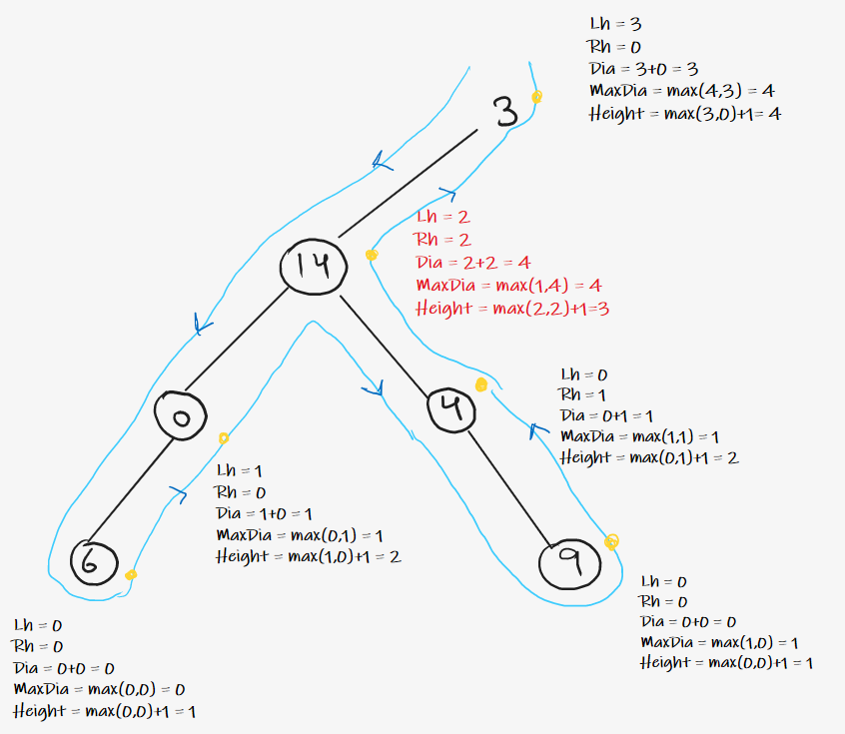

* Reach on **Node 6 ,** Left height = 0 as left == null , Right height = 0 as right == null so Diameter is (0 + 0) = 0. Hence , Maximum Diameter = Max( 0 , 0) = 0 and return height = max(0,0)+1 = 1.
* Reach on **Node 0**, Left height = 1 , Right height = 0 as right == null so Diameter is (1 + 0) = 1. Hence , Maximum Diameter = Max( 0 , 1) = 1 and return height = max(1,0)+1 = 2.
* Reach on **Node 9 ,** Left height = 0 as left == null , Right height = 0 as right == null so Diameter is (0 + 0) = 0. Hence , Maximum Diameter = Max( 1 , 0) = 1 and return height = max(0,0)+1 = 1.
* Reach on **Node 4 ,** Left height = 0 as left == null , Right height = 1 , so Diameter is (0 + 1) = 1. Hence , Maximum Diameter = Max( 1 , 1) = 1 and return height = max(0,1)+1 = 2.
* Reach on **Node 14 ,** Left height = 2 , Right height = 2 , so Diameter is (2 + 2) = 4. Hence , Maximum Diameter = Max( 1 , 4) = 4 and return height = max(2,2)+1 = 3.
* Reach on **Node 3 ,** Left height = 3 , Right height = 0 as right == null , so Diameter is (3 + 0) = 3. Hence , Maximum Diameter = Max( 4 , 3) = 4 and return height = max(3,0)+1 = 4.
* Hence , the maximum diameter is 4 .

**Code**:

public class Solution {

public int diameterOfBinaryTree(TreeNode root) {

int[] diameter = new int[1];

height(root, diameter);

return diameter[0];

}

private int height(TreeNode node, int[] diameter) {

if (node == null) {

return 0;

}

int lh = height(node.left, diameter);

int rh = height(node.right, diameter);

diameter[0] = Math.max(diameter[0], lh + rh);

return 1 + Math.max(lh, rh);

}

}

**Time Complexity:**O(N)

**Space Complexity:**O(1) Extra Space + O(H) Recursion Stack space (Where **“H”** is the height of binary tree ) 

# Maximum Sum Path in Binary Tree

**Problem Statement:** Write a program to find the maximum sum path in a binary tree. A path in a binary tree is a sequence of nodes where every adjacent pair of nodes are connected by an edge. A node can only appear in the sequence at most once. A path need not pass from the root. We need to find the path with the maximum sum in the binary tree.

**Example:**

**Input:**

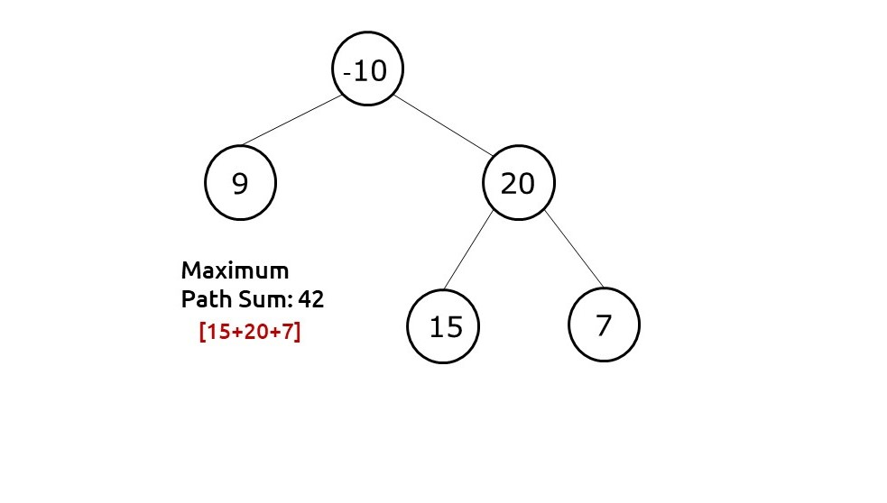

**Output:** The Max Path Sum for the Tree is 42

**Disclaimer**: Don’t jump directly to the solution, try it out yourself first.

### ****Solution:****

**Approach:**A brute force approach would be to generate all paths and compare them. Generating all paths will be a time-costly activity therefore we need to look for something else.

We first need to define what is the maximum path sum through a given node (when that node is acting as the root node/curving point). At a given node with a value, if we find the max leftSumPath in the left-subtree and the max rightSumPath in the right subtree, then the maxPathSum through that node is value+(leftSumPath+rightSumPath).

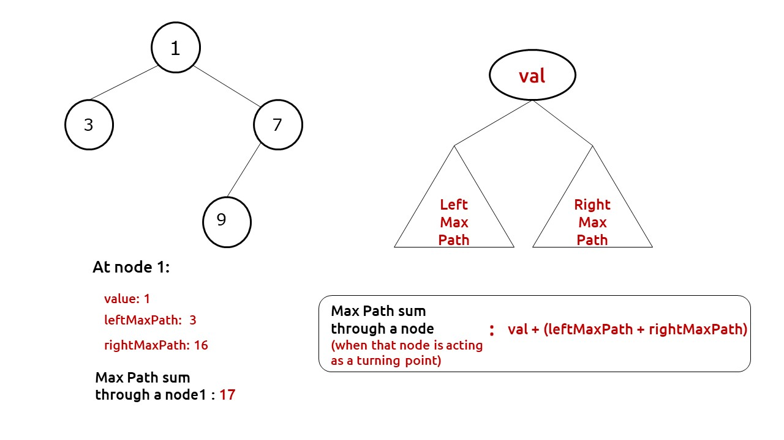

Now we can apply this formula at every node by doing a simple tree traversal and storing the maximum value (our answer) in a reference variable.

For our recursion to work, it is very important to understand what value we return from our function. In our recursive function, we find and compare the maxPathSum from a given node when it is the root/turning point of the path. But what we return is the maxPathSum of that same node when it is **NOT**the root/turning point of the path. To find the latter maxPath, we no longer have the liberty to consider both leftMaxPath and rightMaxPath, we will simply take the maximum of the two and it to the value of the node.

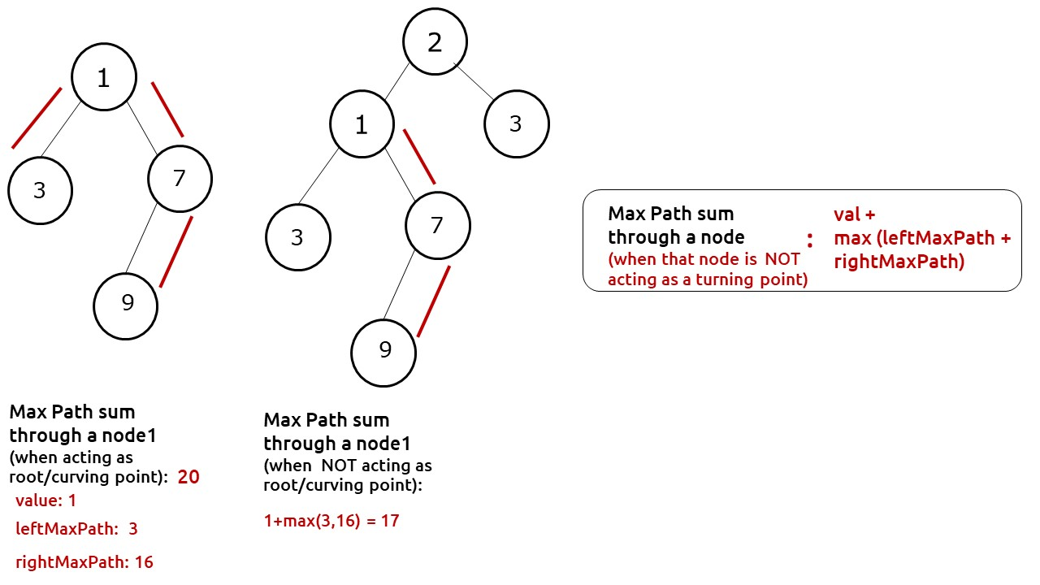

To summarize:

* Initialize a maxi variable to store our final answer.
* Do a simple tree traversal. At each node, find  recursively its leftMaxPath and its rightMaxPath.
* Calculate the maxPath through the node as val + (leftMaxPath + rightMaxPath) and update maxi accordingly.
* Return the maxPath when node is not the curving point as val + max(leftMaxPath, rightMaxPath).

**Code:**

import java.util.*;

class Node {

int val;

Node left, right;

Node(int val) {

this.val = val;

left = null;

right = null;

}

}

class TUF {

public static int maxPathSum(Node root) {

int maxValue[] = new int[1];

maxValue[0] = Integer.MIN_VALUE;

maxPathDown(root, maxValue);

return maxValue[0];

}

public static int maxPathDown(Node node, int maxValue[]) {

if (node == null) return 0;

int left = Math.max(0, maxPathDown(node.left, maxValue));

int right = Math.max(0, maxPathDown(node.right, maxValue));

maxValue[0] = Math.max(maxValue[0], left + right + node.val);

return Math.max(left, right) + node.val;

}

public static void main(String args[]) {

Node root = new Node(-10);

root.left = new Node(9);

root.right = new Node(20);

root.right.left = new Node(15);

root.right.right = new Node(7);

int answer = maxPathSum(root);

System.out.println("The Max Path Sum for this tree is " + answer);

}

}

The Max Path Sum for this tree is 42

**Time Complexity: O(N)**.

Reason: We are doing a tree traversal.

**Space Complexity: O(N)**

Reason: Space is needed for the recursion stack. In the worst case (skewed tree), space complexity can be O(N).

# Check if two trees are identical

**Problem Statement:**Given two Binary Tree. Write a program to check if two trees are identical or not.

**Example 1:**

**Input:**

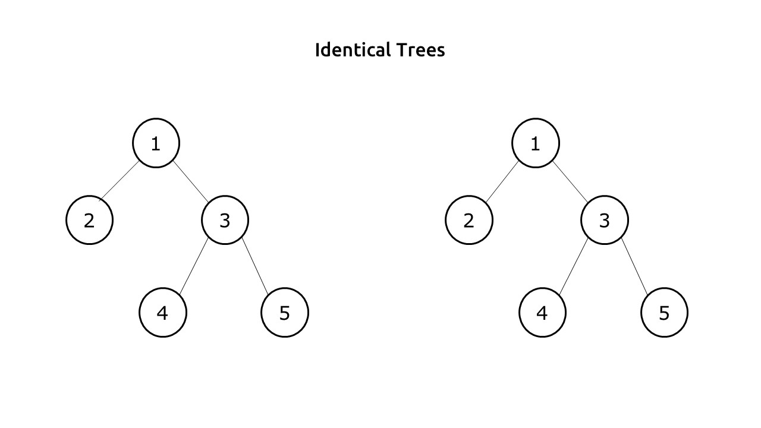

**Output:** Two Trees are identical

**Exaplaination:** Two trees T1 and T2 are said to be identical if these three conditions are met for every pair of nodes :

Value of a node in T1 is equal to the value of the corresponding node in T2.

Left subtree of this node is identical to the left subtree of the corresponding node.

Right subtree of this node is identical to the right subtree of the corresponding node.

**Example 2:**

**Input:**

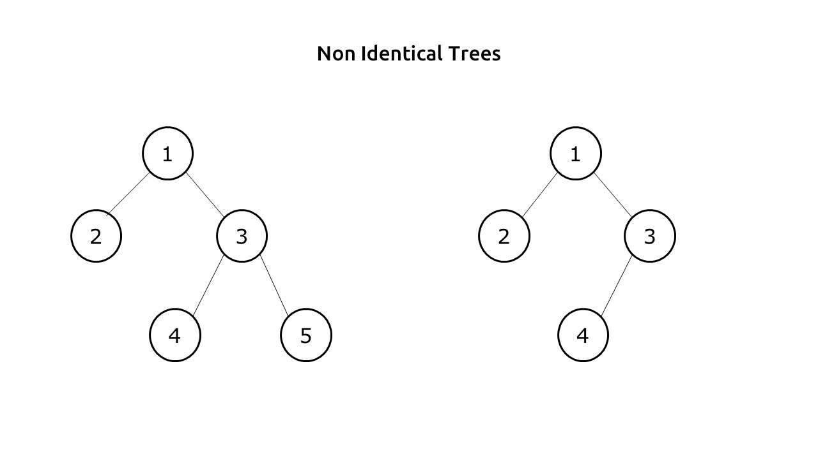

**Output:** Two Trees are not identical

**Disclaimer**: Don’t jump directly to the solution, try it out yourself first.

### ****Solution:****

**Approach:**In order to check whether two trees are identical or not, we need to traverse the trees. While traversing we first check the value of the nodes, if they are unequal we can simply return false, as trees are non-identical. If they are the same, then we need to **recursively** check their left child as well as the right child. When we get all the three values as true(node values, left child, right child) we can conclude that these are identical trees and can return true. Any other combination will return false.

**Dry Run:**

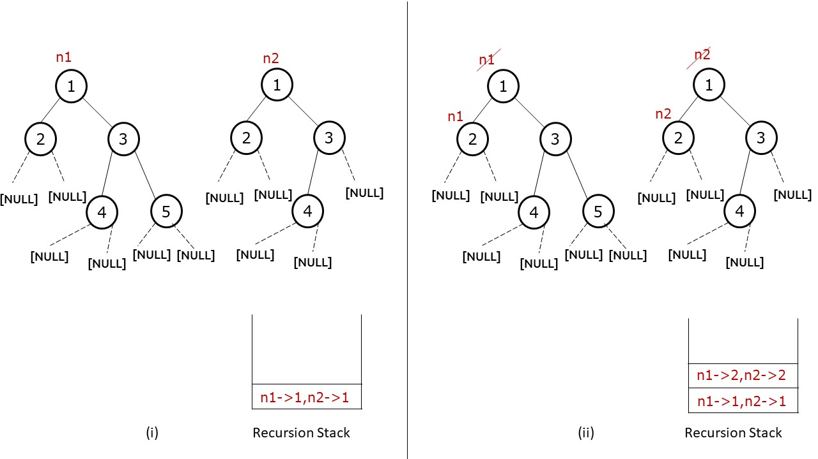

**(i)**Initially we have variables n1 and n2 pointing to the roots of both trees. This function is inside our recursion stack as well.

**(ii)**First we check the values at the nodes. As the values of nodes are equal, we proceed further and recursively call the left child of both nodes. This second function is pushed to our recursion stack.

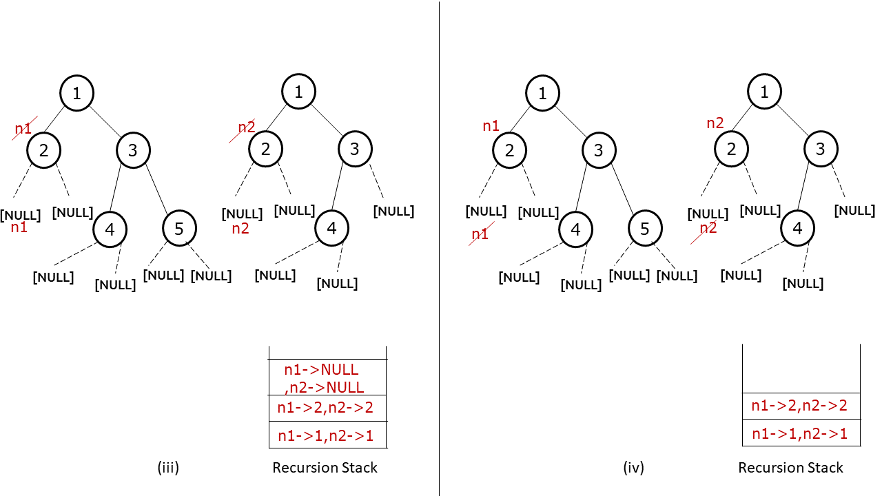

**(iii)** Again we check the nodes. As they are equal, we again check for the left subtrees and add the function to our recursion stack.

(**iv)**Both n1 and n2 point to NULL, so the base condition will be true and we will return true from this function.

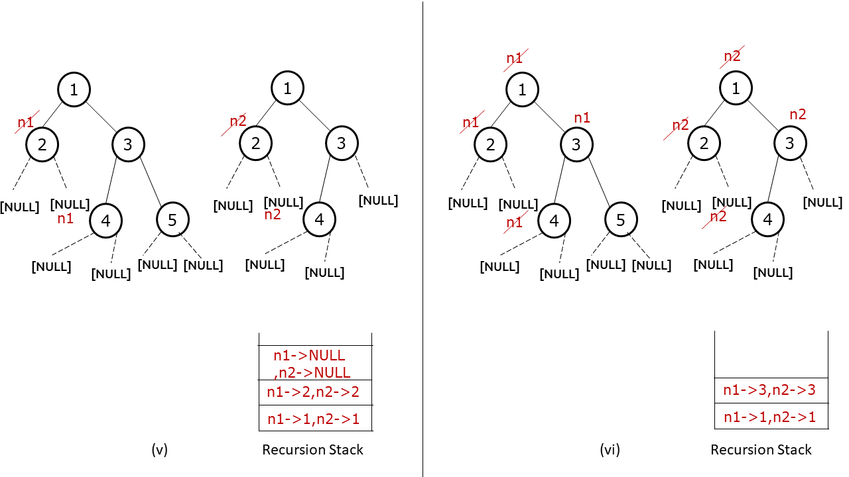

**(v)**At nodes pointing to 2, two out of three conditions return true, so we will proceed further and check the third condition. We will recursively call the right child of the nodes. Again that function will be added to our recursive stack.

**(vi)**Similar to step 4, n1 and n2 point to NULL, therefore we will again return true and the function will be removed from our recursion stack. Now at nodes pointing to 2, all three conditions return true (node values, left child and right child), therefore we can return true from this function and remove it from the recursion stack. Then at node 1, two conditions are true, therefore we call the right child of n1 and n2 to check the third condition.

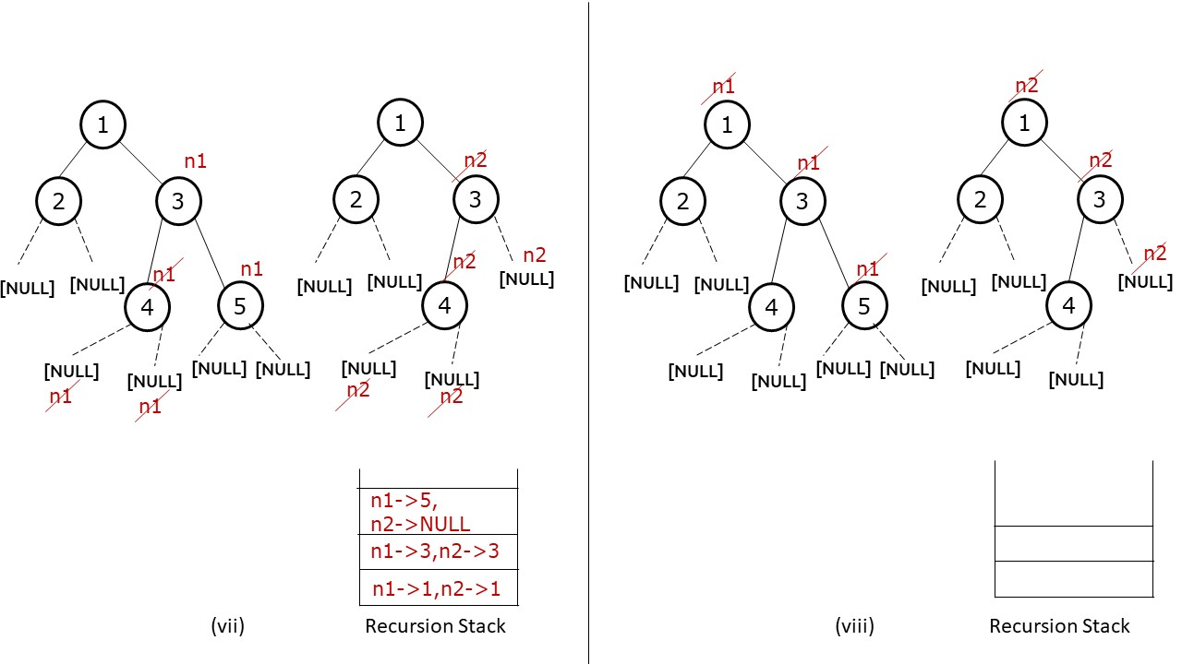

**(vii)**At nodes pointing to 3, we first check the data values which are equal, then we recursively call the function to check for their left child. It turns out to be identical and we get the return value true, then we recursively call the function to check for their right child.

**(viii)**Now n1 points to a node with value 5 whereas n2 points to NULL, this can’t be the case with an identical tree, our second base condition hits and we return false from this function. In the parent function where n1 and n2 point to 3,**only two out of three conditions return true,**therefore we will return the value false. In its parent function where n1 and n2 points to 1, again **only two out of three conditions return true,**therefore we will return false. Hence we will return a false value.

As our first function returns a false to our main function, we can conclude that these two trees are **Non-identical.**

**Code:**

import java.util.*;

class Node {

int data;

Node left, right;

Node(int data) {

this.data = data;

left = right = null;

}

}

public class TUF {

static boolean isIdentical(Node node1, Node node2) {

if (node1 == null && node2 == null)

return true;

else if (node1 == null || node2 == null)

return false;

return ((node1.data == node2.data) && isIdentical(node1.left, node2.left) && isIdentical(node1.right, node2.right));

}

public static void main(String args[]) {

Node root1 = new Node(1);

root1.left = new Node(2);

root1.right = new Node(3);

root1.right.left = new Node(4);

root1.right.right = new Node(5);

Node root2 = new Node(1);

root2.left = new Node(2);

root2.right = new Node(3);

root2.right.left = new Node(4);

if (isIdentical(root1, root2))

System.out.println("Two Trees are identical");

else System.out.println("Two trees are non-identical");

}

}

**Output:**

Two trees are non-identical

**Time Complexity: O(N)**.

Reason: We are doing a tree traversal.

**Space Complexity: O(N)**

Reason: Space is needed for the recursion stack. In the worst case (skewed tree), space complexity can be O(N).

# Zig Zag Traversal Of Binary Tree

**Problem Statement:** Given the root of a binary tree, return the zigzag level order traversal of Binary Tree. (i.e., from left to right, then right to left for the next level and alternate between).

**Examples:**

**Example 1:**

**Input:** root = [3,9,20,null,null,15,7]

**Output:** [[3],[20,9],[15,7]]

**Explanation:** From the root, we follow this terminology, left to right -> right to left -> left to right and so on so forth.

**Example 2:**

**Input:** root = [[0]]

**Output :** [[0]]

**Explanation:** We just have a single node which acts as the root, so going from left to right, we get just one node that is the root node itself.

**Intuition:** Considering the fact that we need to print the nodes, level by level, our first guess would definitely be that it must be related to level order traversal. If we closely examine, for even levels we need to go from left to right while for odd levels we need to go from right to left.

**Approach**: The above idea, could be implemented with a queue. We initially keep an empty queue and push the root node. We also need to keep the left to right bool variable that keeps check of the current level we are in. As we traverse nodes in the queue, we need to push them in a temporary array. If left to right is false we need to reverse the array and push it in our data structure or else, simply push it in our data structure. In the end, when we have finished traversing the current level, we need to toggle our left to the right variable.

**Code:**

import java.util.*;

class Node {

int val;

Node left, right;

Node(int val) {

this.val = val;

left = null;

right = null;

}

}

class TUF {

public static ArrayList < ArrayList < Integer >> zigzagLevelOrder(Node root) {

Queue < Node > queue = new LinkedList < Node > ();

ArrayList < ArrayList < Integer >> wrapList = new ArrayList < > ();

if (root == null) return wrapList;

queue.offer(root);

boolean flag = true;

while (!queue.isEmpty()) {

int levelNum = queue.size();

ArrayList < Integer > subList = new ArrayList < Integer > (levelNum);

for (int i = 0; i < levelNum; i++) {

int index = i;

if (queue.peek().left != null) queue.offer(queue.peek().left);

if (queue.peek().right != null) queue.offer(queue.peek().right);

if (flag == true) subList.add(queue.poll().val);

else subList.add(0, queue.poll().val);

}

flag = !flag;

wrapList.add(subList);

}

return wrapList;

}

public static void main(String args[]) {

int i, j;

Node root = new Node(3);

root.left = new Node(9);

root.right = new Node(20);

root.right.left = new Node(15);

root.right.right = new Node(7);

ArrayList < ArrayList < Integer >> ans;

ans = zigzagLevelOrder(root);

System.out.println("Zig Zag Traversal of Binary Tree ");

for (i = 0; i < ans.size(); i++) {

for (j = 0; j < ans.get(i).size(); j++) {

System.out.print(ans.get(i).get(j) + " ");

}

System.out.println();

}

}

}

**Output:**

Zig Zag Traversal of Binary Tree  
3  
20 9  
15 7

**Time Complexity: O(N)**

**Space Complexity: O(N)**

# Boundary Traversal of a Binary Tree

**Problem Statement: BoundaryTraversal of a binary tree**. Write a program for the Anti-Clockwise Boundary traversal of a binary tree.

**Example:**

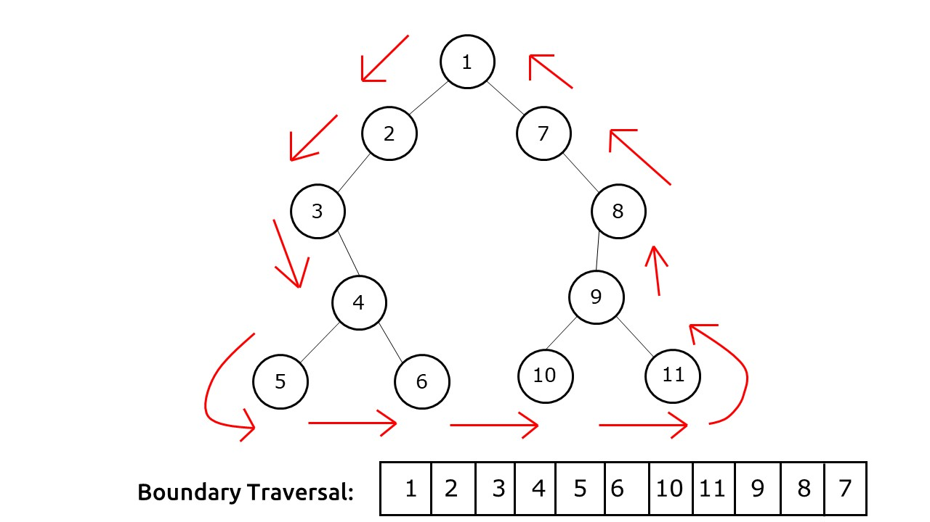

## **Solution :**

**Disclaimer**: Don’t jump directly to the solution, try it out yourself first.

**Approach:**Boundary traversal in an anti-clockwise direction can be described as a traversal consisting of three parts:

1. **Part 1:**Left Boundary of the tree (excluding the leaf nodes).
2. **Part 2:**All the leaf nodes travelled in the left to right direction.
3. **Part 3:**Right Boundary of the tree (excluding the leaf nodes), traversed in the reverse direction.

We take a simple data structure like a vector/Arraylist to store the Boundary Traversal. The root node is coming from both the boundaries (left and right). Therefore, to avoid any confusion, we push it on our list at the very start.

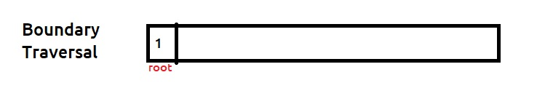

We will now see the approach to finding these three parts.

**Part 1:** Left Boundary

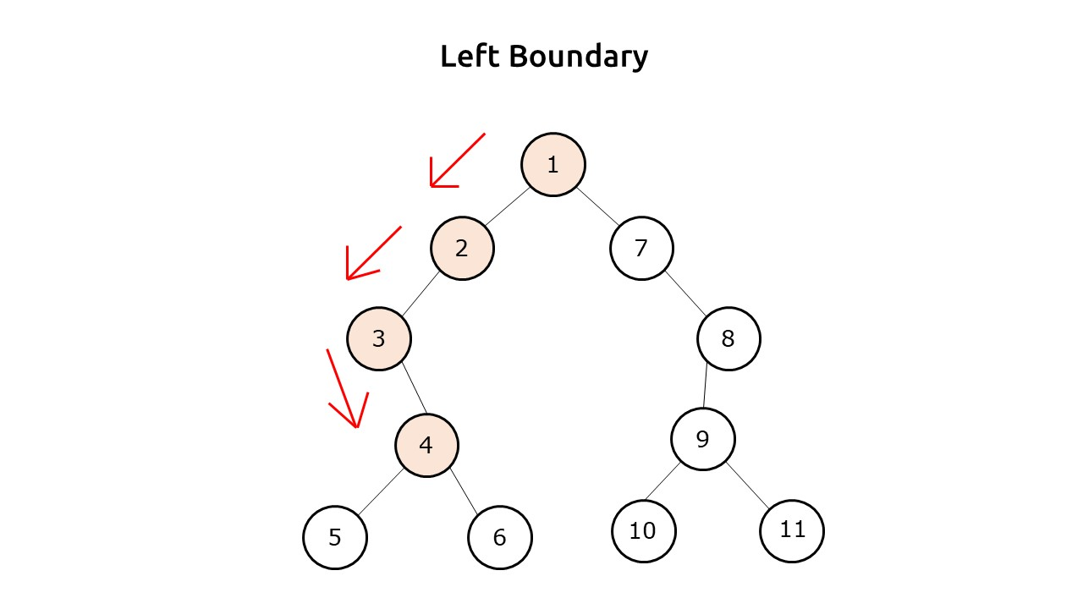

To traverse the left boundary, we can set a simple iteration. Initially, we make the cur pointer point to the root’s left. In every iteration, if the cur node is not a leaf node, we print it. Then we always try to move left of the cur pointer. If there is no left child, then we move to the right of cur and in the next iteration, again try to move to the left first. We stop our execution when cur is pointing to NULL.

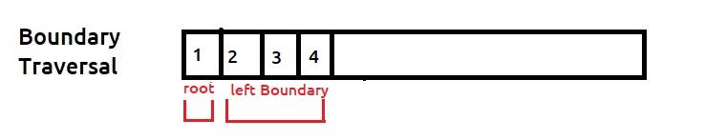

**Part 2:**Leaf nodes

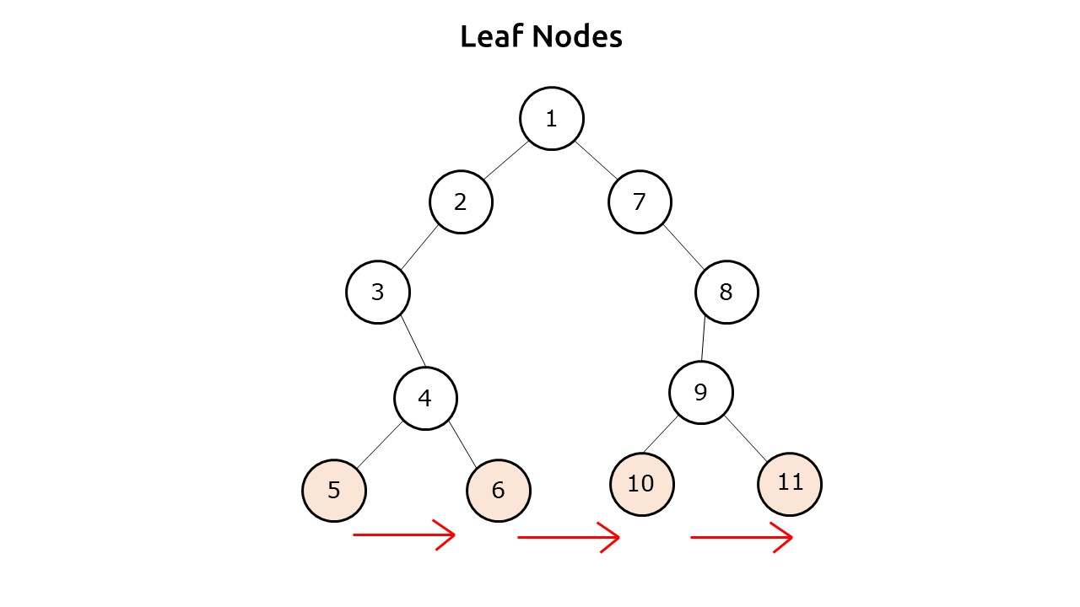

To print the leaf nodes, we can do a simple preorder traversal, and check if the current node is a leaf node or not. If it is a leaf node just print it.

Please note that we want the leaves to come in a specific order which is bottom-left to top-right, therefore a level order traversal will not work because it will print the upper-level leaves first. Therefore, we use a preorder traversal.

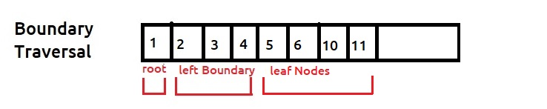

**Part 3:**Right Boundary

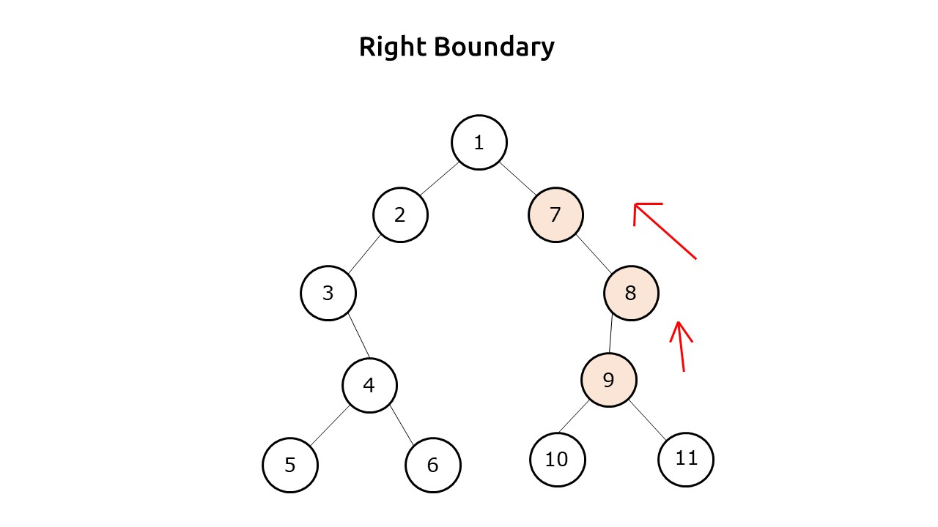

We need to print the right boundary in the **Reverse**direction. It is very similar to the left boundary traversal. We initialize our cur pointer to the right child of the root node and set an iterative loop. To achieve the reverse direction, we take an auxiliary list. In every iteration, we check if the current node is not a leaf node then we push it to the auxiliary list. Then we first try to move right of cur, if there is no right child only then we move left. We stop our execution once cur points to NULL.

Now the auxiliary list contains the nodes of the right boundary. We iterate from the end to start off this list and in every iteration, push the value to our main boundary traversal list. This way we get the nodes in the reverse direction.

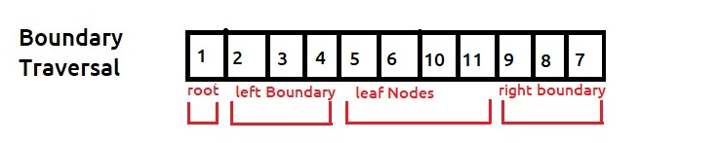

**Dry Run:**In case you want to watch the dry run for this approach, please watch the video attached below.

**Code:**

import java.util.*;

class Node {

int data;

Node left, right;

Node(int data) {

this.data = data;

left = null;

right = null;

}

}

public class Main {

static Boolean isLeaf(Node root) {

return (root.left == null) && (root.right == null);

}

static void addLeftBoundary(Node root, ArrayList < Integer > res) {

Node cur = root.left;

while (cur != null) {

if (isLeaf(cur) == false) res.add(cur.data);

if (cur.left != null) cur = cur.left;

else cur = cur.right;

}

}

static void addRightBoundary(Node root, ArrayList < Integer > res) {

Node cur = root.right;

ArrayList < Integer > tmp = new ArrayList < Integer > ();

while (cur != null) {

if (isLeaf(cur) == false) tmp.add(cur.data);

if (cur.right != null) cur = cur.right;

else cur = cur.left;

}

int i;

for (i = tmp.size() - 1; i >= 0; --i) {

res.add(tmp.get(i));

}

}

static void addLeaves(Node root, ArrayList < Integer > res) {

if (isLeaf(root)) {

res.add(root.data);

return;

}

if (root.left != null) addLeaves(root.left, res);

if (root.right != null) addLeaves(root.right, res);

}

static ArrayList < Integer > printBoundary(Node node) {

ArrayList < Integer > ans = new ArrayList < Integer > ();

if (isLeaf(node) == false) ans.add(node.data);

addLeftBoundary(node, ans);

addLeaves(node, ans);

addRightBoundary(node, ans);

return ans;

}

public static void main(String args[]) {

Node root = new Node(1);

root.left = new Node(2);

root.left.left = new Node(3);

root.left.left.right = new Node(4);

root.left.left.right.left = new Node(5);

root.left.left.right.right = new Node(6);

root.right = new Node(7);

root.right.right = new Node(8);

root.right.right.left = new Node(9);

root.right.right.left.left = new Node(10);

root.right.right.left.right = new Node(11);

ArrayList < Integer > boundaryTraversal;

boundaryTraversal = printBoundary(root);

System.out.println("The Boundary Traversal is : ");

for (int i = 0; i < boundaryTraversal.size(); i++) {

System.out.print(boundaryTraversal.get(i) + " ");

}

}

}

**Output:**

The Boundary Traversal is : 1 2 3 4 5 6 10 11 9 8 7

**Time Complexity: O(N)**.

Reason: The time complexity will be O(H) + O(H) + O(N) which is ≈ O(N)

**Space Complexity: O(N)**

Reason: Space is needed for the recursion stack while adding leaves. In the worst case (skewed tree), space complexity can be O(N).

# Vertical Order Traversal of Binary Tree

**Problem Statement: Vertical Order Traversal Of A Binary Tree**. Write a program for Vertical Order Traversal order of a Binary Tree.

**Example:**

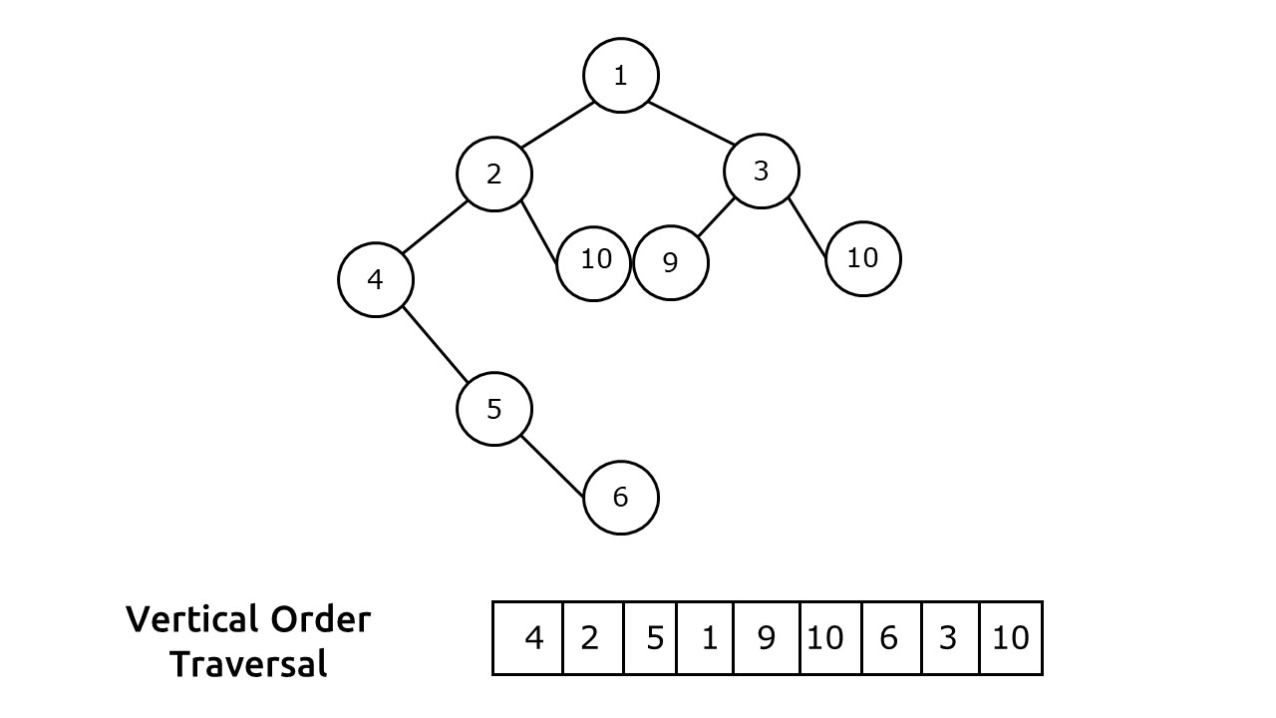

**Problem Description:**

Vertical Order Traversal, as the name suggests is a traversal in which we divide the binary tree in verticals from left to right, and in every vertical, we print the nodes from top to bottom.

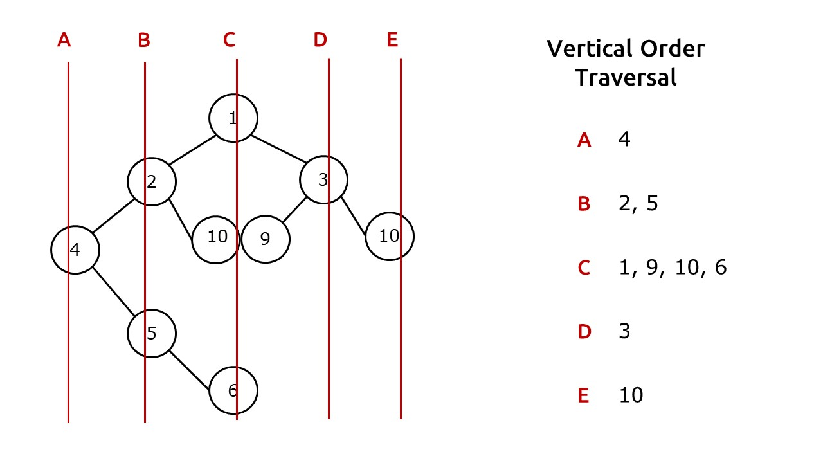

Note:

* There can be duplicate values among the nodes (here 10 is repeated twice).
* If two or more nodes are overlapping at the same position(here 10 and 9), then they will be printed in ascending order.

### ****Solution :****

**Disclaimer**: Don’t jump directly to the solution, try it out yourself first.

**Intuition:**First of all, we need to assign a vertical and a level to every node. Once we assign them, we need to figure out a suitable data structure to store them. This data structure should give us the nodes with left-side vertical first and in every vertical, top-level node should appear first.

**Approach:**

We will perform a tree traversal and assign a vertical and level to every node. Based on this vertical and node, we store the node in our special data structure. For easy understanding, we break it into these steps:

**Step-1: Assigning vertical and level to every node**

We can perform any tree traversal for this step. Here we are taking the example of level order traversal. In the initial step when we push the node to our queue, we will push two more variables to it, one for the vertical and one for the level (both initialized as zero). Now whenever we push the left child of the node, we decrease vertical by 1 and increase level by 1, whereas whenever we push the right child of the node, we increase both vertical and level by one.

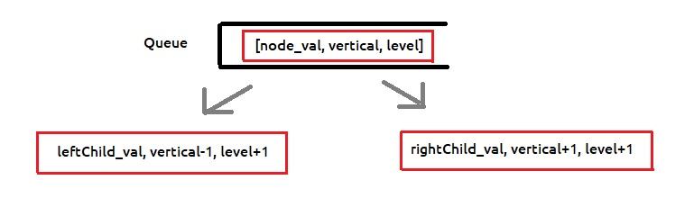

Verticals and levels will be marked as follows:

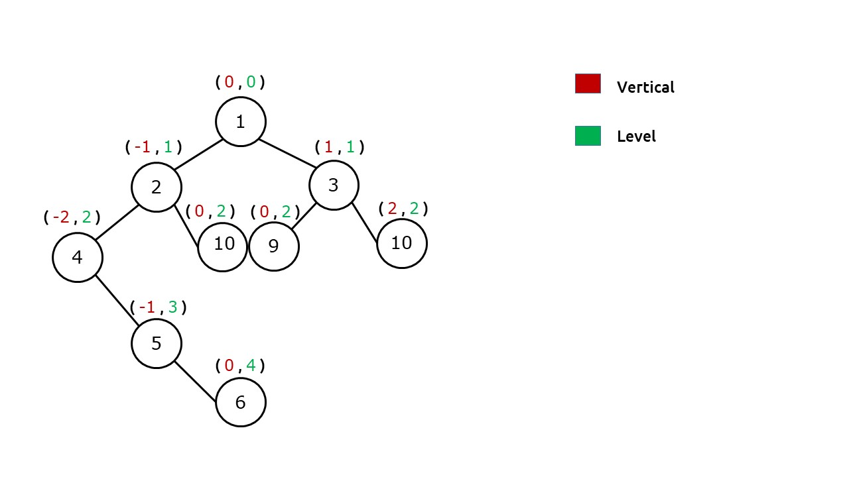

**Step-2: Storing Verticals and levels to our data structure**

When we are assigning the verticals and levels, it is very important to store them in a suitable data structure. After assigning we have:

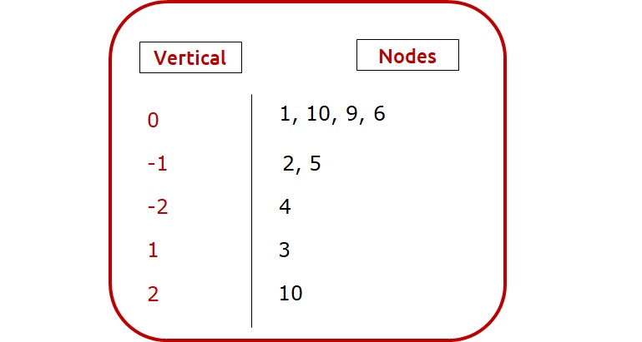

In the vertical order traversal, we need to print the nodes of the left vertical first, therefore in our example, nodes of -2 vertical will be the first to  be printed. Therefore, we need a data structure that can store nodes according to their vertical value and give us the nodes of least values first. Hence we will use a **map** as it satisfies both criterias.



Now, we will explore X. In a single vertical we want to get the nodes by their levels. In our example, vertical 0 has nodes of three different levels, we will print level 0 first (node 1), then level 2 (node 9 and 10) and at last level 4 (node 6). Therefore as in the case of our verticals, we will again use**map** to store nodes level-wise inside the vertical. So, our data structure will become:

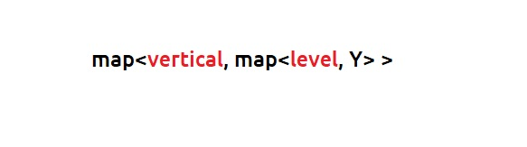

Now, we will explore Y. There can be a case that two or more nodes overlap at the same vertical and level, as with case of node 9 and node 10 at vertical 0 and level 2. In such a case we will print nodes with lesser value first. Therefore for every level, we need a data-structure which can store node values in a sorted order. Moreover, as duplicate values are allowed in our tree, our data structure needs to handle this well. This is acheived by using [**multiset**](https://www.cplusplus.com/reference/set/multiset/)**in C++**. Multiset is similar to a set which keeps elements in sorted order but also allows duplicates. **In Java**, we can use **priority queues** as it gives us the minimum value at the top.

Therefore, our final data structure will be:

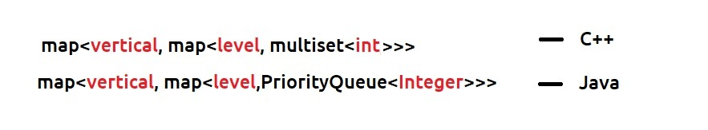

**Note:**This is not the only choice for the data structure. You are free to choose any other data structure as well but the requirements remain the same. Instead of a multiset/priority queue, simple lists can also be used but then we will need to sort them in our last step.

**Step 3: Printing vertical order traversal from our data structure**

In the last step, we iterate over our verticals by using the data structure of step 2. In every iteration, we take a list(to store all nodes of that vertical) and again iterate over the levels. We then push the nodes of the level (stored in the multiset/priority queue) and push it to our vertical list. Once we iterate over all verticals we get our vertical order traversal.

**Dry Run:**In case you want to watch the dry run for this approach, please watch the video attached below.

**Code:**

import java.util.*;

class TreeNode {

int data;

TreeNode left, right;

TreeNode(int data) {

this.data = data;

left = null;

right = null;

}

}

class Tuple {

TreeNode node;

int row;

int col;

public Tuple(TreeNode _node, int _row, int _col) {

node = _node;

row = _row;

col = _col;

}

}

public class TUF {

public static List < List < Integer >> findVertical(TreeNode root) {

TreeMap < Integer, TreeMap < Integer, PriorityQueue < Integer >>> map = new TreeMap < > ();

Queue < Tuple > q = new LinkedList < Tuple > ();

q.offer(new Tuple(root, 0, 0));

while (!q.isEmpty()) {

Tuple tuple = q.poll();

TreeNode node = tuple.node;

int x = tuple.row;

int y = tuple.col;

if (!map.containsKey(x)) {

map.put(x, new TreeMap < > ());

}

if (!map.get(x).containsKey(y)) {

map.get(x).put(y, new PriorityQueue < > ());

}

map.get(x).get(y).offer(node.data);

if (node.left != null) {

q.offer(new Tuple(node.left, x - 1, y + 1));

}

if (node.right != null) {

q.offer(new Tuple(node.right, x + 1, y + 1));

}

}

List < List < Integer >> list = new ArrayList < > ();

for (TreeMap < Integer, PriorityQueue < Integer >> ys: map.values()) {

list.add(new ArrayList < > ());

for (PriorityQueue < Integer > nodes: ys.values()) {

while (!nodes.isEmpty()) {

list.get(list.size() - 1).add(nodes.poll());

}

}

}

return list;

}

public static void main(String args[]) {

TreeNode root = new TreeNode(1);

root.left = new TreeNode(2);

root.left.left = new TreeNode(4);

root.left.right = new TreeNode(10);

root.left.left.right = new TreeNode(5);

root.left.left.right.right = new TreeNode(6);

root.right = new TreeNode(3);

root.right.left = new TreeNode(9);

root.right.right = new TreeNode(10);

List < List < Integer >> list = new ArrayList < > ();

list = findVertical(root);

System.out.println("The Vertical Traversal is : ");

for (List < Integer > it: list) {

for (int nodeVal: it) {

System.out.print(nodeVal + " ");

}

System.out.println();

}

}

}

**Output:**

The Vertical Traversal is :

4

2 5

1 9 10 6

3

10

**Time Complexity: O(N*logN)**

**Space Complexity: O(N)**

# Top view of a Binary Tree

**Problem Statement:** Given below is a binary tree. The task is to print the top view of the binary tree. The top view of a binary tree is the set of nodes visible when the tree is viewed from the top.

**Example 1:**

**Input:**

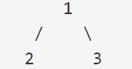

**Output:** 2 1 3

**Example 2:**

**Input:**

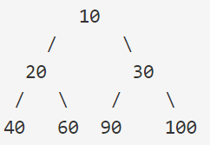

**Output:** 40 20 10 30 100

**Solution:**

**Intuition**:  We can mark straight lines like in the image below and mark them with +ve and -ve indexes. The first node of every line will be my top view.

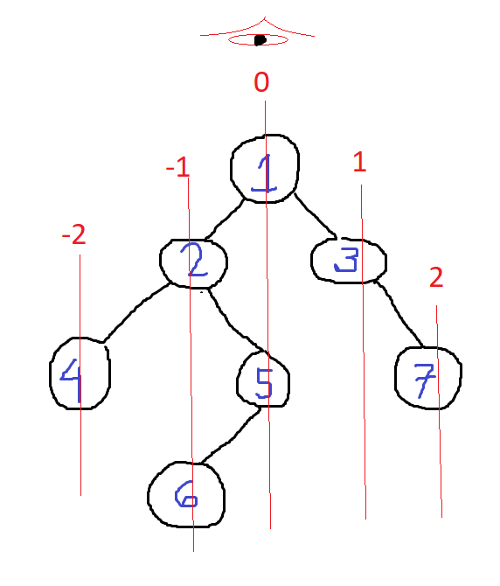

**Approach**:

* First we have to make a queue of pair which have nodes and their respective +ve and -ve indexes.
* Then we need a map data structure to store the lines and the nodes. This map will store the data in the form of sorted orders of keys(Lines).
* Here we will follow the level order traversal.
* Traverse through the nodes starting with root,0 and store them to the queue.
* Until the queue is not empty, store the node  and line no. in 2 separate variable .
* Then check if that line is present in the map or not
* If not present then store the line and the node->val to the map
* Otherwise store the node->left and node->right along with there line nos. to the queue.
* Then print the node->val from the map

**Code:**

class Solution

{

//Function to return a list of nodes visible from the top view

//from left to right in Binary Tree.

static ArrayList<Integer> topView(Node root)

{

ArrayList<Integer> ans = new ArrayList<>();

if(root == null) return ans;

Map<Integer, Integer> map = new TreeMap<>();

Queue<Pair> q = new LinkedList<Pair>();

q.add(new Pair(root, 0));

while(!q.isEmpty()) {

Pair it = q.remove();

int hd = it.hd;

Node temp = it.node;

if(map.get(hd) == null) map.put(hd, temp.data);

if(temp.left != null) {

q.add(new Pair(temp.left, hd - 1));

}

if(temp.right != null) {

q.add(new Pair(temp.right, hd + 1));

}

}

for (Map.Entry<Integer,Integer> entry : map.entrySet()) {

ans.add(entry.getValue());

}

return ans;

}

}

**Time Complexity: O(N)**

**Space Complexity: O(N)**

# Bottom view of a Binary Tree

**Problem Statement:** Given a binary tree, print the bottom view from left to right. A node is included in the bottom view if it can be seen when we look at the tree from the bottom.

**Example 1:**

**Input:**

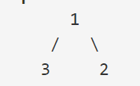

**Output:** 3 1 2

**Explanation:**

**Explanation**:

If you look up from the bottom from left to right then first we get 3, then 1 and 2.

**Example 2:**

**Input:**

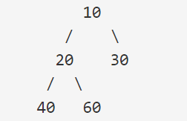

**Output:** 40 20 60 30

**Explanation**:

If you look up from the bottom from left to right then first we get 40, then 20, 60(it blocks 10), and 30.

**Disclaimer**: Don’t jump directly to the solution, try it out yourself first

**Solution**

**Intuition**:  We can mark straight lines like in the image below and mark them with +ve and -ve indexes. The Last node of every line will be my Bottom view.

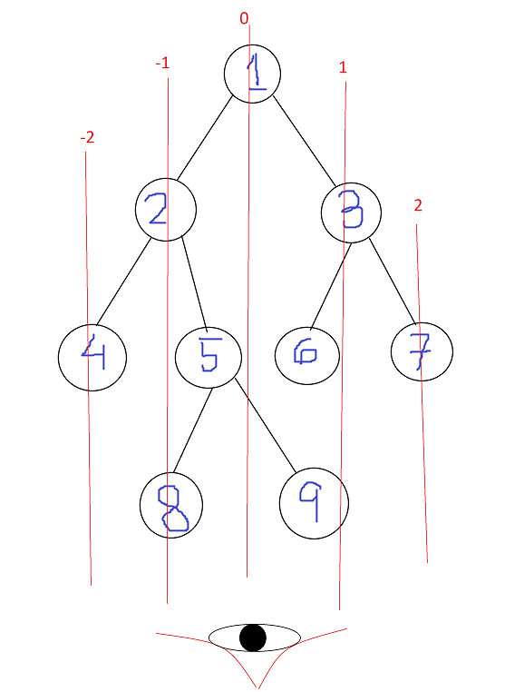

**Approach**:

* First we have to make a queue of pair which have nodes and their respective +ve and -ve indexes.
* Then we need a map data structure to store the lines and the nodes. This map will store the data in the form of sorted orders of keys(Lines).
* Here we will follow the level order traversal.
* Traverse through the nodes starting with root,0 and store them to the queue.
* Until the queue is not empty, store the node  and line no. in 2 separate variables .
* Then store the line and the node->val to the map, if there will be any node value present that corresponds to a line in the map , it will be replaced by the new node value and by this we will get the last node of each line.
* Store the node->left and node->right along with their line nos. to the queue.
* Then print the node->val from the map

**Tip**: Here there is only 1 small difference from the Top View of the Tree. Here we don’t need to check whether the node is previously present on the map or node before entering it. We have to replace the node of each line if that was previously present on the map.

**Code:**

class Solution

{

//Function to return a list containing the bottom view of the given tree.

public ArrayList <Integer> bottomView(Node root)

{

ArrayList<Integer> ans = new ArrayList<>();

if(root == null) return ans;

Map<Integer, Integer> map = new TreeMap<>();

Queue<Node> q = new LinkedList<Node>();

root.hd = 0;

q.add(root);

while(!q.isEmpty()) {

Node temp = q.remove();

int hd = temp.hd;

map.put(hd, temp.data);

if(temp.left != null) {

temp.left.hd = hd - 1;

q.add(temp.left);

}

if(temp.right != null) {

temp.right.hd = hd + 1;

q.add(temp.right);

}

}

for (Map.Entry<Integer,Integer> entry : map.entrySet()) {

ans.add(entry.getValue());

}

return ans;

}

}

**Time Complexity: O(N)**

**Space Complexity: O(N)**

# Right/Left view of binary tree

**Problem Statement:** Given a Binary Tree, find the **Right/Left view** of it. The right view of a Binary Tree is a set of nodes visible when the tree is viewed from the **right**side. The left view of a Binary Tree is a set of nodes visible when the tree is viewed from the **left** side.

**Example 1:**

**Input:**



**Output:** Right view- 1 2

Left view- 1 3

**Explanation**: Seeing through the left side it sees only 1 and 3 while through the right side we only see 1 and 2.

**Example 2:**

**Input:**



**Output:** Right View- 10 30 60

Left view- 10 20 40

**Explanation**: Seeing through the left side it sees only 10, 20, and 40 while through the right side we only see 10, 30, and 60.

**Solution:**

**Disclaimer**: Don’t jump directly to the solution, try it out yourself first.

**Intuition**: We have to do a Recursive Level Order Traversal.

Root Right Left     —-> for Right view

Root Left Right     —–> for Left view

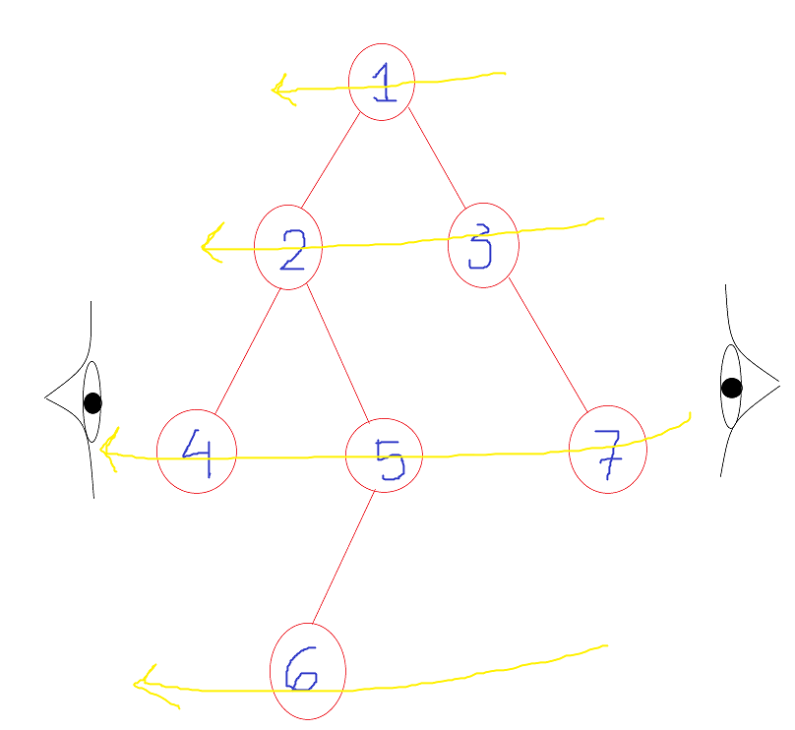

**Approach**:

* Create an vector data structure inside both the left and the right side view function
* Call for the recursive _left and recursive_right function respectively with the (root,level,vector). Here level will be initially passed as 0.
* Return the vector.
* Now in the recursive_left function
  + If vector size is equal to the level then push_back its node value to the vector data structure.
  + Otherwise call recursive_left for (node->left,level+1,vector)
  + Call recursive_left for (node->right,level+1,vector)
* Now in the recursive_right function
  + If vector size is equal to the level then push_back its node value to the vector data structure.
  + Otherwise call recursive_right for (node->right,level+1,vector)
  + Call recursive_right for (node->left,level+1,vector)

**Tip**: The Code for the Left and the Right View is almost identical.

In the Right view code first, you have to call the recursive function for the right then the left node

AND

In the Left view code first, you have to call the recursive function for the Left than the right node

**Code:**For the right view of the binary tree.

public class Solution {

public List<Integer> rightSideView(TreeNode root) {

List<Integer> result = new ArrayList<Integer>();

rightView(root, result, 0);

return result;

}

public void rightView(TreeNode curr, List<Integer> result, int currDepth){

if(curr == null){

return;

}

if(currDepth == result.size()){

result.add(curr.val);

}

rightView(curr.right, result, currDepth + 1);

rightView(curr.left, result, currDepth + 1);

}

}

**Time Complexity: O(N)**

**Space Complexity: O(H)       (H -> Height of the Tree)**

**Code:** For the left view of binary tree.

public class Solution {

public List<Integer> lightSideView(TreeNode root) {

List<Integer> result = new ArrayList<Integer>();

leftView(root, result, 0);

return result;

}

public void leftView(TreeNode curr, List<Integer> result, int currDepth){

if(curr == null){

return;

}

if(currDepth == result.size()){

result.add(curr.val);

}

leftView(curr.left, result, currDepth + 1);

leftView(curr.right, result, currDepth + 1);

}

}

**Time Complexity: O(N)**

**Space Complexity: O(H)       (H -> Height of the Tree)**

# Check for Symmetrical Binary Tree

**Problem Statement:**

**Check for Symmetrical Binary Trees**

Write a program to check whether a binary tree is symmetrical or not.

**Problem Description:**

A symmetrical binary tree is a tree that forms a mirror of itself around the center. In other words, every node in the left subtree will have a mirror image in the right subtree.

**Examples:**

**Example 1:**

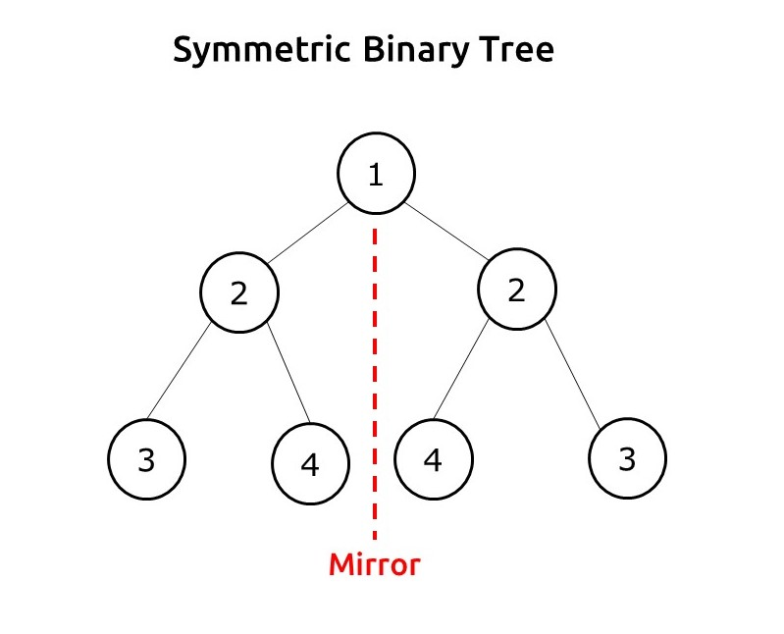

**Example 2:**

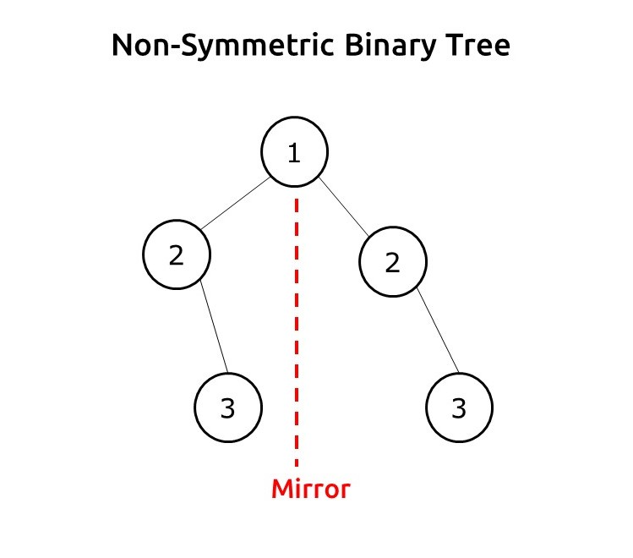

**Disclaimer**: Don’t jump directly to the solution, try it out yourself first.

**Pre-req**: Tree Traversal

### ****Solution :****

**Intuition:**We need to understand the property of the mirror. We can ignore the root node as it is lying on the mirror line. In the next level, for a symmetric tree, the node at the root’s left should be equal to the node at the root’s right.

If we take two variables root1 and root2 to represent the left child of root and right child of the root, then

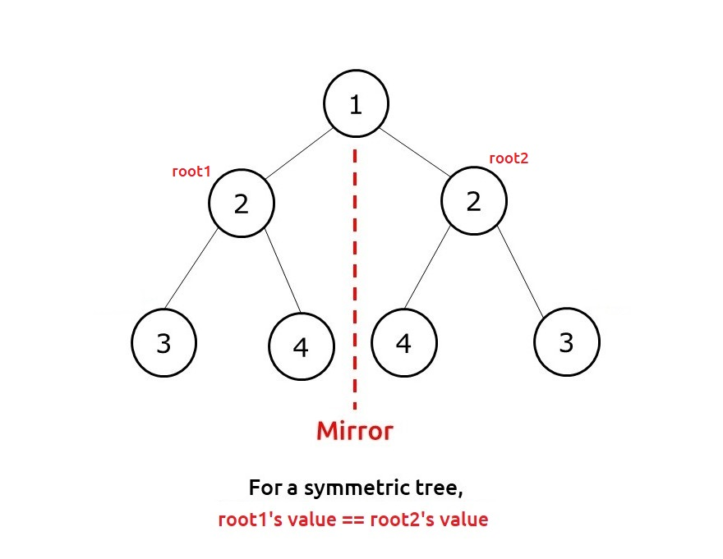

Further, we need to understand that when root1’s value is equal to root2’s value, we need to further check for its children. As we are concerned about node positions through a mirror, root1’s left child should be checked with root2’s right child and root1’s right child should be checked with root2’s left child.

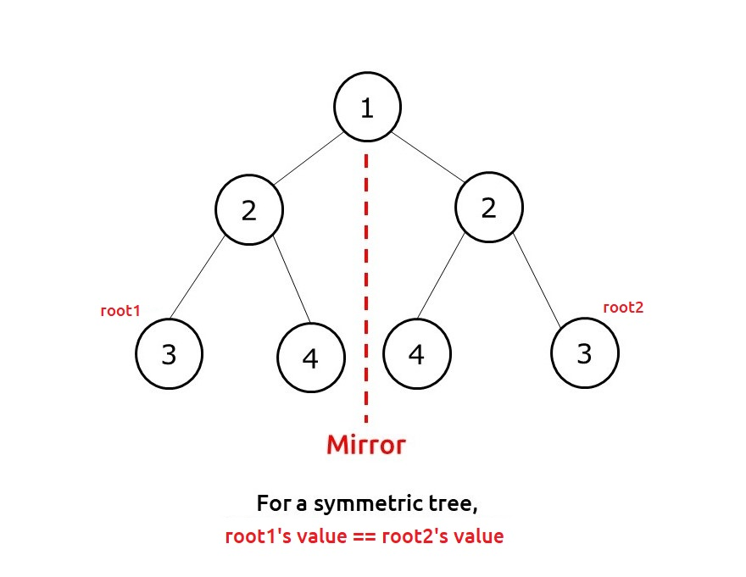

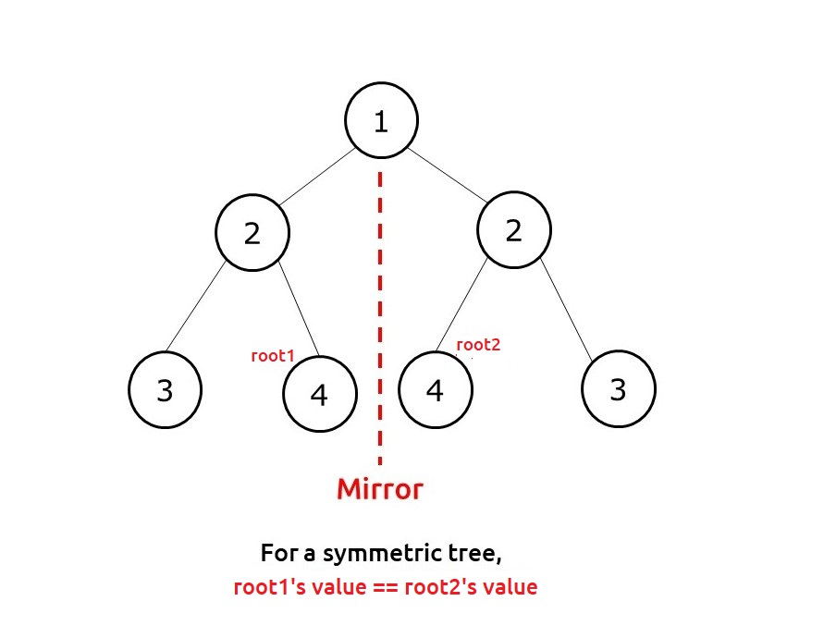

**Approach:**

The algorithm steps can be summarized as follows::

* We take two variables root1 and root2 initially both pointing to the root.
* Then we use any tree traversal to traverse the nodes. We will simultaneously change root1 and root2 in this traversal function.
* For the base case, if both are pointing to NULL, we return true, whereas if only one points to NULL and other to a node, we return false.
* If both points to a node, we first compare their value, if it is the same we check for the lower levels of the tree.
* We recursively call the function to check the root1’s left child with root2’s right child; then we again recursively check the root1’s right child with root2’s left child.
* When all three conditions ( node values of left and right and two recursive calls) return true, we return true from our function else we return false.

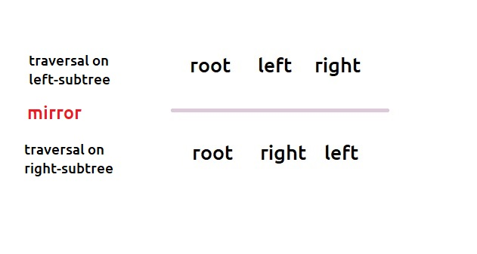

**Dry Run:**In case you want to watch the dry run for this approach, please watch the video attached below.

**Code:**

import java.util.*;

class Node {

int data;

Node left, right;

Node(int data)

{

this.data=data;

left=null;

right=null;

}

}

class TUF{

static boolean isSymmetricUtil(Node root1, Node root2) {

if (root1 == null || root2 == null)

return root1 == root2;

return (root1 . data == root2 . data) && isSymmetricUtil(root1 . left, root2 .

right) && isSymmetricUtil(root1 . right, root2 . left);

}

static boolean isSymmetric(Node root) {

if (root==null) return true;

return isSymmetricUtil(root . left, root . right);

}

public static void main(String args[]) {

Node root = new Node(1);

root . left = new Node(2);

root . left . left = new Node(3);

root . left . right = new Node(4);

root . right = new Node(2);

root . right . left = new Node(4);

root . right . right = new Node(3);

boolean res;

res = isSymmetric(root);

if (res)

System.out.println("The tree is symmetrical");

else System.out.println("The tree is NOT symmetrical");

}

}

**Output:**

The tree is symmetrical

**Time Complexity: O(N)**

Reason: We are doing simple tree traversal and changing both root1 and root2 simultaneously.

**Space Complexity: O(N)**

Reason: In the worst case (skewed tree), space complexity can be O(N).

# Print Root to Node Path in a Binary Tree

**Problem Statement:** **Print Root to Node Path In A Binary Tree**. Write a program to print path from root to a given node in a binary tree.

**Problem Description:**

We are given a binary tree T and a node V. We need to print a path from the root of the tree to the node.

**Note:**

* No two nodes in the tree have the same data value.
* It is assured that the node V is present and a path always exists.

**Examples**:

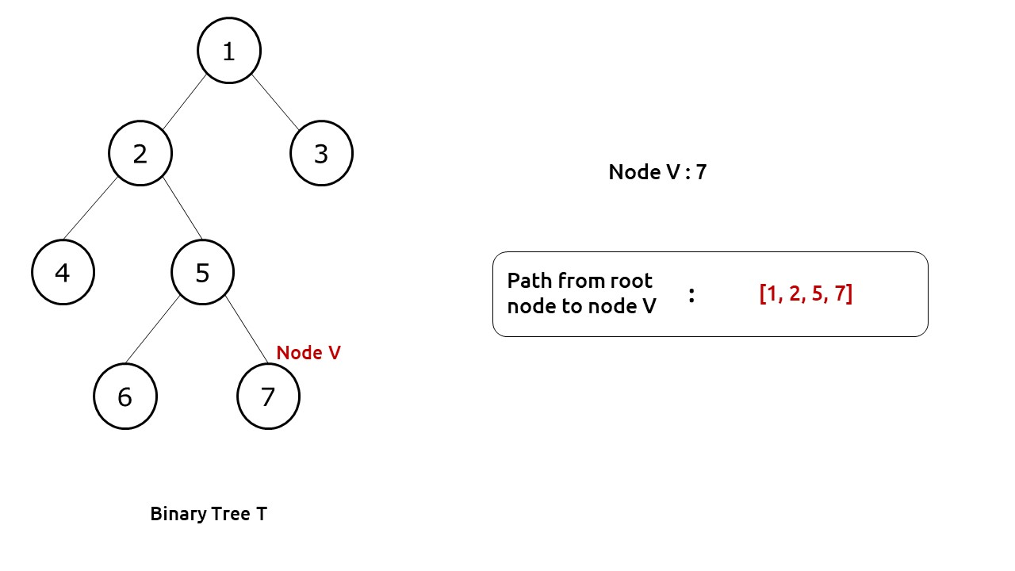

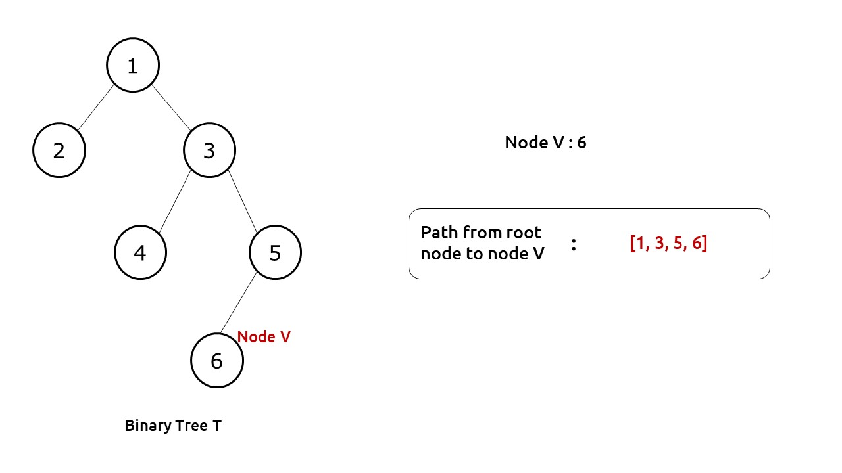

**Disclaimer**: Don’t jump directly to the solution, try it out yourself first.

**Pre-req**: Traversal Techniques & Recursion

**Solution :**

**Intuition:**

First of all, we need to find the node V in our tree for which we need to find the path. We can use any depth-first traversal technique (preorder, inorder, postorder) in order to find the required node.

If we look at the diagram below, we see that whenever we find the required node, its path is well present in our recursion call stack. We just need to figure out how we can use the recursive calls to print the required path.

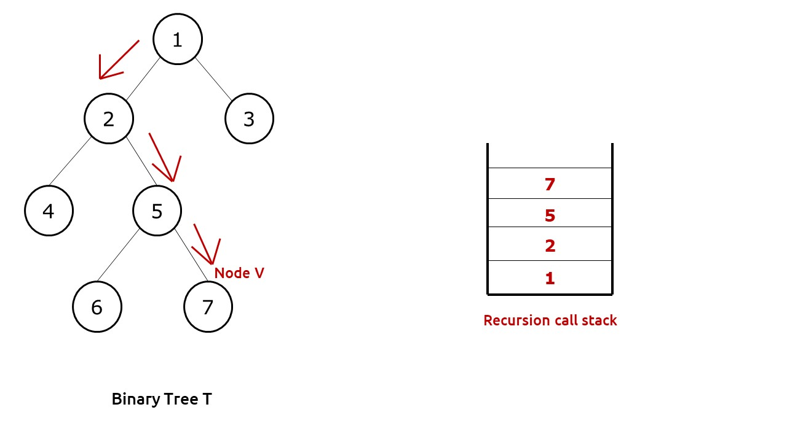

**Approach:**

We will use an external list to store our path. This list will be passed by reference to our recursive function. Moreover, we can set the return value of our function as boolean, this will help us to know whether node V was found in a subtree or not.

The algorithm steps can be stated as follows:

* We pass the function with our root node, the path list and node V.
* For the base case, if root is pointing to NULL, we return false as clearly node V can’t be found.
* Now we first push the node to our path list.
* Then we check whether the current node is the target node or not, if it is then no further execution is needed and we return to the parent function.
* If not, then we recursively call its left and right child to find the target node V. If any one of them returns true, it means we have found node V at lower levels and return true from the current function.
* If the value is not found at the current node and neither in any of the recursive calls, it means that the value is not present in the current sub-tree, therefore we pop out the current node from the path list and return false.

**Dry Run:**In case you want to watch the dry run for this approach, please watch the video attached below.

**Code:**

import java.util.*;

class Node {

int data;

Node left, right;

Node(int data) {

this.data = data;

left = null;

right = null;

}

}

public class TUF {

static boolean getPath(Node root, ArrayList < Integer > arr, int x) {

// if root is NULL

// there is no path

if (root == null)

return false;

// push the node's value in 'arr'

arr.add(root.data);

// if it is the required node

// return true

if (root.data == x)

return true;

// else check whether the required node lies

// in the left subtree or right subtree of

// the current node

if (getPath(root.left, arr, x) ||

getPath(root.right, arr, x))

return true;

// required node does not lie either in the

// left or right subtree of the current node

// Thus, remove current node's value from

// 'arr'and then return false

arr.remove(arr.size() - 1);

return false;

}

public static void main(String args[]) {

Node root = new Node(1);

root.left = new Node(2);

root.left.left = new Node(4);

root.left.right = new Node(5);

root.left.right.left = new Node(6);

root.left.right.right = new Node(7);

root.right = new Node(3);

ArrayList < Integer > arr = new ArrayList < > ();

boolean res;

res = getPath(root, arr, 7);

System.out.print("The path is ");

for (int it: arr) {

System.out.print(it + " ");

}

}

}

**Output:**

The path is 1 2 5 7

**Time Complexity: O(N)**

Reason: We are doing a simple tree traversal.

**Space Complexity: O(N)**

Reason: In the worst case (skewed tree), space complexity can be O(N).

# Lowest Common Ancestor for two given Nodes

**Problem Statement:** Given a binary tree, Find the Lowest Common Ancestor for two given Nodes (x,y).

**Lowest Common Ancestor(LCA):**The lowest common ancestor is defined between two nodes x and y as the lowest node in T that has both x and y as descendants (where we allow a node to be a descendant of itself.

**Examples:**

**Consider the following Binary Tree**

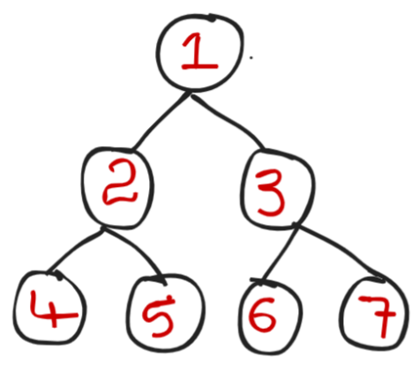

**Example 1:**

**Input:** x = 4 , y = 5

**Output:** 2

**Explanation:** All ancestors for 4,5 are 2,1. But we need Lowest Common ancestor, So we will consider lowest and also common ancestor that is 2

**Example 2:**

**Input:**

x = 2 , y = 3

**Output:** 1

**Explanation:** Lowest Common Ancestor for x,y i.e for 2,3 is 1

**Example 3:**

**Input:**

x= 6 , y = 7

**Output:** 3

**Explanation:** Lowest Common Ancestor for x,y i.e for 6,7 is 3

**Solution:**

**Disclaimer**: Don’t jump directly to the solution, try it out yourself first.

**Intuition**:

The very first thing we can observe from the question is that we can find the LCA of 2 given nodes from

        i) Left subtree or in

       ii)Right subtree, if not in both the subtrees then root will be the  LCA.

**Approach**:

1. If root is null or if root is x or if root is y then return root
2. Made a recursion call for both

i) Left subtree

ii)Right subtree

Because we would find LCA in the left or right subtree only.

1. If the left subtree recursive call gives a null value that means we haven’t found LCA in the left subtree, which means we found LCA on the right subtree. So we will return right.
2. If the right subtree recursive call gives null value, that means we haven’t found LCA on the right subtree, which means we found LCA on the left subtree. So we will return left .
3. If both left & right calls give values (not null)  that means the root is the LCA.

Let’s take an example and will try to understand the approach more clearly:

LCA of (x,y) = > (4,5) = ? (from above given example)

* Root is 1 which is not null and x,y is not equal to root, So the 1st statement in approach  will not execute.
* i) Call left subtree, While calling recursively it will find 4 and this call will return 4 to its parent

Point to Note: At present, the root is 2 ( Look at below recursion tree for better understanding)

i) Call the right subtree ( i.e right of 2), While calling recursively it will find 5  and this call will return 5 to its parent.

* Now the left recursive  call returns value (not null) i.e 4 and also the right recursive call returns value (not null) i.e 5 to its root ( at present root is 2) , and this 2 will return itself to its root i.e to 1 (main root).

Point to Note: At present, the root is 1 ( Look at below recursion tree for better understanding)

* Now, the left subtree gives a value i.e 2.
* Right recursive call will give null value .because x,y are not present in the right subtree.
* As we know if the right recursive call gives null then we return the answer which we got from the left call, So we will return 2.
* Hence LCA of (4,5) is 2.

**For a better understanding of the** **above example (LCA OF 4,5) :**

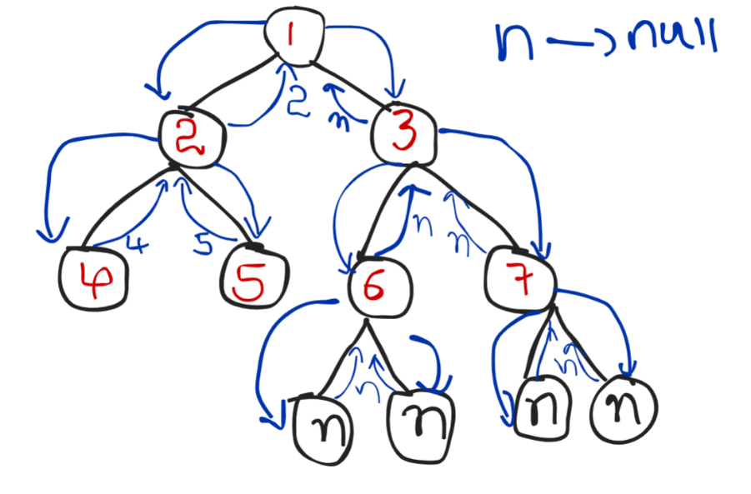

**Code:**

class Solution {

public TreeNode lowestCommonAncestor(TreeNode root, TreeNode p, TreeNode q) {

//base case

if (root == null || root == p || root == q) {

return root;

}

TreeNode left = lowestCommonAncestor(root.left, p, q);

TreeNode right = lowestCommonAncestor(root.right, p, q);

//result

if(left == null) {

return right;

}

else if(right == null) {

return left;

}

else { //both left and right are not null, we found our result

return root;

}

}

}

**Time complexity**: O(N) where n is the number of nodes.

**Space complexity**: O(N), auxiliary space.

# Maximum Width of a Binary Tree

**Problem Statement:**Write a program to find the **Maximum Width of A Binary Tree**.

**Examples:**

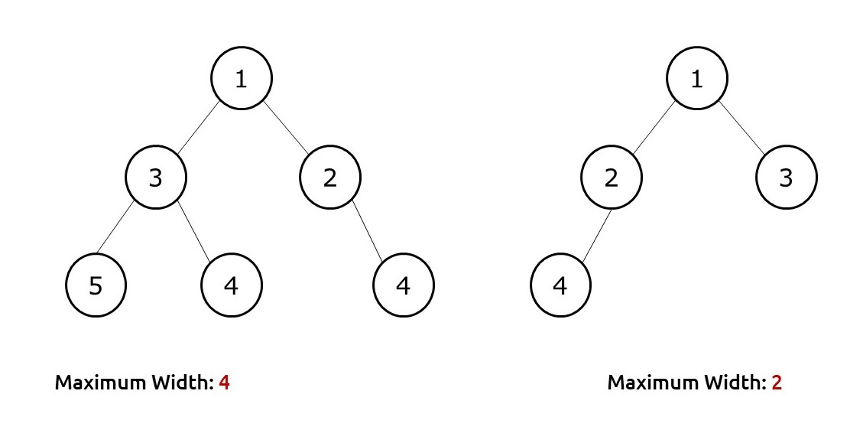

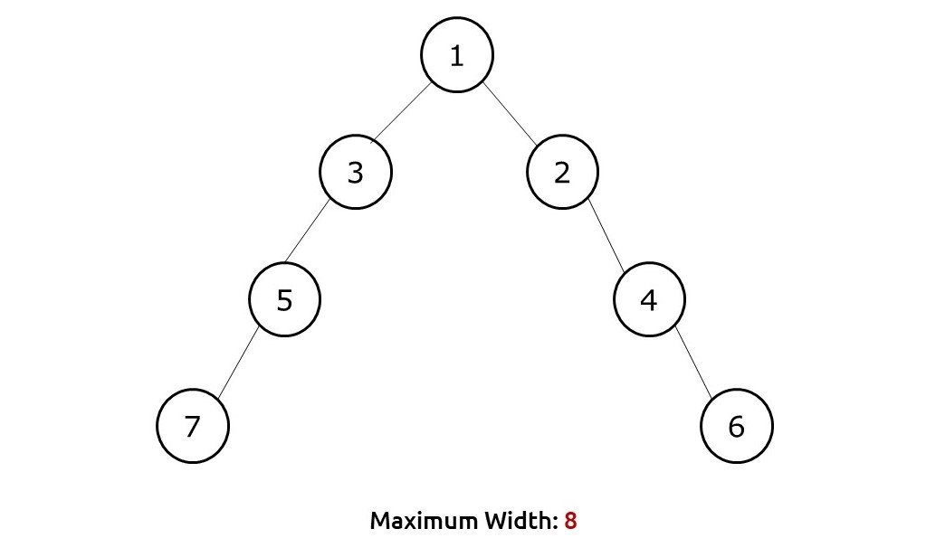

**Problem Description:**

The maximum width of a binary tree is the maximum of all the level widths. Width for a level is defined as the maximum number of nodes between the leftmost and rightmost node of the level(including the end nodes and the null nodes between the end nodes).

**Pre-req: Level Order Traversal**

**Disclaimer**: Don’t jump directly to the solution, try it out yourself first.

### ****Solution :****

**Intuition:**

First of all, we need to understand the meaning of width at a level clearly. In the following image, we can see how the null nodes play an important role in the width calculation

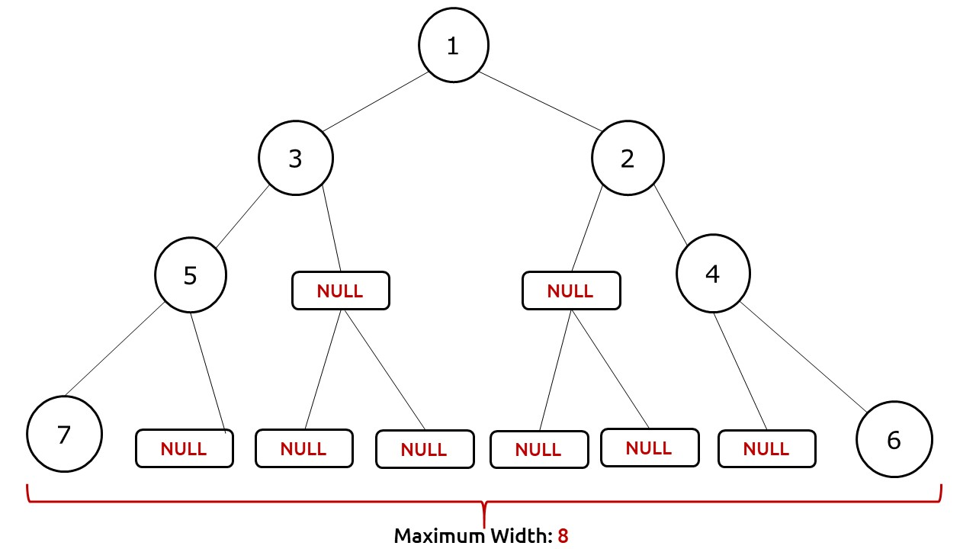

Now we see that the width is defined by the nodes of one particular level. Therefore we can use a level order traversal to traverse the tree and in every level, we try to find the leftmost and rightmost node of that level. To achieve this we would need a proper indexing strategy to uniquely index nodes of a level. Once we know the leftMost and rightMost nodes, width can be defined as (rightMost- leftMost +1).

**Approach:**

We will perform a special level order traversal with two loops where inner loops traverse the nodes of a single level. This is to ensure that we can do our calculations once a single level is traversed. In the traversal, we will assign an index to a node. The indexing strategy is described as below:

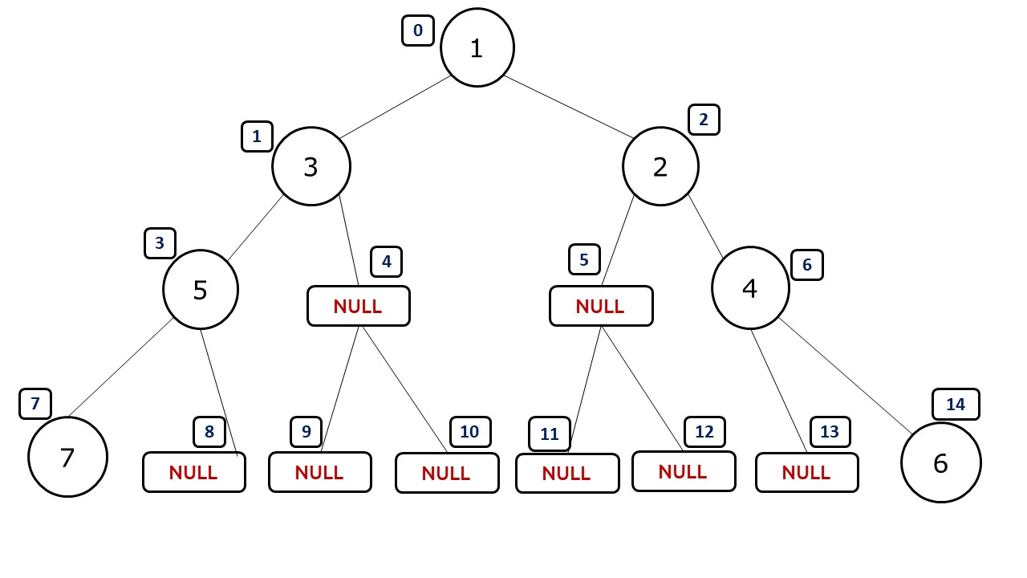

If we index the tree as shown above we can easily calculate the width of the tree as rightMostNode – leftMostNode +1. Then we can return the maximum width as our answer. To store the index, we can use a pair of values in our queue( that we use for level order traversal). If we are at index i, then its left and right child are(in 0-based indexing): 2*i+1 and 2*i+2 respectively. Please note that NULL nodes are not hampering the indexing in any way.

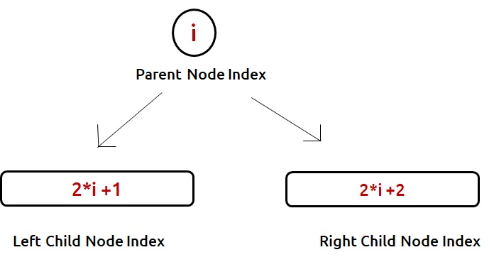

**Prevention of Integer Overflow**

This approach has a problem, as we are multiplying 2 to the current index, it can happen in a tree that we overshoot the bound of an integer. Therefore, we need to find a strategy to prevent it.

Before starting a level, we can store the left-most index in a variable( say curMin). Now whenever we assign the index for its children, we take the parent node index as (i-curMin) rather than i. The below illustration will clear the concept.

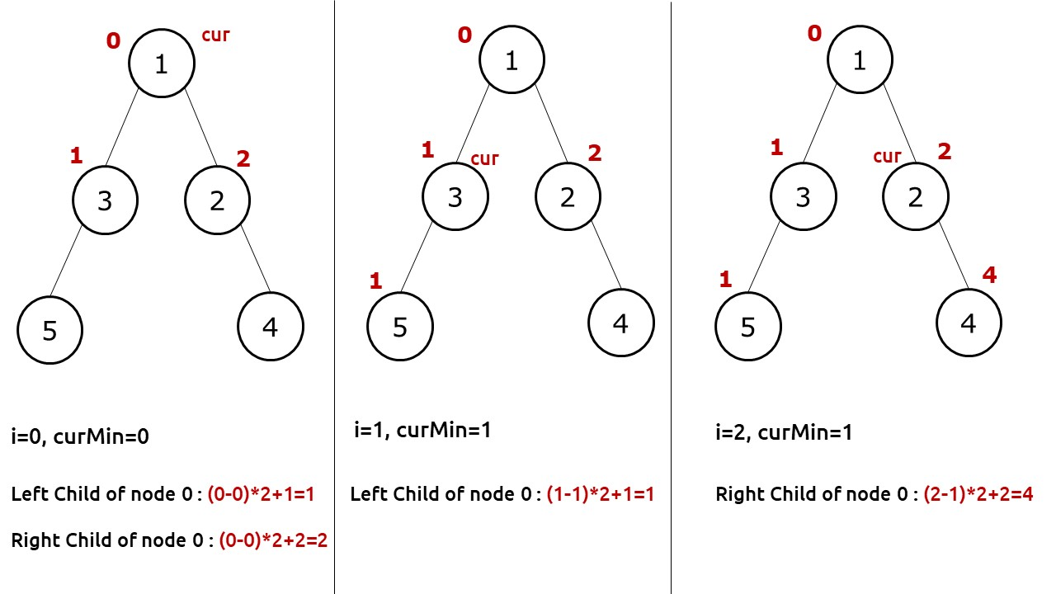

As our final answer is a range of nodes in a level, i,e rightMost- leftMost+1; this strategy will not affect the answer and at the same time prevent the integer overflow case.

The algorithm approach can be stated as:

* We take a queue and push the root node along with index 0.
* We traverse the tree using a level order traversal.
* In the level order traversal we set another loop to run for the size of the queue, so that we visit the same level nodes inside it.
* Before a level starts, we use a variable(say curMin) to store the index of the first node.
* We assign an index to every node, and to its children as described above.
* When the inner loop is at the first node of a level, we store its index in another variable(sayleftMost)
* When the inner loop is at the last node of a level, we store its index in another variable(say rightMost)
* After a level  in the outer loop, we calculate the width of the level as (rightMost – leftMost +1).
* We return the maximum width as the answer.

**Dry Run:**In case you want to watch the dry run for this approach, please watch the video attached below.

**Code:**

import java.util.*;

class TreeNode {

int data;

TreeNode left, right;

TreeNode(int data)

{

this.data=data;

left=null;

right=null;

}

}

class Pair {

TreeNode node;

int num;

Pair(TreeNode _node, int _num) {

num = _num;

node = _node;

}

}

class Solution {

public static int widthOfBinaryTree(TreeNode root) {

if(root == null) return 0;

int ans = 0;

Queue<Pair> q = new LinkedList<>();

q.offer(new Pair(root, 0));

while(!q.isEmpty()){

int size = q.size();

int mmin = q.peek().num; //to make the id starting from zero

int first = 0,last = 0;

for(int i=0; i<size; i++){

int cur_id = q.peek().num-mmin;

TreeNode node = q.peek().node;

q.poll();

if(i==0) first = cur_id;

if(i==size-1) last = cur_id;

if(node.left != null)

q.offer(new Pair(node.left, cur_id*2+1));

if(node.right != null)

q.offer(new Pair(node.right, cur_id*2+2));

}

ans = Math.max(ans, last-first+1);

}

return ans;

}

public static void main(String args[]) {

TreeNode root = new TreeNode(1);

root . left = new TreeNode(3);

root . left . left = new TreeNode(5);

root . left . left . left = new TreeNode(7);

root . right = new TreeNode(2);

root . right . right = new TreeNode(4);

root . right . right . right = new TreeNode(6);

int maxWidth = widthOfBinaryTree(root);

System.out.println("The maximum width of the Binary Tree is "+maxWidth);

}

}

**Output:**

The maximum width of the Binary Tree is 8

**Time Complexity: O(N)**

Reason: We are doing a simple level order traversal. The inner loop simply traverses the nodes level-wise and doesn’t add to the complexity.

**Space Complexity: O(N)**

# Check for Children Sum Property in a Binary Tree

**Problem Statement: Children Sum Property in a Binary Tree.** Write a program that converts any binary tree to one that follows the children sum property.

The children sum property is defined as, For every node of the tree, the value of a node is equal to the sum of values of its children(left child and right child).

**Note:**

* The node values can be increased by 1 any number of times but decrement of any node value is not allowed.
* A value for a NULL node can be assumed as 0.
* You are not allowed to change the structure of the given binary tree.

**Example:**

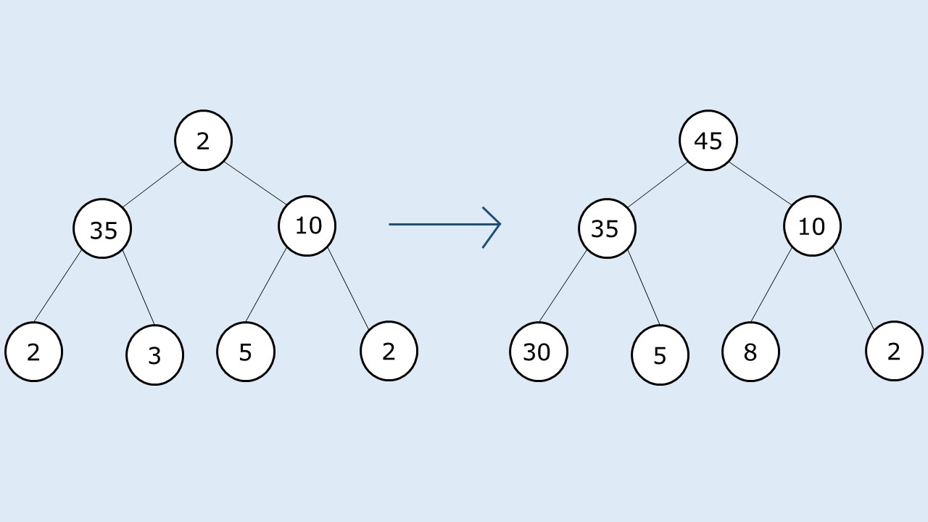

**Pre-req: Tree Traversals**

**Disclaimer**: Don’t jump directly to the solution, try it out yourself first.

### ****Solution :****

**Intuition:**

The first intuition that comes to our mind is to do a tree traversal and at every node make the node value equal to the sum of value(s) of its children. This approach will work in a tree-like this(given below), if we do a postorder traversal and update the node values after visiting the children.

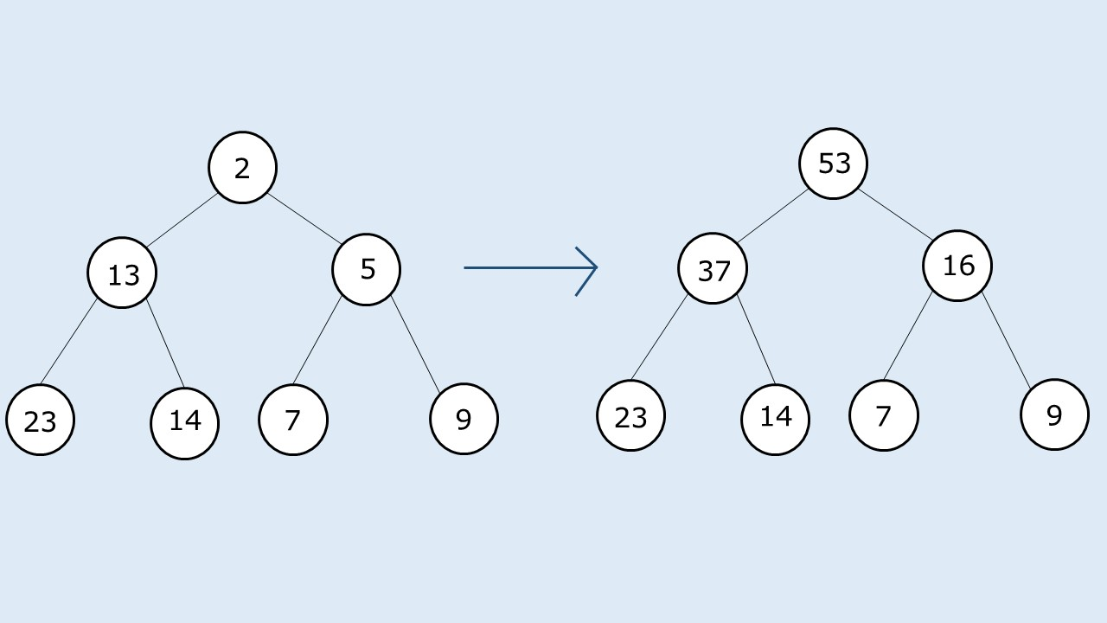

As in the given tree, every node value is less than the sum of the node values of its children; this approach works. Now we will see where this approach will fail and why. If we consider the following case:

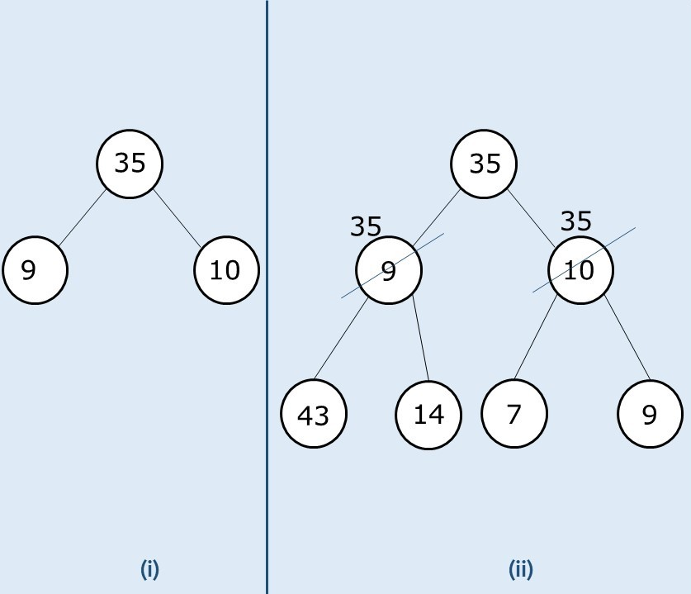

* In case (i), we see that the root node’s value is greater than the sum of both the leaf nodes. In such a case it is not possible to assign a node as the sum of its children( as we are not allowed to decrement a value). In such a case we simply assign the node value of the children to its parent.
* In case (ii) as we have a tree further down, we first implement the strategy discussed in case(i), now we see that at the second level we are having both the cases where, 35 is less than (43+14) and 35 is greater than (7+9). For the latter case we again implement the strategy and make both its children 35. For the former case, we simply traverse the tree and set it to the sum of its children.

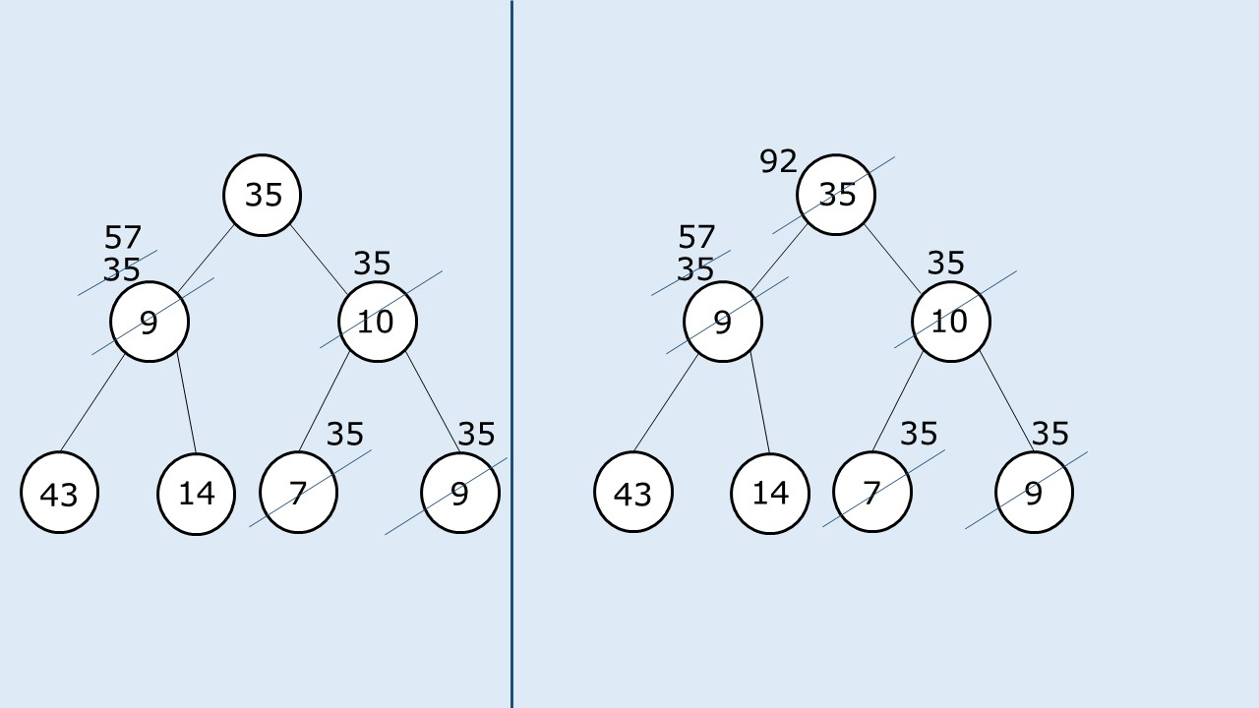

**Approach:**

We perform a tree traversal and check whether the current node value is greater than the sum of node values of its children. If this is the case, we simply assign its children to the same value of the current node and then recurse for the children. We do so because we are not allowed to decrement a node value. So we set the children to a large value in order to increment the parent.

It can happen in subsequent recursions that this child value is further changed, therefore it is necessary that when we return to a node after returning from its children, we set it to the sum of node values of its children explicitly.

The algorithm approach can be stated as follows:

* We perform a simple dfs traversal on the tree.
* For the base case, if the node is pointing to NULL, we simply return.
* At every node, first we find the sum of values of the children( For a NULL child, value is assumed to be 0).
* If node’s value > sum of children node value, we assign both the children’s value to their parent’s node value.
* Then we visit the children using recursion.
* After we return to the node after visiting its children, we explicitly set its value to be equal to the sum of its values of its children.

**Dry Run:**In case you want to watch the dry run for this approach, please watch the video attached below.

**Code:**

import java.util.*;

class Node {

int data;

Node left, right;

Node(int data)

{

this.data=data;

left=null;

right=null;

}

}

class TUF{

static void reorder(Node root) {

if (root == null) return;

int child = 0;

if (root . left!=null) {

child += root . left . data;

}

if (root . right!=null) {

child += root . right . data;

}

if (child < root . data) {

if (root . left!=null) root . left . data = root . data;

else if (root . right!=null) root . right . data = root . data;

}

reorder(root . left);

reorder(root . right);

int tot = 0;

if (root . left!=null) tot += root . left . data;

if (root . right!=null) tot += root . right . data;

if (root . left!=null || root . right!=null) root . data = tot;

}

static void changeTree(Node root) {

reorder(root);

}

public static void main(String args[]) {

Node root = new Node(2);

root . left = new Node(35);

root . left . left = new Node(2);

root . left . right = new Node(3);

root . right = new Node(10);

root . right . left = new Node(5);

root . right . right = new Node(2);

changeTree(root);

}

}

**Time Complexity: O(N)**

Reason: We are doing a simple tree traversal.

**Space Complexity: O(N)**

Reason: In the worst case( skewed tree), space complexity can be O(N).

# Print all the Nodes K Distance in Binary Tree

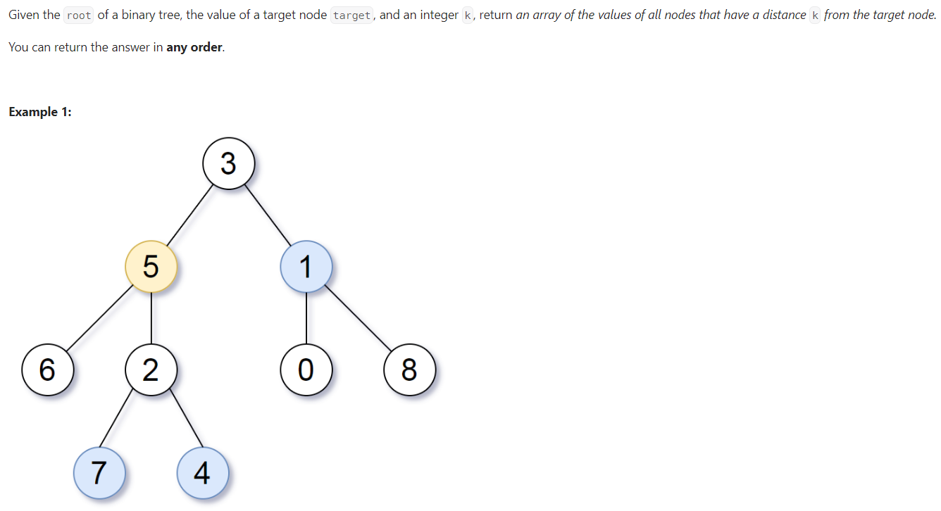

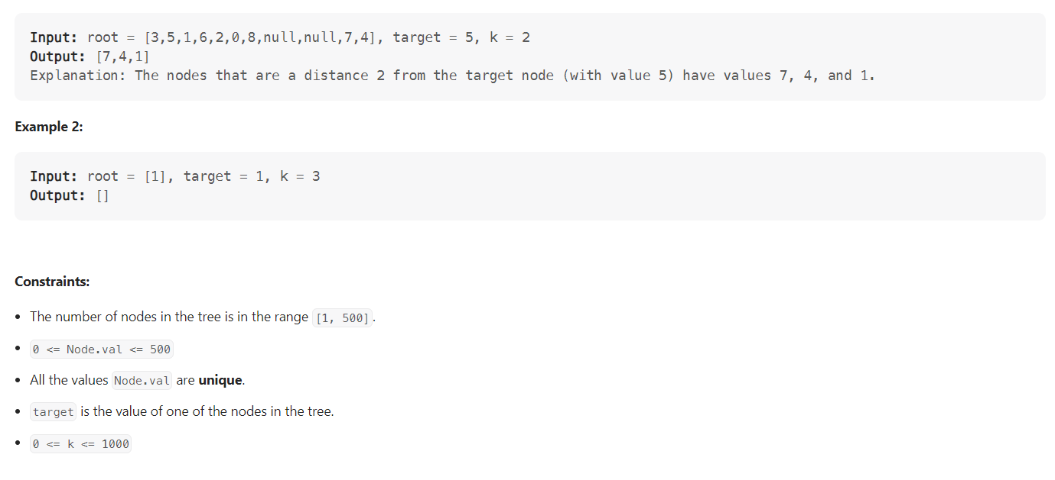

**Code**

public class PrintAllNodesAtKDistance {  
 private void markParents(TreeNode root, Map<TreeNode, TreeNode> parent_track, TreeNode target) {  
 Queue<TreeNode> queue = new LinkedList<TreeNode>();  
 queue.offer(root);  
 while(!queue.isEmpty()) {  
 TreeNode current = queue.poll();  
 if(current.left != null) {  
 parent_track.put(current.left, current);  
 queue.offer(current.left);  
 }  
 if(current.right != null) {  
 parent_track.put(current.right, current);  
 queue.offer(current.right);  
 }  
 }  
 }  
 public List<Integer> distanceK(TreeNode root, TreeNode target, int k) {  
 Map<TreeNode, TreeNode> parent_track = new HashMap<>();  
 markParents(root, parent_track, root);  
 Map<TreeNode, Boolean> visited = new HashMap<>();  
 Queue<TreeNode> queue = new LinkedList<TreeNode>();  
 queue.offer(target);  
 visited.put(target, true);  
 int curr_level = 0;  
 while(!queue.isEmpty()) { /*Second BFS to go upto K level from target node and using our hashtable info*/  
 int size = queue.size();  
 if(curr_level == k) break;  
 curr_level++;  
 for(int i=0; i<size; i++) {  
 TreeNode current = queue.poll();  
 if(current.left != null && visited.get(current.left) == null) {  
 queue.offer(current.left);  
 visited.put(current.left, true);  
 }  
 if(current.right != null && visited.get(current.right) == null ) {  
 queue.offer(current.right);  
 visited.put(current.right, true);  
 }  
 if(parent_track.get(current) != null && visited.get(parent_track.get(current)) == null) {  
 queue.offer(parent_track.get(current));  
 visited.put(parent_track.get(current), true);  
 }  
 }  
 }  
 List<Integer> result = new ArrayList<>();  
 while(!queue.isEmpty()) {  
 TreeNode current = queue.poll();  
 result.add(current.val);  
 }  
 return result;  
 }  
}

# Time to burn a Binary Tree

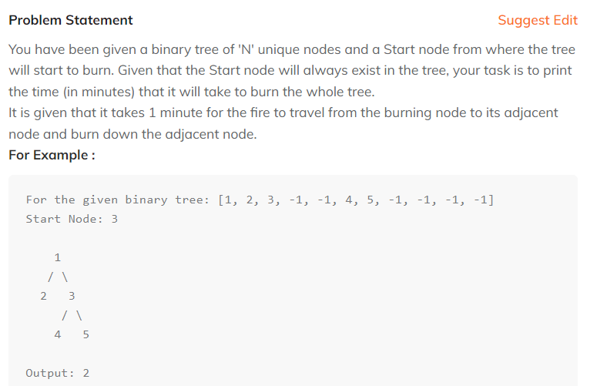

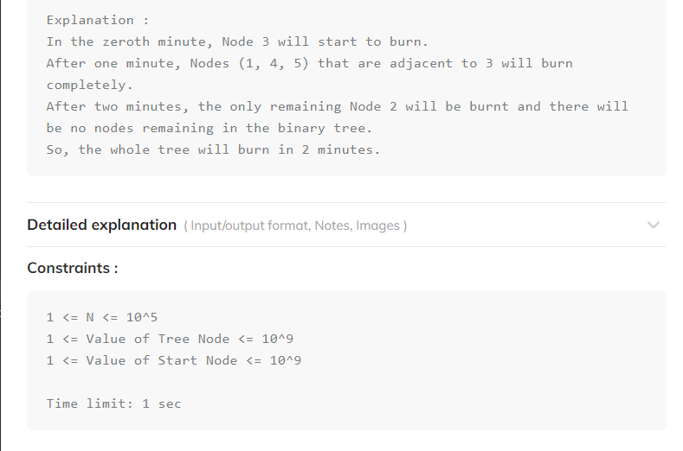

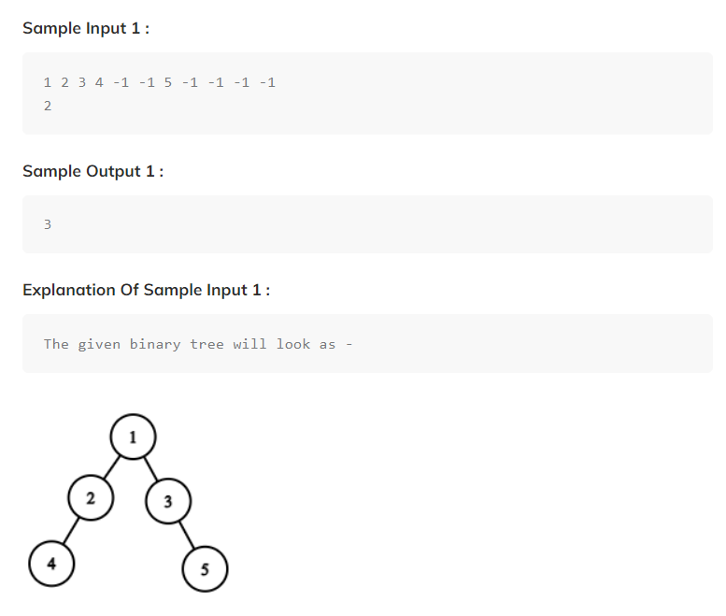

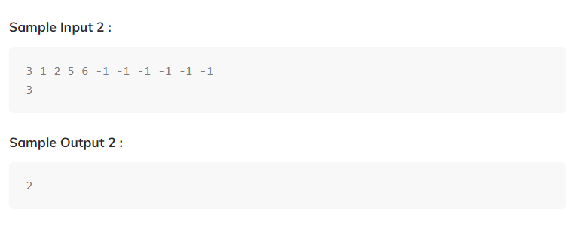

Code:

public class TimeToBurnATree {  
 private static BinaryTreeNode<Integer> bfsToMapParents(BinaryTreeNode<Integer> root,  
 HashMap<BinaryTreeNode<Integer>, BinaryTreeNode<Integer>> mpp, int start) {  
 Queue<BinaryTreeNode<Integer>> q = new LinkedList<>();  
 q.offer(root);  
 BinaryTreeNode<Integer> res = null;  
 while(!q.isEmpty()) {  
 BinaryTreeNode<Integer> node = q.poll();  
 if(node.data == start) res = node;  
 if(node.left != null) {  
 mpp.put(node.left, node);  
 q.offer(node.left);  
 }  
 if(node.right != null) {  
 mpp.put(node.right, node);  
 q.offer(node.right);  
 }  
 }  
 return res;  
 }  
 private static int findMaxDistance(HashMap<BinaryTreeNode<Integer>, BinaryTreeNode<Integer>> mpp, BinaryTreeNode<Integer> target) {  
 Queue<BinaryTreeNode<Integer>> q = new LinkedList<>();  
 q.offer(target);  
 HashMap<BinaryTreeNode<Integer>,Integer> vis = new HashMap<>();  
 vis.put(target, 1);  
 int maxi = 0;  
  
 while(!q.isEmpty()) {  
 int sz = q.size();  
 int fl = 0;  
  
 for(int i = 0;i<sz;i++) {  
 BinaryTreeNode<Integer> node = q.poll();  
 if(node.left != null && vis.get(node.left) == null) {  
 fl = 1;  
 vis.put(node.left, 1);  
 q.offer(node.left);  
 }  
 if(node.right != null && vis.get(node.right) == null) {  
 fl = 1;  
 vis.put(node.right, 1);  
 q.offer(node.right);  
 }  
  
 if(mpp.get(node) != null && vis.get(mpp.get(node)) == null) {  
 fl = 1;  
 vis.put(mpp.get(node), 1);  
 q.offer(mpp.get(node));  
 }  
 }  
 if(fl == 1) maxi++;  
 }  
 return maxi;  
 }  
 public static int timeToBurnTree(BinaryTreeNode<Integer> root, int start)  
 {  
 HashMap<BinaryTreeNode<Integer>, BinaryTreeNode<Integer>> mpp = new HashMap<>();  
 BinaryTreeNode<Integer> target = *bfsToMapParents*(root, mpp, start);  
 int maxi = *findMaxDistance*(mpp, target);  
 return maxi;  
 }  
  
 public static void main(String[] args) {  
 BinaryTreeNode<Integer> root = new BinaryTreeNode<>(1);  
 root.left = new BinaryTreeNode<>(2);  
 root.right = new BinaryTreeNode<>(3);  
 root.left.left = new BinaryTreeNode<>(4);  
 root.left.left.right = new BinaryTreeNode<>(7);  
 root.right.left = new BinaryTreeNode<>(5);  
 root.right.right = new BinaryTreeNode<>(6);  
 System.*out*.println(*timeToBurnTree*(root, 2));  
 }  
}

public class BinaryTreeNode<T> {  
 T data;  
 BinaryTreeNode<T> left;  
 BinaryTreeNode<T> right;  
  
 public BinaryTreeNode(T data) {  
 this.data = data;  
 }  
}

# Count Number of Nodes in a Binary Tree

In this article, we will solve the most asked coding interview problem: Count Number of Nodes in a Binary Tree

Write a program that calculates the number of nodes in a complete binary tree.

**Example:**

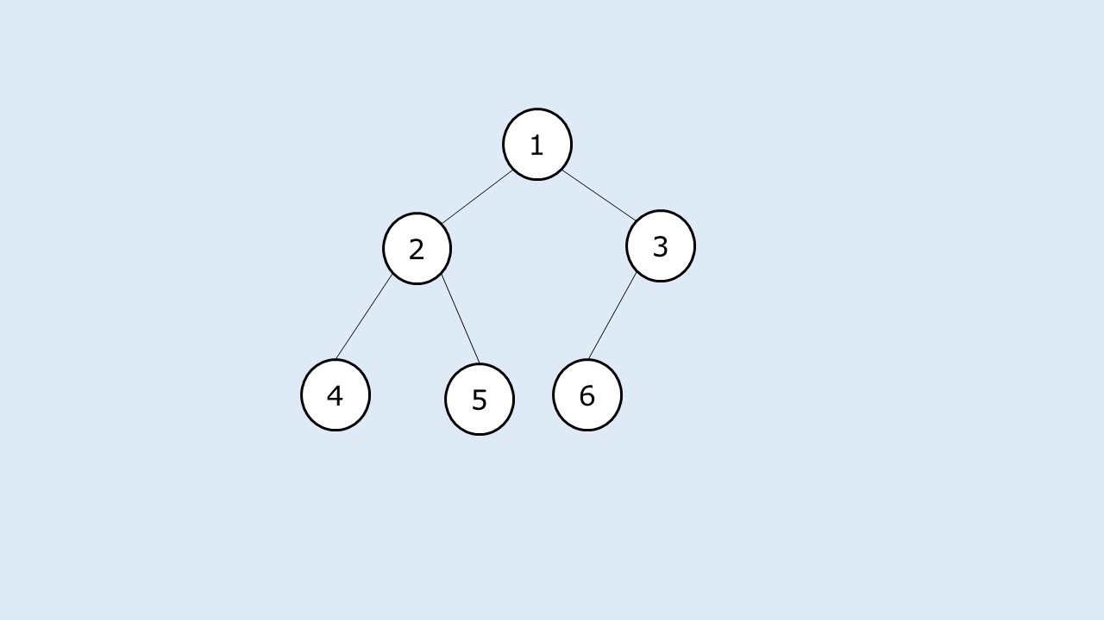

**Output:**

The total number of nodes in the given complete binary tree are: 6

**What is a complete binary tree?**

A complete binary tree is a binary tree whose:

* All levels except the last one are completely filled. The last level may or may not be completely filled.
* Nodes in the last level are as left as possible.

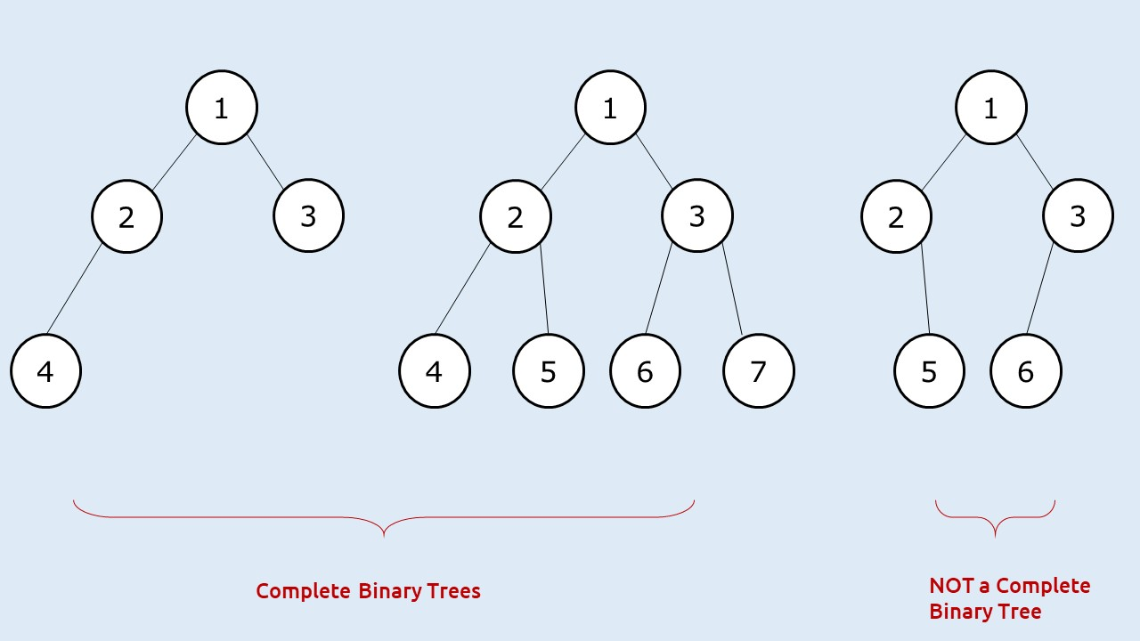

**Disclaimer**: Don’t jump directly to the solution, try it out yourself first.

### ****Solution :****

**Solution 1: Using any tree traversal – O(N) Approach**

**Approach:**

The first approach that comes to our mind is to use any tree traversal ( say inorder), and count the number of nodes as we are traversing the tree.

**Code:**

import java.util.*;

class Node {

int data;

Node left, right;

Node(int data)

{

this.data=data;

left=null;

right=null;

}

}

class TUF{

static void inOrderTrav(Node curr, int count[]) {

if (curr == null)

return;

count[0]++;

inOrderTrav(curr . left, count);

inOrderTrav(curr . right, count);

}

public static void main(String args[]) {

Node root = new Node(1);

root . left = new Node(2);

root . right = new Node(3);

root . left . left = new Node(4);

root . left . right = new Node(5);

root . right . left = new Node(6);

int count[]=new int[1];

inOrderTrav(root, count);

System.out.println("The total number of nodes in the given complete binary tree

are: "+count[0]);

}

}

**Output:**

The total number of nodes in the given complete binary tree are: 6

**Time Complexity: O(N)**.

Reason: We are traversing for every node of the tree

**Space Complexity: O(logN)**

Reason: Space is needed for the recursion stack. As it is a complete tree, the height of that stack will always be logN.

**Approach 2: Efficient Approach – O(log^2 N) solution**

We will now try to form an algorithm that takes less than O(N) time.

We are given a complete binary tree that has two special properties:

* All levels except the last one are completely filled
* Last level nodes are as left as possible.

If we get to know the height of the binary tree (say h), we can find out the maximum number of nodes that can be present by the formula: **2h – 1.** So there is some relation between height and number of nodes.

How to find the height in less than O(N) time? As the given tree is a complete binary tree, we can find the height of the binary tree by just finding the left height of the tree, as the left height will always be equal to the height of the tree.

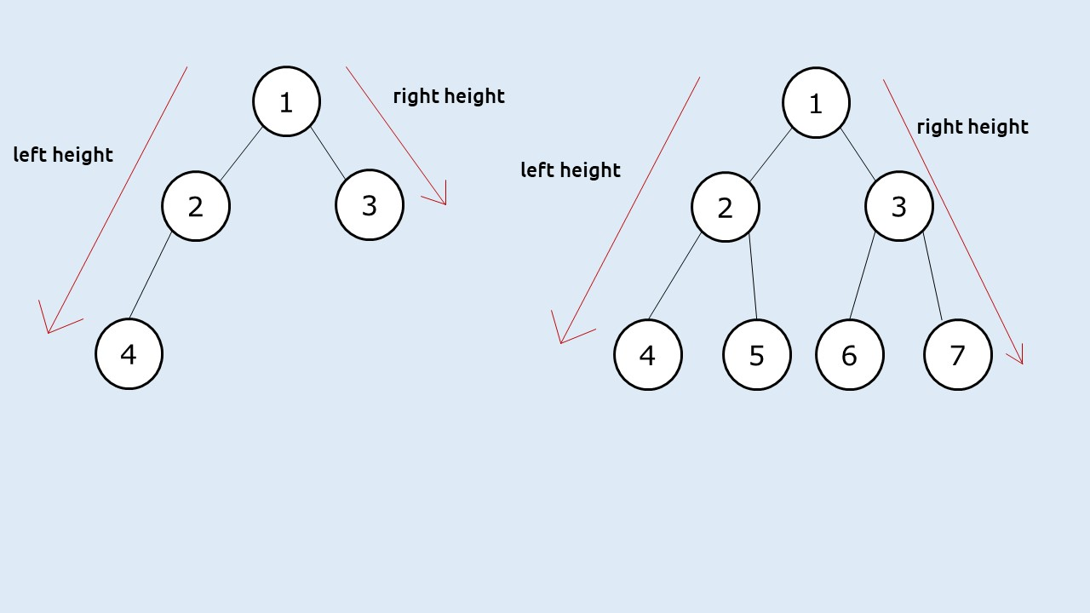

If the last level of the binary tree is completely filled( a perfect binary tree), then this left height will give us the total count of nodes present by the formula: **2h – 1.** Now how to check whether the last level is completely filled? A simple way is to find the right height of the given tree, then:

* If leftHeight == rightHeight, then the last level nodes are completely filled
* If leftHeight != rightHeight, then the last level nodes are not completely filled

In the second case, when leftHeight != rightHeight, we can take the help of recursion and say to recursively find the number of nodes in the left subtree (say leftNodes) and in the right subtree(say rightNodes) and then return 1 + leftNodes + rightNodes.

**Approach:**

The algorithm steps can be stated as :

* Set a recursive function to calculate the number of nodes.
* In the recursive function, calculate leftHeight and the right Height of the tree from the given node.
* If leftHeight == rightHeight, return **2leftHeight – 1**.
* If leftHeight != rightHeight, recursively call the function to calculate nodes in left subtree(leftNodes) and the right subtree(rightNodes) and return 1+leftNodes+rightNodes.

**Dry Run:**

Let us take a bigger example:

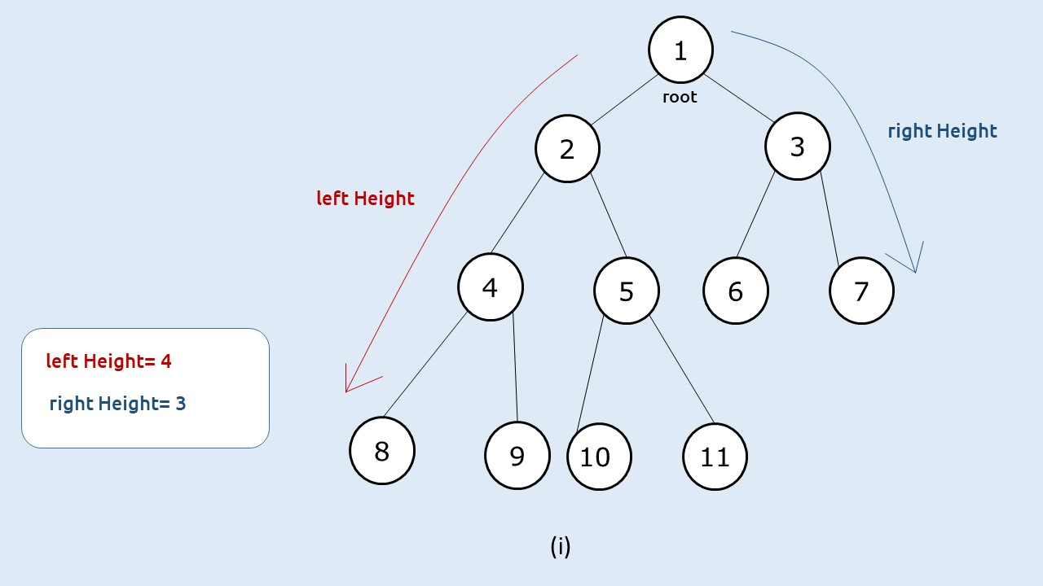

**(i)**First when we are at the root node, we will find the left height and the right height. In this case, as leftHeight != rightHeight, we will recursively call the function to find leftNodes and rightNodes.

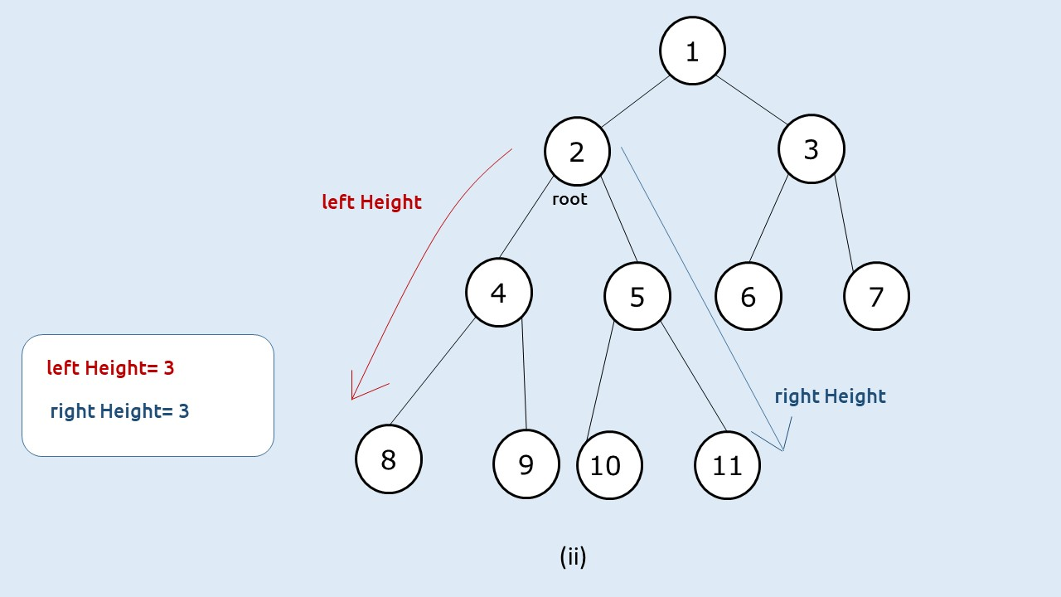

**(ii)** Then, we find the answer for the first recursive call of step 1. When root = 2, we see that the left height == right Height(both equal to 3), so we simply return 2^(3) – 1 (which is 7).

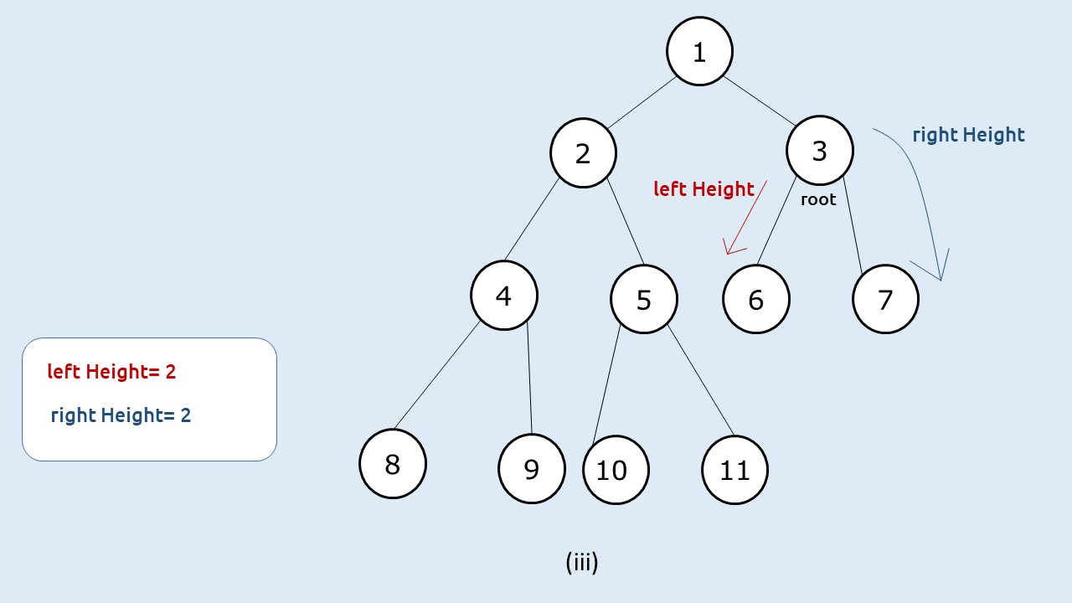

**(iii)** Then, we find the answer for the second recursive call of step 1. When root = 3, we see that the left height == right Height(both equal to 2), so we simply return 2^(2) – 1 (which is 3).

**(iv)**At last, we will return to the root node of the tree (node 1) and we will return 1+ leftNodes + rightNodes, i.e 1+7+3 = 11.

**Code:**

import java.util.*;

class Node {

int data;

Node left, right;

Node(int data)

{

this.data=data;

left=null;

right=null;

}

}

class TUF{

static int findHeightLeft(Node cur) {

int hght = 0;

while(cur!=null) {

hght++;

cur = cur.left;

}

return hght;

}

static int findHeightRight(Node cur) {

int hght = 0;

while(cur!=null) {

hght++;

cur = cur.right;

}

return hght;

}

static int countNodes(Node root) {

if(root == null) return 0;

int lh = findHeightLeft(root);

int rh = findHeightRight(root);

if(lh == rh) return (1<<lh) - 1;

int leftNodes = countNodes(root.left);

int rightNodes = countNodes(root.right);

return 1 + leftNodes + rightNodes;

}

public static void main(String args[]) {

Node root = new Node(1);

root . left = new Node(2);

root . right = new Node(3);

root . left . left = new Node(4);

root . left . right = new Node(5);

root . right . left = new Node(6);

root . right . right = new Node(7);

root . left . left . left = new Node(8);

root . left . left . right = new Node(9);

root . left . right . left = new Node(10);

root . left . right . right = new Node(11);

System.out.println("The total number of nodes in the given complete binary tree

are: "+countNodes(root));

}

}

**Output:**

The total number of nodes in the given complete binary tree are: 11

**Time Complexity: O(log^2 N)**.

Reason: To find the leftHeight and right Height we need only logN time and in the worst case we will encounter the second case(leftHeight!=rightHeight) for at max logN times, so total time complexity will be O(log N * logN)

**Space Complexity: O(logN)**

Reason: Space is needed for the recursion stack when calculating height. As it is a complete tree, the height will always be logN.

# Requirements needed to construct a Unique Binary Tree

By Using Pre-order and post-order data we can’t generate a unique binary tree

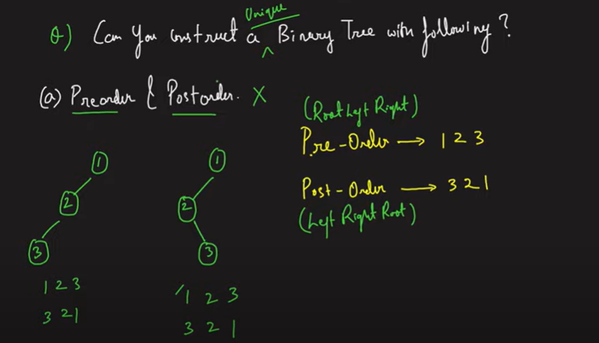

But if we have In Order Data and any of post/pre order data we can construct a unique binary tree.

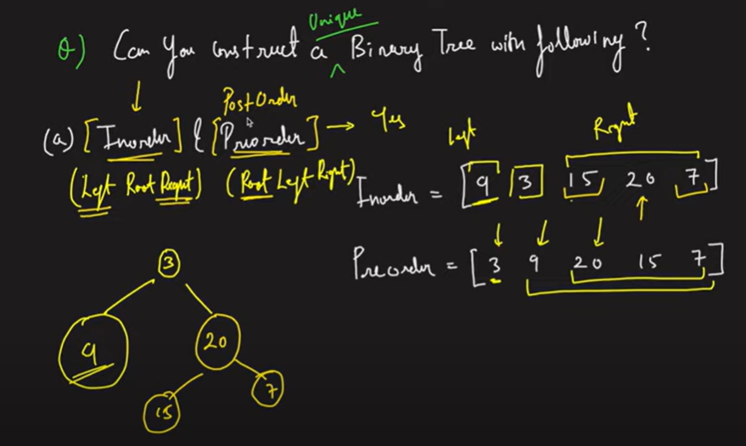

# Construct A Binary Tree from Inorder and Preorder Traversal

In this article we will solve the most asked coding interview problem: Construct A Binary Tree from Inorder and Preorder Traversal.

**Construct A Binary Tree from Inorder and Preorder Traversal**

Given the Inorder and Preorder Traversal of a binary tree, we need to construct the unique binary tree represented by them.

**Example:**

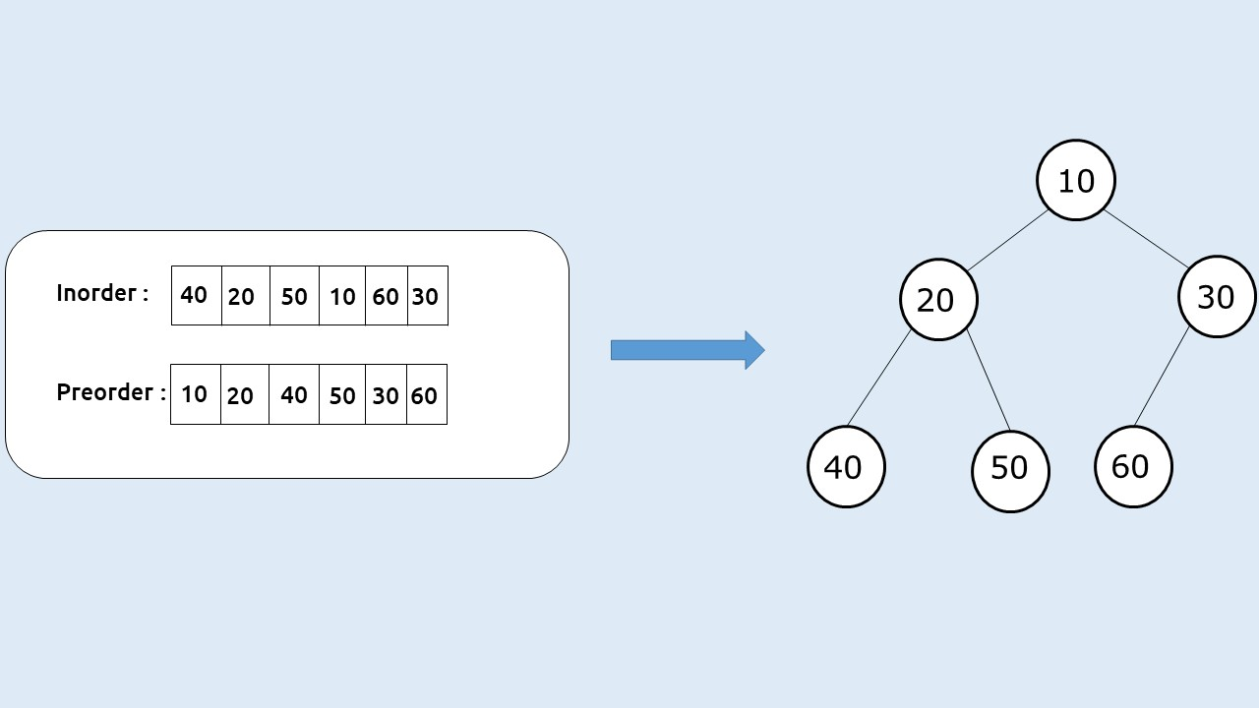

**Disclaimer:**Don’t jump directly to the solution, try it out yourself first.

**Solution:**

In [this article](https://takeuforward.org/binary-tree/how-to-construct-a-binary-tree-using-different-traversals/), we learned that a unique binary tree can be constructed using a preorder and an inorder traversal. Here we will discuss the solution.

**Intuition:**

Inorder traversal is a special traversal that helps us to identify a node and its left and right subtree. Preorder traversal always gives us the root node as the first element. Using these properties we can construct the unique binary tree.

Given this example:

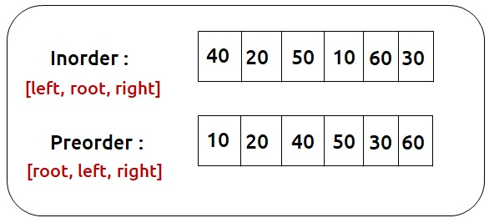

Here 10 (first element of preorder) is the root element. So we can find its index in the inorder traversal(say elem). The left subtree of the root will be present to the left side of in order whereas the right subtree of root will be present on the right side of elem in the inorder traversal:

We can define a recursive function that creates one node at a time. First, we create the root node, and then we can take the help of recursion to create its left and right subtrees. In order to make recursion work, we need to provide the correct inorder and preorder traversal of the subtree for every recursive call.

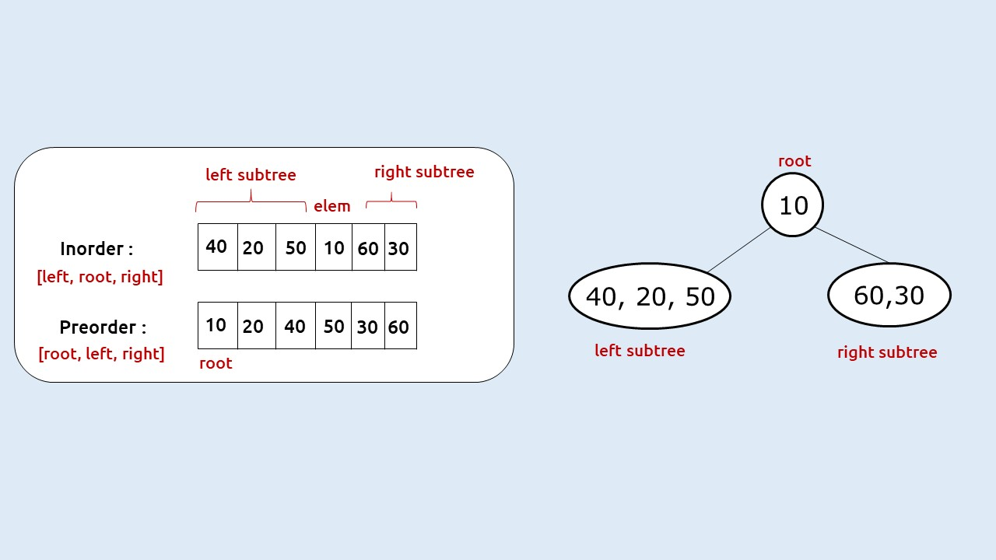

To make more efficient function calls we can use variables (inStart, inEnd) and (preStart and preEnd) in order to point to the start and end of the inorder and preorder traversal respectively, and avoid copying of arrays.

Next, we need to figure out how we are going to search the root index in the inorder traversal. For this, we have two options: Linear Search and Hashmaps. We will choose the second one because it will return us the index in constant time. Before making the first recursive call, we will simply add all the (value, index) pairs to a map and pass it to our recursive function.

If n is the size of the Inorder traversal/Preorder traversal. Then our first function call will be :

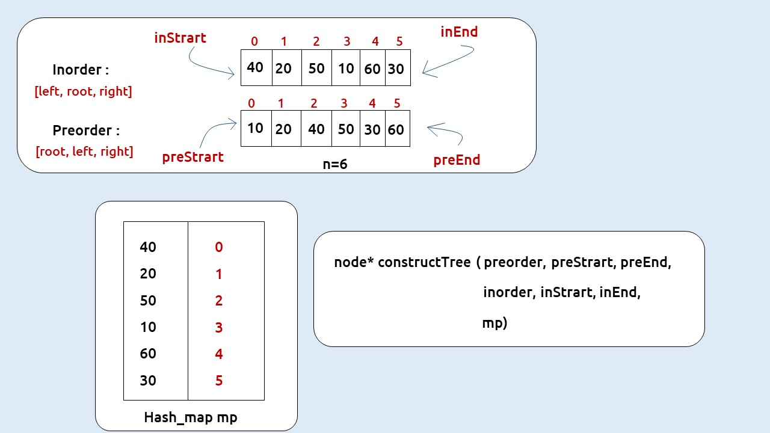

Now the main task left is to pass the correct preStart, preEnd, inStart, inEnd to the respective recursive calls for the left and right subtree. We can calculate the number of elements in the left subtree from the root index, say nElems (elem – InStart, where elem is the index of root in inorder traversal). As inorder is **[left, root, right] and preorder is [root, left, right]** the number of elements (nElems) will easily tell us the preorder and inorder traversal of the subtrees according to the following table:

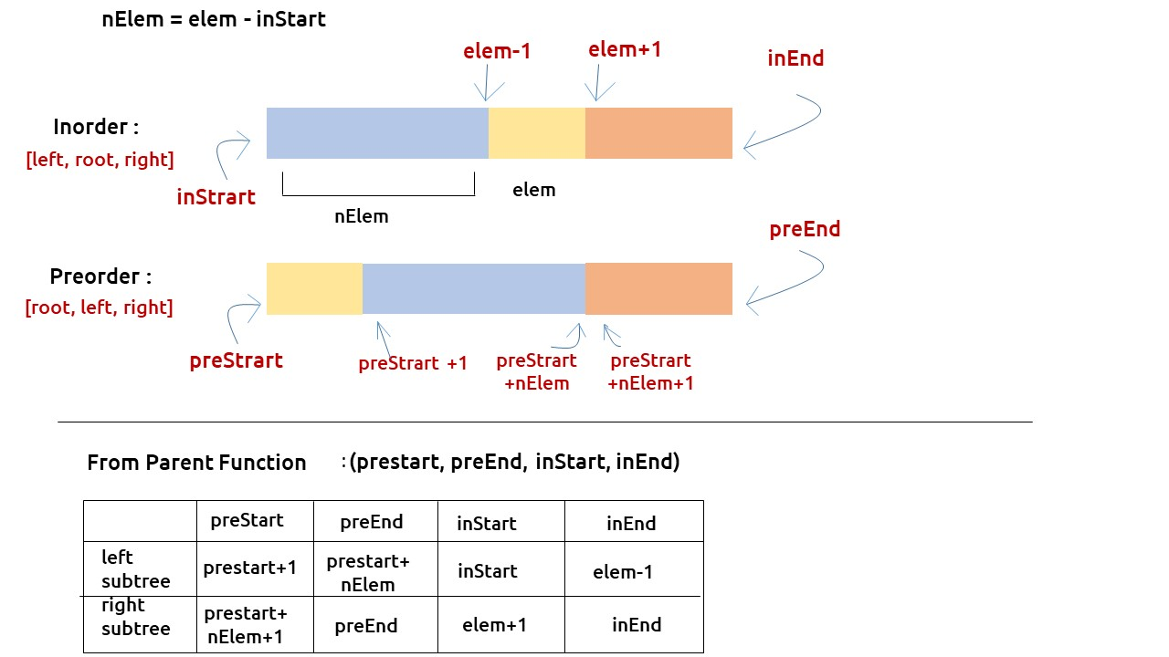

The base case will be when inStart> inEnd or preStart > preEnd, in that case, we can simply return NULL.

**Approach:**

The algorithm approach can be stated as:

* Create a map to store the inorder indexes.
* Call the function constructTree with all 7 parameters as shown above.
* In the recursive function, first check the base case, if (preStart,>preEnd || inStart> inEnd) then return NULL.
* Construct a node (say root) with the root value( first element of preorder).
* Find the index of the root, say elem from the hashmap.
* Find the number of elements ( say nElem) in the left subtree  = elem – inStart
* Call recursively for the left subtree with correct values (shown in the above table) and store the answer received in root->left.
* Call recursively for the right subtree with correct values (shown in the above table) and store the answer received in root->right.
* Return root

**Dry Run:**To understand a detailed dry run of this approach, please watch the video attached below.

**Code:**

* C++ Code
* Java Code

import java.util.*;

class TreeNode {

int val;

TreeNode left;

TreeNode right;

TreeNode(int val) {

this.val = val;

left = null;

right = null;

}

}

//utility function to insert node in the list

class TUF {

static TreeNode buildTree(int[] preorder, int[] inorder) {

Map < Integer, Integer > inMap = new HashMap < Integer, Integer > ();

for (int i = 0; i < inorder.length; i++) {

inMap.put(inorder[i], i);

}

TreeNode root = buildTree(preorder, 0, preorder.length - 1, inorder, 0,

inorder.length - 1, inMap);

return root;

}

static TreeNode buildTree(int[] preorder, int preStart, int preEnd, int[]

inorder, int inStart, int inEnd, Map < Integer, Integer > inMap) {

if (preStart > preEnd || inStart > inEnd) return null;

TreeNode root = new TreeNode(preorder[preStart]);

int inRoot = inMap.get(root.val);

int numsLeft = inRoot - inStart;

root.left = buildTree(preorder, preStart + 1, preStart + numsLeft, inorder,

inStart, inRoot - 1, inMap);

root.right = buildTree(preorder, preStart + numsLeft + 1, preEnd, inorder,

inRoot + 1, inEnd, inMap);

return root;

}

public static void main(String args[]) {

int preorder[] = {10,20,40,50,30,60};

int inorder[] = {40,20,50,10,60,30};

TreeNode root = buildTree(preorder, inorder);

}

}

.**Time Complexity: O(N)**

Assumption: Hashmap returns the answer in constant time.

**Space Complexity: O(N)**

Reason: We are using an external hashmap of size ‘N’.

# Construct Binary Tree from Inorder and PostOrder Traversal

In this article, we will solve the most asked coding interview problem: **Construct A Binary Tree from Inorder and PostOrder Traversal**.

Given Inorder and PostOrder Traversal of a binary tree, we need to construct the unique binary tree represented by them.

**Example:**

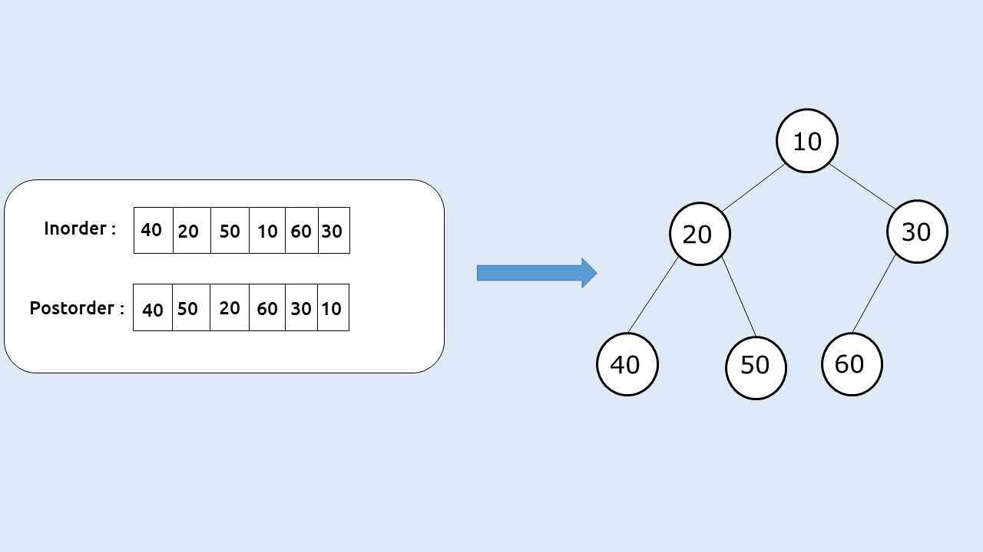

**Disclaimer:**Don’t jump directly to the solution, try it out yourself first.

**Solution:**

In [this article](https://takeuforward.org/binary-tree/how-to-construct-a-binary-tree-using-different-traversals/), we learned that a unique binary tree can be constructed using a postorder and an inorder traversal. Here we will discuss the solution.

**Intuition:**

Inorder traversal is a special traversal that helps us to identify a node and its left and right subtree. Postorder traversal always gives us the root node as its last element. Using these properties we can construct the unique binary tree.

Given this example:

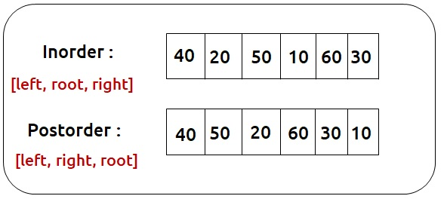

Here 10 (last element of postorder) is the root element. So we can find its index in the inorder traversal(say elem). The left subtree of the root will be present to the left side of inorder whereas the right subtree of root will be present on the right side of elem in the inorder traversal:

We can define a recursive function that creates one node at a time. First, we create the root node, and then we can take the help of recursion to create its left and right subtrees. In order to make recursion work, we need to provide the correct inorder and postorder traversal of the subtree for every recursive call.

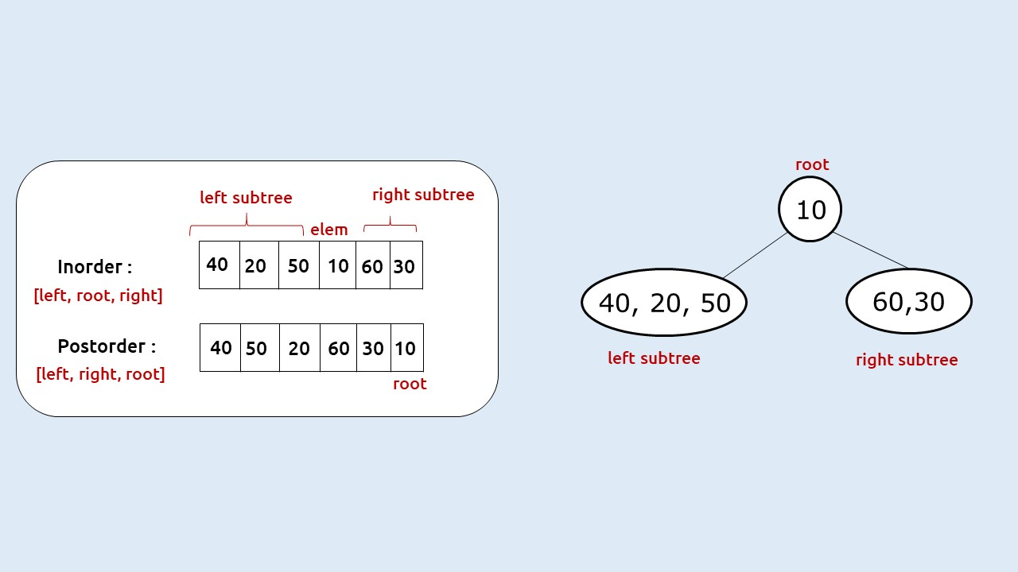

To make more efficient function calls we can use variables (inStart, inEnd) and (postStart and postEnd) in order to point to the start and end of the inorder and postorder traversal respectively, and avoid copying of arrays.

Next, we need to figure out how we are going to search the root index in the inorder traversal. For this, we have two options: Linear Search and Hashmaps. We will choose the second one because it will return us the index in constant time. Before making the first recursive call, we will simply add all the (value, index) pairs to a map and pass it to our recursive function.

If n is the size of the Inorder traversal/Postorder traversal. Then our first function call will be :

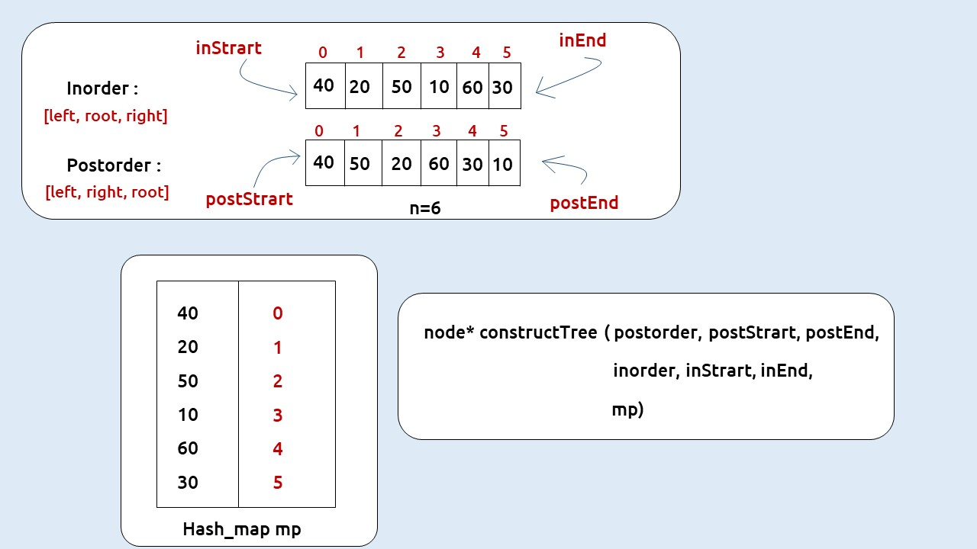

Now the main task left is to pass the correct postStart, postEnd, inStart, inEnd to the respective recursive calls for the left and right subtree. We can calculate the number of elements in the left subtree from the root index, say nElems (elem – InStart, where elem is the index of root in inorder traversal). As inorder is **[left, root, right]** and postorder is **[left, right, root]** the number of elements (nElems) will easily tell us the preorder and inorder traversal of the subtrees according to the following table:

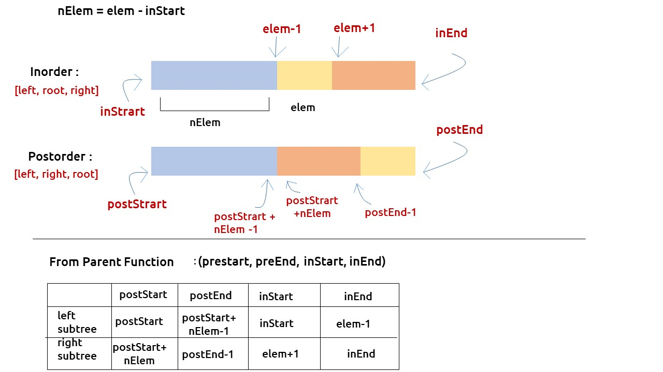

The base case will be when inStart> inEnd or postStart > postEnd, in that case, we can simply return NULL.

**Approach:**

The algorithm approach can be stated as:

* Create a map to store the inorder indexes.
* Call the function constructTree with all 7 parameters as shown above.
* In the recursive function, first check the base case, if (postStart,>postEnd || inStart> inEnd) then return NULL.
* Construct a node (say root) with the root value( last element of postorder).
* Find the index of the root, say elem from the hashmap.
* Find the number of elements ( say nElem) in the left subtree  = elem – inStart
* Call recursively for the left subtree with correct values (shown in the above table) and store the answer received in root->left.
* Call recursively for the right subtree with correct values (shown in the above table) and store the answer received in root->right.
* Return root

**Dry Run:**To understand a detailed dry run of this approach, please watch the video attached below.

**Code:**

class Solution {

public TreeNode buildTree(int[] inorder, int[] postorder) {

if (inorder == null || postorder == null || inorder.length !=

postorder.length)

return null;

HashMap<Integer, Integer> hm = new HashMap<Integer,Integer>();

for (int i=0;i<inorder.length;++i)

hm.put(inorder[i], i);

return buildTreePostIn(inorder, 0, inorder.length-1, postorder, 0,

postorder.length-1,hm);

}

private TreeNode buildTreePostIn(int[] inorder, int is, int ie, int[] postorder,

int ps, int pe,HashMap<Integer,Integer> hm){

if (ps>pe || is>ie) return null;

TreeNode root = new TreeNode(postorder[pe]);

int ri = hm.get(postorder[pe]);

TreeNode leftchild = buildTreePostIn(inorder, is, ri-1, postorder, ps,

ps+ri-is-1, hm);

TreeNode rightchild = buildTreePostIn(inorder,ri+1, ie, postorder,

ps+ri-is, pe-1, hm);

root.left = leftchild;

root.right = rightchild;

return root;

}

}

**Time Complexity: O(N)**

Assumption: Hashmap returns the answer in constant time.

**Space Complexity: O(N)**

Reason: We are using an external hashmap of size ‘N’.

# Serialize And Deserialize a Binary Tree

**Problem Statement:**Design an algorithm to serialize and deserialize a binary tree. There is no restriction on how your serialization/deserialization algorithm should work. You just need to ensure that a binary tree can be serialized to a string and this string can be deserialized to the original tree structure.

**Examples:**

**Example 1:**

**Input:** root = [1,2,3,null,null,4,5]

**Output:** [1,2,3,null,null,4,5]

**Explanation:** The input and the output would be the same for this problem as we are serializing the tree and again deserializing the string format to the binary tree format.

**Example 2:**

**Input:** root = []

**Result:** []

### ****Solution:****

**Disclaimer**: Don’t jump directly to the solution, try it out yourself first.

**Intuition:**

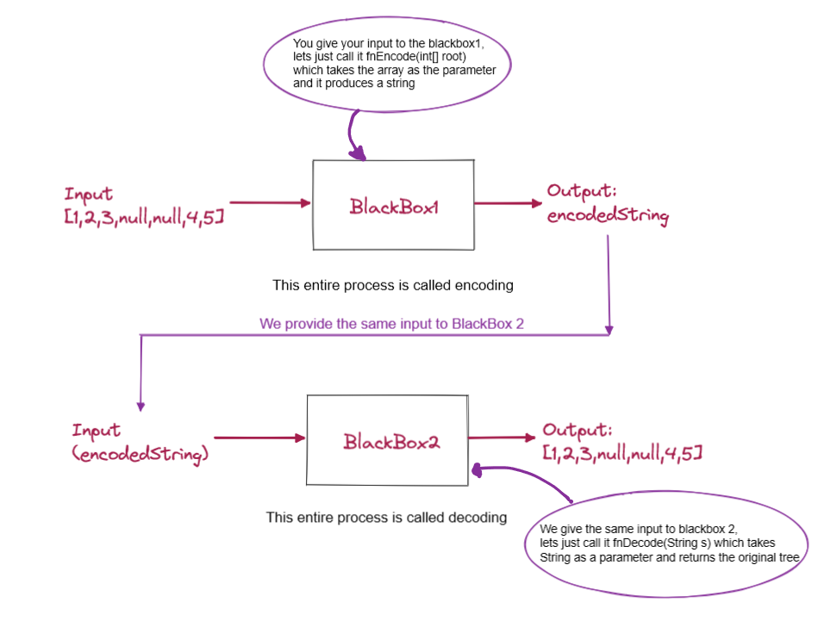

**Approach:**

Now let’s dive into the different approaches we have.

Now, there are a lot of ways to solve this particular problem like inorder traversal, preorder traversal, post-order traversal.

We will be solving this problem using the Level Order Traversal. Now just to give a basic gist, what happens in level order traversal is that we go through each level and print the node value.

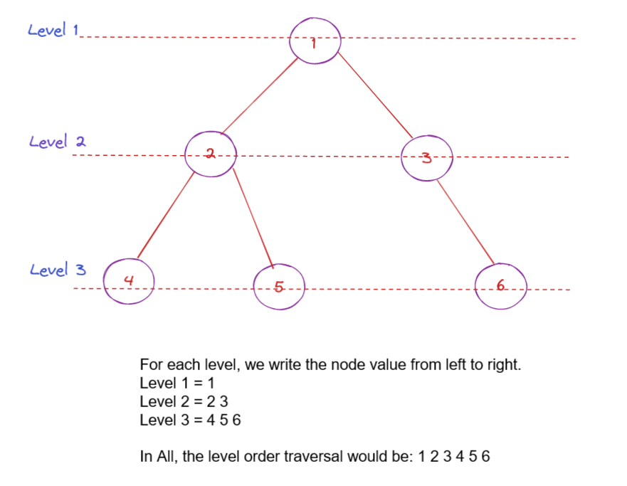

The above diagram pretty much sums up the level order traversal of the binary tree.

Now, let’s get back to the encoding and decoding problem.

Using the level order traversal, we are going to encode the given binary tree. Let’s see how.

Let’s consider the following tree:

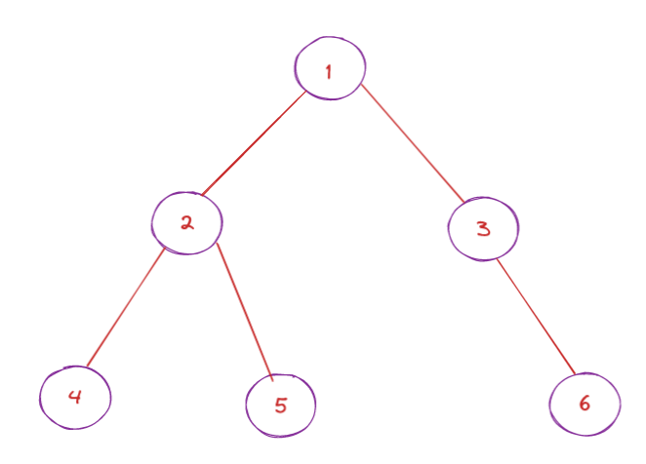

Notice that node 3 does not have a left child and there is no way to identify that 3’s left child is missing. To solve this problem, we substitute node 3’s left child with some value to indicate that the left child is missing.

So we can substitute with any character except for a number since the node values are numbers already, we would get confused.

The character that we are going to use to substitute is “#”.

Now substitution doesn’t mean that we are going to modify the input data, it is just for our understanding to solve this particular problem. We will understand how exactly we are going to add the value in the code.

Now, let’s imagine the binary tree with our substitution method. The tree would now look like this:

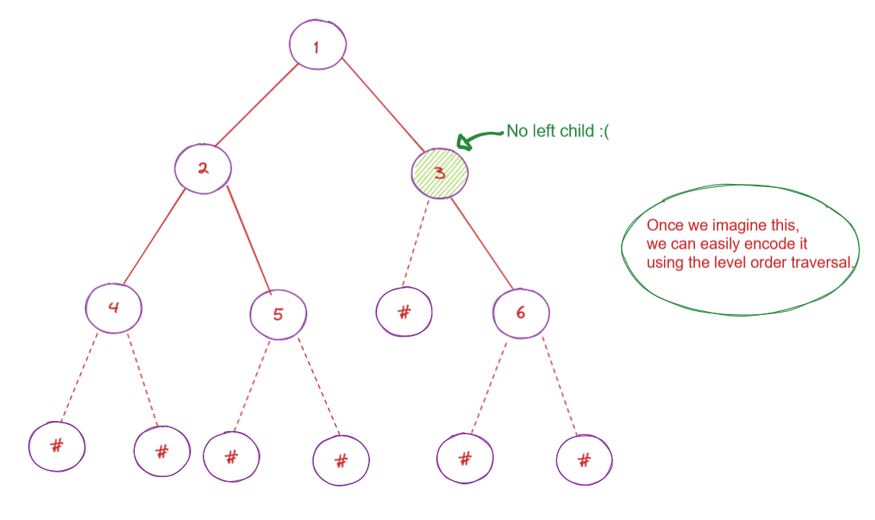

Now we do a simple level order traversal and we achieve the following result **“1,2,3,4,5,#,6,#,#,#,#,#,#”**

Let’s now learn how to deserialize the string:

This is the encoded string: “12345#6######”. So we start from the left and we will use the queue data structure to solve this BlackBox 2.

So, we take the first guy that is 1 and insert it into the queue. Make sure, if the input string is empty or null, it means that there is no tree.

Alright, so 1 is inserted into the queue and we create a root node with the value as 1.

Now, we start iterating on the queue and we say 1s left would be the next character present in the string. In our case it is 2, so we put that in the queue and also assign it as the left child of 1.

Now the right child of 1 would be 3 in our case, that is the next character in the string. We assign 3 as the right child of 1 and put it into the queue. Now 1 is done.

We take the next element from the queue and repeat the same process. Whenever we encounter a # we know that the value of that particular node is null, so we assign null and we won’t be putting that into the queue.

In the end, we would have our decoded Binary Tree.

**Code:**

public class Codec {

public String serialize(TreeNode root) {

if (root == null) return "";

Queue<TreeNode> q = new LinkedList<>();

StringBuilder res = new StringBuilder();

q.add(root);

while (!q.isEmpty()) {

TreeNode node = q.poll();

if (node == null) {

res.append("n ");

continue;

}

res.append(node.val + " ");

q.add(node.left);

q.add(node.right);

}

return res.toString();

}

public TreeNode deserialize(String data) {

if (data == "") return null;

Queue<TreeNode> q = new LinkedList<>();

String[] values = data.split(" ");

TreeNode root = new TreeNode(Integer.parseInt(values[0]));

q.add(root);

for (int i = 1; i < values.length; i++) {

TreeNode parent = q.poll();

if (!values[i].equals("n")) {

TreeNode left = new TreeNode(Integer.parseInt(values[i]));

parent.left = left;

q.add(left);

}

if (!values[++i].equals("n")) {

TreeNode right = new TreeNode(Integer.parseInt(values[i]));

parent.right = right;

q.add(right);

}

}

return root;

}

}

**Time Complexity:**O(N)

**Space Complexity:** O(N)

# Morris Inorder Traversal of a Binary tree

**Problem Statement:** Write a program for Morris Inorder Traversal of a Binary Tree.

**Example**:

**Input:**

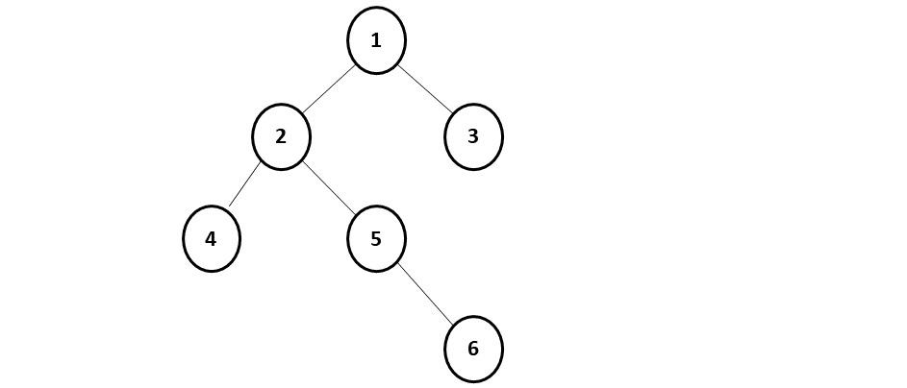

**Output:** Inorder Traversal of this binary tree will be:- 4,2,5,6,1,3

**Disclaimer**: Don’t jump directly to the solution, try it out yourself first.

### ****Solution:****

**Intuition:**We first need to understand what we do in inorder traversal: **Left, Current, Right**.

If we draw a path of our traversal, we will get:

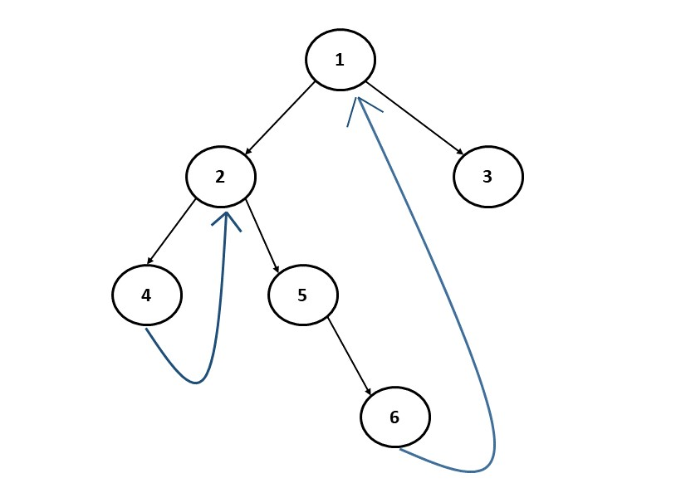

This is exactly our threaded binary tree, which we use in the algorithm.

We need to figure out how we can go back in the tree from a child to a parent without using recursion. We break this tree into small sub-trees (marked in red):

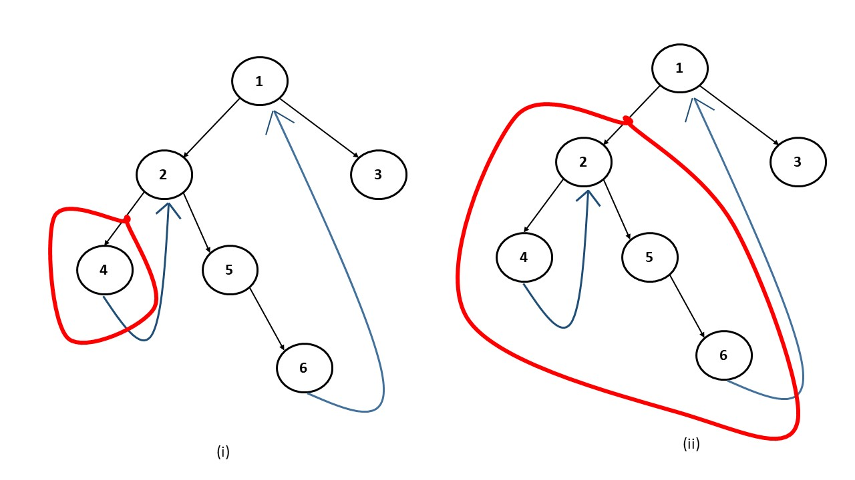

In figure (i), we see that when we are at node 4 and this red subtree has no right child, we move to the parent of this subtree, i.e node 2. Similarly, in figure(ii), when we are at node 6, this red subtree has no right child, therefore we move to its parent, i.e node 1.

We observe a pattern that whenever we are at the last node of a subtree such that the right child is pointing to none, we move to the parent of this subtree.

**Approach:**

When we are currently at a node, the following cases can arise:

* **Case 1:**When the current node has no left subtree. In this scenario, there is nothing to be traversed on the left side, so we simply print the value of the current node and move to the right of the current node.
* **Case 2:**When there is a left subtree and the right-most child of this left subtree is pointing to null. In this case we need to set the right-most child to point to the current node, instead of NULL and move to the left of the current node.
* **Case 3:**When there is a left subtree and the right-most child of this left-subtree is already pointing to the current node. In this case we know that the left subtree is already visited so we need to print the value of the current node and move to the right of the current node.

**Note:**Case 3 is very important as we need to remove the new links added to restore the original tree.

To summarize, at a node whether we have to move left or right is determined whether the node has a left subtree. If it doesn’t we move to the right. If there is a left subtree then we see its rightmost child. If the rightmost child is pointing to NULL, we move the current node to its left. If the rightmost child is already pointing towards the current node, we remove that link and move to the right of the current node. We will stop the execution when the current points to null and we have traversed the whole tree.

**Code:**

class Solution {

public List<Integer> inorderTraversal(TreeNode root) {

List<Integer> inorder = new ArrayList<Integer>();

TreeNode cur = root;

while(cur != null) {

if(cur.left == null) {

inorder.add(cur.val);

cur = cur.right;

}

else {

TreeNode prev = cur.left;

while(prev.right != null && prev.right != cur) {

prev = prev.right;

}

if(prev.right == null) {

prev.right = cur;

cur = cur.left;

}

else {

prev.right = null;

inorder.add(cur.val);

cur = cur.right;

}

}

}

return inorder;

}

}

**Time Complexity: O(N)**.

**Space Complexity: O(1)**

Reason: We are not using recursion.

# Morris Preorder Traversal of a Binary Tree

**Problem Statement:** **Morris Preorder Traversal of a Binary tree**. Given a Binary Tree, find the Morris preorder traversal of Binary Tree.

**Example:**



**Output:** Preorder Traversal of this binary tree will be:- 1,2,4,5,6,3

**Pre-requisite:**[Morris Inorder Traversal](https://takeuforward.org/data-structure/morris-inorder-traversal-of-a-binary-tree/)

**Disclaimer**: Don’t jump directly to the solution, try it out yourself first.

### ****Solution:****

**Intuition:**

As we have learned [**Morris’s Inorder traversa**](https://takeuforward.org/?s=Morris+inorder)l in this tutorial, Morris’s preorder traversal is quite similar. We need to understand the difference in the way we are traversing the tree.

In Morris Inorder Traversal, we are traversing the tree in the way:- Left, Root, Right. In Morris Preorder traversal we want to traverse the tree in the way:- Root, Left, Right. Therefore, the following code changes are required:

* When the current node has a left child: In Morris Inorder traversal we would simply make the new thread required and then move the current node to its left. When we return to the original node from the thread we print it. But in Morris preorder traversal, we want to print the root before visiting the left child, therefore after we set the thread, we first print the current node’s value and then move it to its left.
* When the current node has no left child: This case remains exactly the same because if there is nothing to visit on the left, we will want to print the current node’s value and move right in both traversals. Therefore, there will be no code modification.

The threaded binary tree will remain the same.



**Approach:**

The algorithm can be described as:

When we are currently at a node, the following cases can arise:

* **Case 1:**When the current node has no left subtree. In this scenario, there is nothing to be traversed on the left side, so we simply print the value of the current node and move to the right of the current node.
* **Case 2:**When there is a left subtree and the right-most child of this left subtree is pointing to null. In this case we need to set the right-most child to point to the current node, instead of NULL, print the current node value and move to the left of the current node.
* **Case 3:**When there is a left subtree and the right-most child of this left-subtree is already pointing to the current node. In this case we know that the left subtree is already visited so we need to reset the last node to NULL and move the current node to its right.

**Note:**Case 3 is very important as we need to remove the new links added to restore the original tree.

To summarize, at a node whether we have to move left or right is determined whether the node has a left subtree. If it doesn’t we move to the right. If there is a left subtree then we see its rightmost child. If the rightmost child is pointing to NULL, we print the current node’s value and move it to its left. If the rightmost child is already pointing towards the current node, we remove that link and move to the right of the current node. We will stop the execution when the current points to null and we have traversed the whole tree.

**Code:**

import java.util.*;

class Node {

int data;

Node left, right;

Node(int data) {

this.data = data;

left = null;

right = null;

}

}

public class Main {

static ArrayList < Integer > preorderTraversal(Node root) {

ArrayList < Integer > preorder = new ArrayList < > ();

Node cur = root;

while (cur != null) {

if (cur.left == null) {

preorder.add(cur.data);

cur = cur.right;

} else {

Node prev = cur.left;

while (prev.right != null && prev.right != cur) {

prev = prev.right;

}

if (prev.right == null) {

prev.right = cur;

preorder.add(cur.data);

cur = cur.left;

} else {

prev.right = null;

cur = cur.right;

}

}

}

return preorder;

}

public static void main(String args[]) {

Node root = new Node(1);

root.left = new Node(2);

root.right = new Node(3);

root.left.left = new Node(4);

root.left.right = new Node(5);

root.left.right.right = new Node(6);

ArrayList < Integer > preorder = new ArrayList < > ();

preorder = preorderTraversal(root);

System.out.println("The Preorder Traversal is: ");

for (int i = 0; i < preorder.size(); i++) {

System.out.print(preorder.get(i) + " ");

}

}

}

**Output:**

The Preorder Traversal is: 1 2 4 5 6 3

**Time Complexity: O(N)**.

**Space Complexity: O(1)**

# Flatten Binary Tree to Linked List

**Problem Statement: Flatten Binary Tree To Linked List**. Write a program that flattens a given binary tree to a linked list.

**Note:**

* The sequence of nodes in the linked list should be the same as that of the **preorder traversal**of the binary tree.
* The linked list nodes are the same binary tree nodes. You are not allowed to create extra nodes.
* The right child of a node points to the next node of the linked list whereas the left child points to NULL.

**Example:**

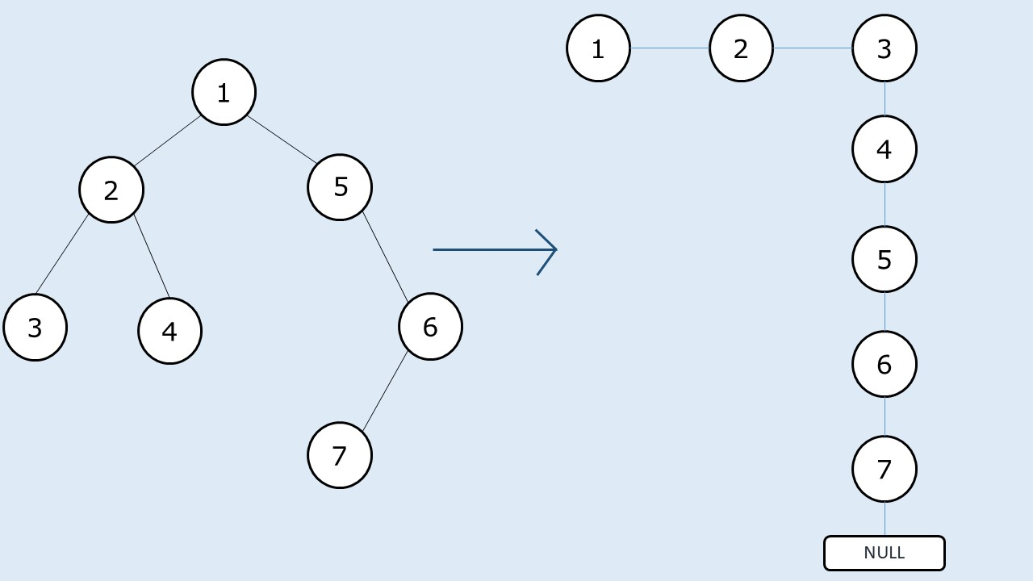

**Pre-req: Traversal Techniques**

**Disclaimer**: Don’t jump directly to the solution, try it out yourself first.

## **Solution 1: Using Recursion**

**Intuition:**

The sequence of nodes in the linked list should be that of the preorder traversal. We will take a smaller example.

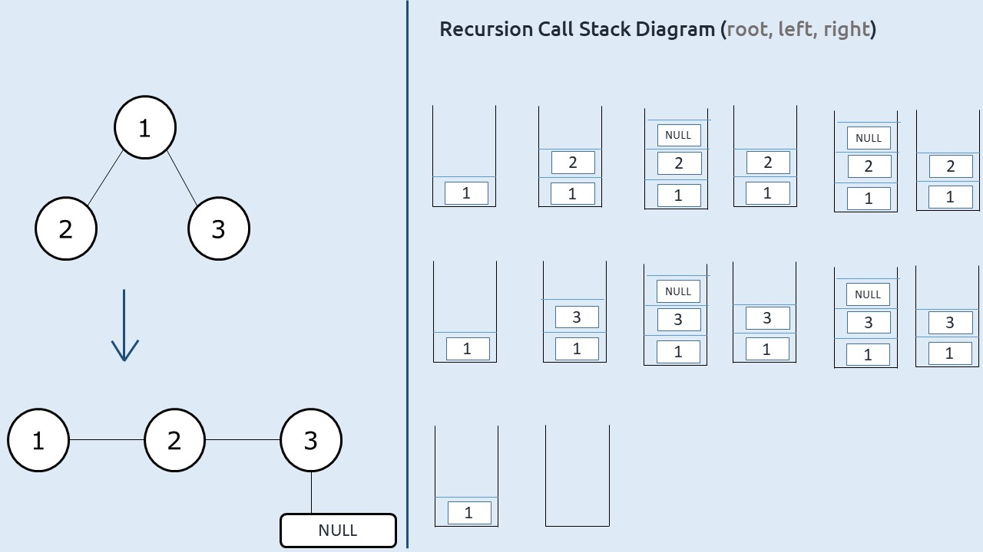

At starting node 1, what we finally want is that node 1’s right child should point to its current left child (node 2). Now If we set it like this in our preorder traversal there will be no way to reach node 3.

We need to modify our traversal technique. If we somehow start at node 3 (last node of the linked list), we need not traverse its right child as it is NULL, therefore we can straightaway set its right child to its left child( which is again NULL) and set its left child to NULL. Now we need to get to the second last node of the linked list (node 2) and set the right child to node 3. After that, we need to move to the third last node i.e node 1.

**Approach:**

The algorithm steps can be stated as:

* If we observe, we are moving in a **reverse postorder**way : i.e **right, left, root.**
* We take a reference variable (say prev) to store the previous node( initialized to NULL).
* Whenever we visit a node, we set the right child to the prev and left child to NULL.
* Next we assign this current node to prev.
* We perform the above two operations on all the nodes in the traversal.

**Dry run:**

The following illustrations will give a clear idea.

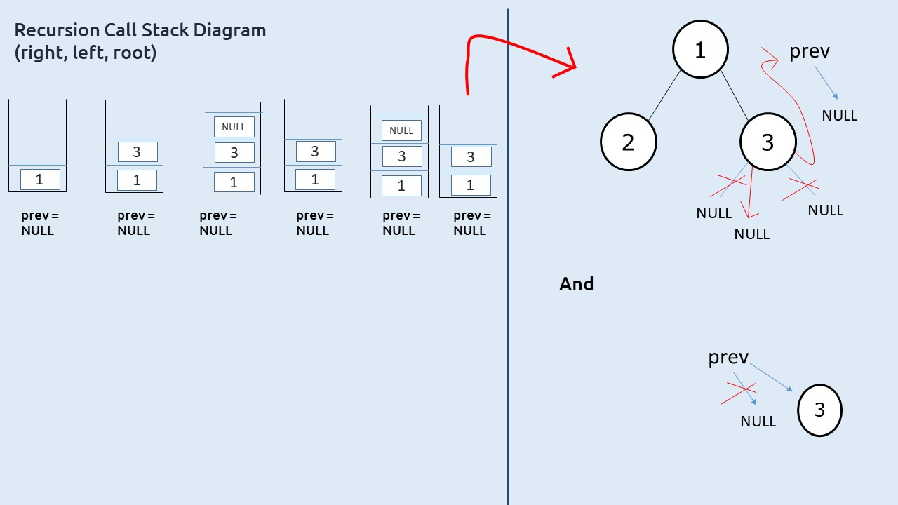

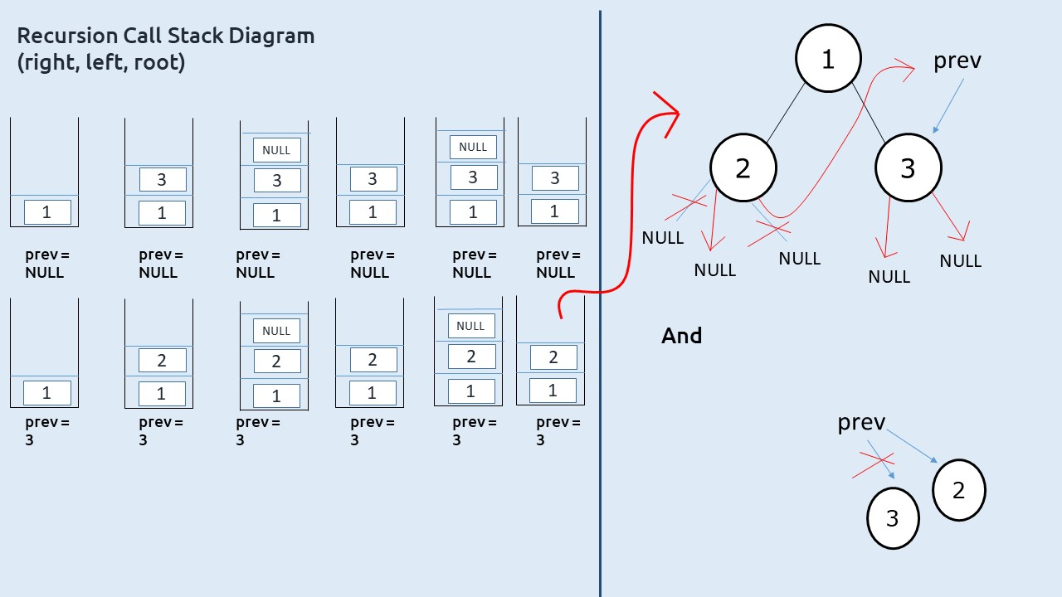

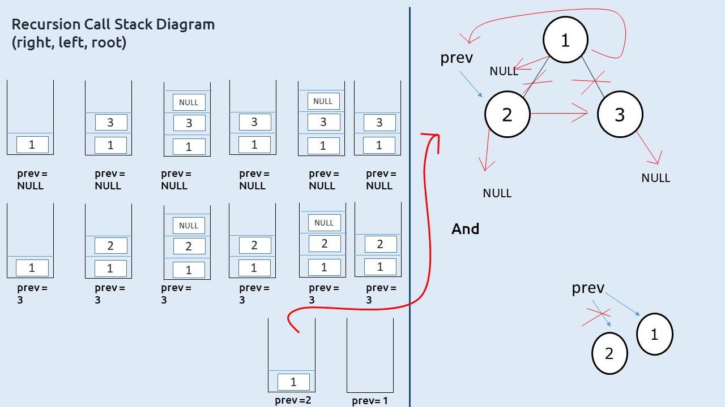

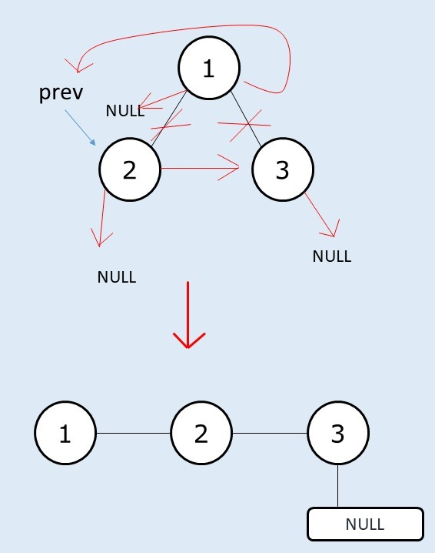

**Code:**

import java.util.*;

class Node {

int data;

Node left, right;

Node(int data)

{

this.data=data;

left=null;

right=null;

}

}

public class Solution {

static Node prev = null;

static void flatten(Node root) {

if (root == null) return;

flatten(root . right);

flatten(root . left);

root . right = prev;

root . left = null;

prev = root;

}

public static void main(String args[]) {

Node root = new Node(1);

root . left = new Node(2);

root . left . left = new Node(3);

root . left . right = new Node(4);

root . right = new Node(5);

root . right . right = new Node(6);

root . right . right . left = new Node(7);

flatten(root);

while(root.right!=null)

{

System.out.print(root.data+"->");

root=root.right;

}

System.out.print(root.data);

}

}

**Output:**

1->2->3->4->5->6->7

**Time Complexity: O(N)**

Reason: We are doing a simple preorder traversal.

**Space Complexity: O(N)**

Reason: Worst case time complexity will be O(N) (in case of skewed tree).

## **Solution 2: Iterative Approach – Using Stack**

**Intuition:**

In a binary tree, generally, we need to set the right child of the node to the left and the left child to NULL. If the given tree is a left-skewed tree, this action alone will flatten the binary tree.

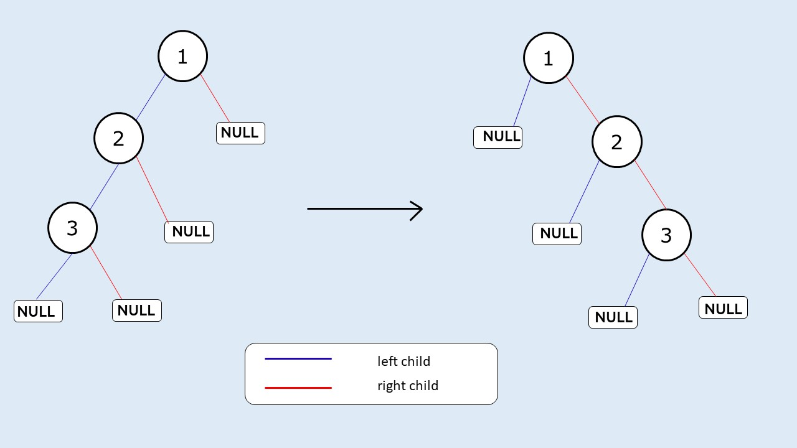

Now the main question arises is what if the current node doesn’t have a left child? In that case, we don’t want to assign its right child to NULL( its left child), rather we want it to assign to itself so that our preorder sequence is maintained. In case the right child is also not present(a leaf node) we would want to assign the right child to some parent node’s right child.

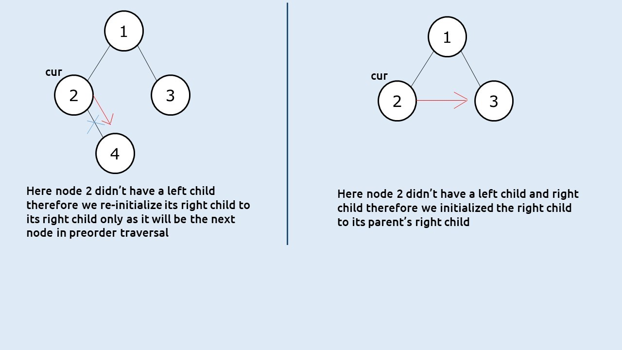

To get to this parent’s right node we will use a stack. Whenever we are at a node we want to prioritize its left child if it is present. If it is not present we want to look at the right child. A stack is a LIFO data structure, we first push the right child and then the left child. Then we set the right child of the node to the stack’s top and left child as NULL. This way the stack always provides the correct next node.

**Approach:**

The algorithm approach can be stated as:

* Take a stack and push the root node to it.
* Set a while loop till the stack is non-empty.
* In every iteration, take the node at the top of the stack( say cur) and pop the stack.
* If cur has a right child, push it to the stack.
* If cur has a left child, push it to the stack.
* Set the right child of cur to node at stack’s top.
* Set the left child of cur as NULL.

**Dry Run:**

We will take a smaller example.

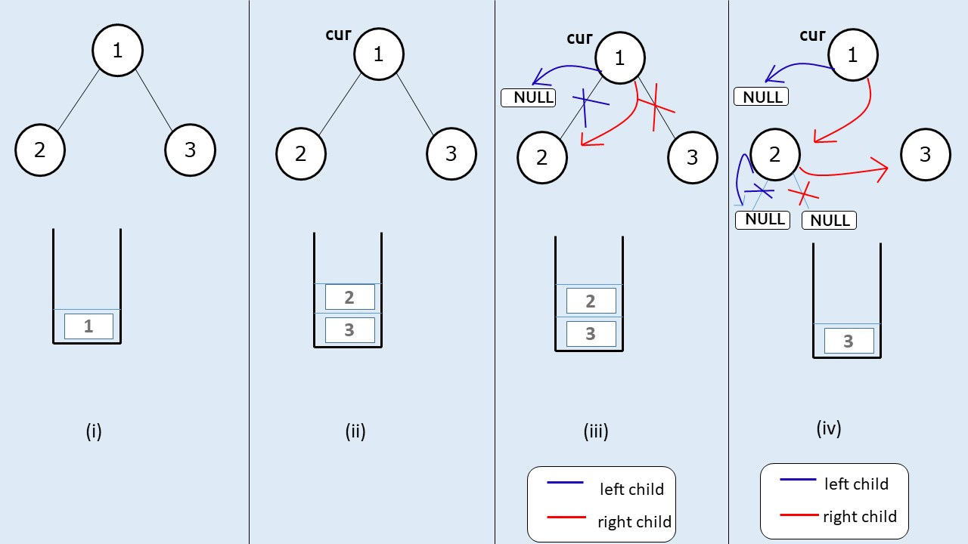

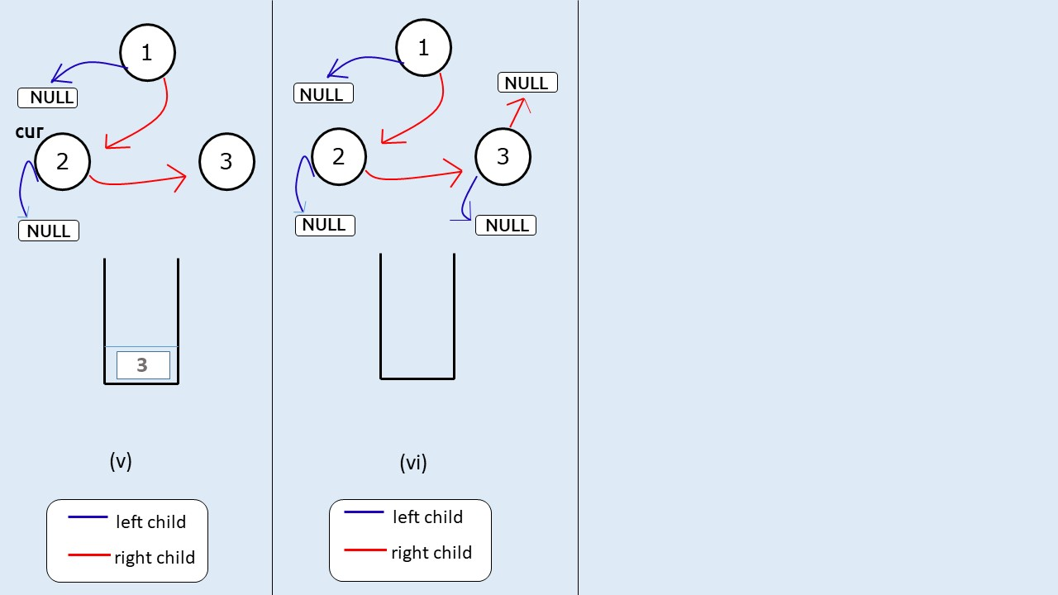

**Code:**

import java.util.*;

class Node {

int data;

Node left, right;

Node(int data)

{

this.data=data;

left=null;

right=null;

}

}

public class Solution {

static Node prev = null;

static void flatten(Node root) {

if (root == null) return;

Stack < Node > st=new Stack<>();

st.push(root);

while (!st.isEmpty()) {

Node cur = st.peek();

st.pop();

if (cur . right != null) {

st.push(cur . right);

}

if (cur . left != null) {

st.push(cur . left);

}

if (!st.isEmpty()) {

cur . right = st.peek();

}

cur . left = null;

}

}

public static void main(String args[]) {

Node root = new Node(1);

root . left = new Node(2);

root . left . left = new Node(3);

root . left . right = new Node(4);

root . right = new Node(5);

root . right . right = new Node(6);

root . right . right . left = new Node(7);

flatten(root);

while(root.right!=null)

{

System.out.print(root.data+"->");

root=root.right;

}

System.out.print(root.data);

}

}

**Output:**

1->2->3->4->5->6->7

**Time Complexity: O(N)**

Reason: The loop will execute for every node once.

**Space Complexity: O(N)**

## **Solution 3 – Using Intuition behind Morris Traversal.**

**Pre- req: Morris Traversal**

**Intuition:**We will use the intuition behind morris’s traversal. In Morris Traversal we use the concept of a threaded binary tree.

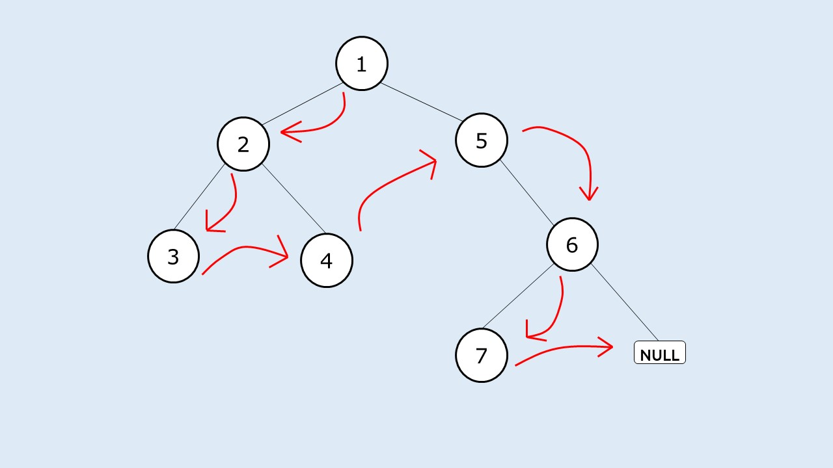

If we set the right child of every node like this(marked in red) and the left child as NULL, our job will be done.

**Approach:**

The algorithm can be described as:

* At a node(say cur) if there exists a left child, we will find the rightmost node in the left subtree(say prev).
* We will set prev’s right child to cur’s right child,
* We will then set cur’s right child to it’s left child.
* We will then move cur to the next node by assigning cur it to its right child
* We will stop the execution when cur points to NULL.

**Dry Run:**

We will take a smaller example.

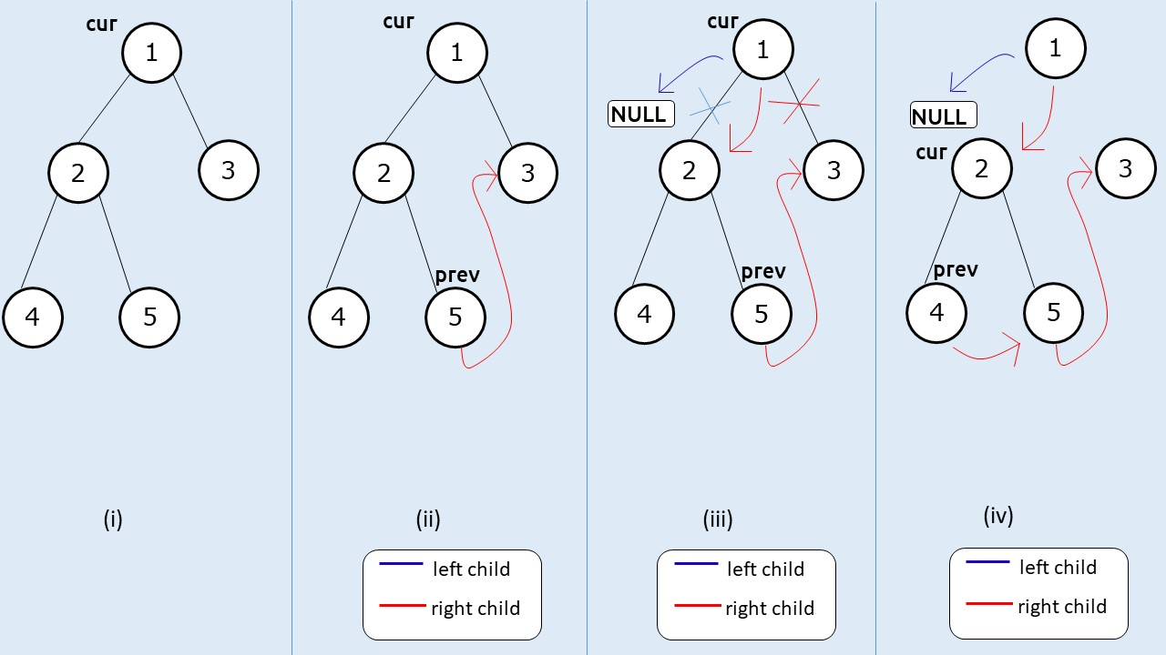

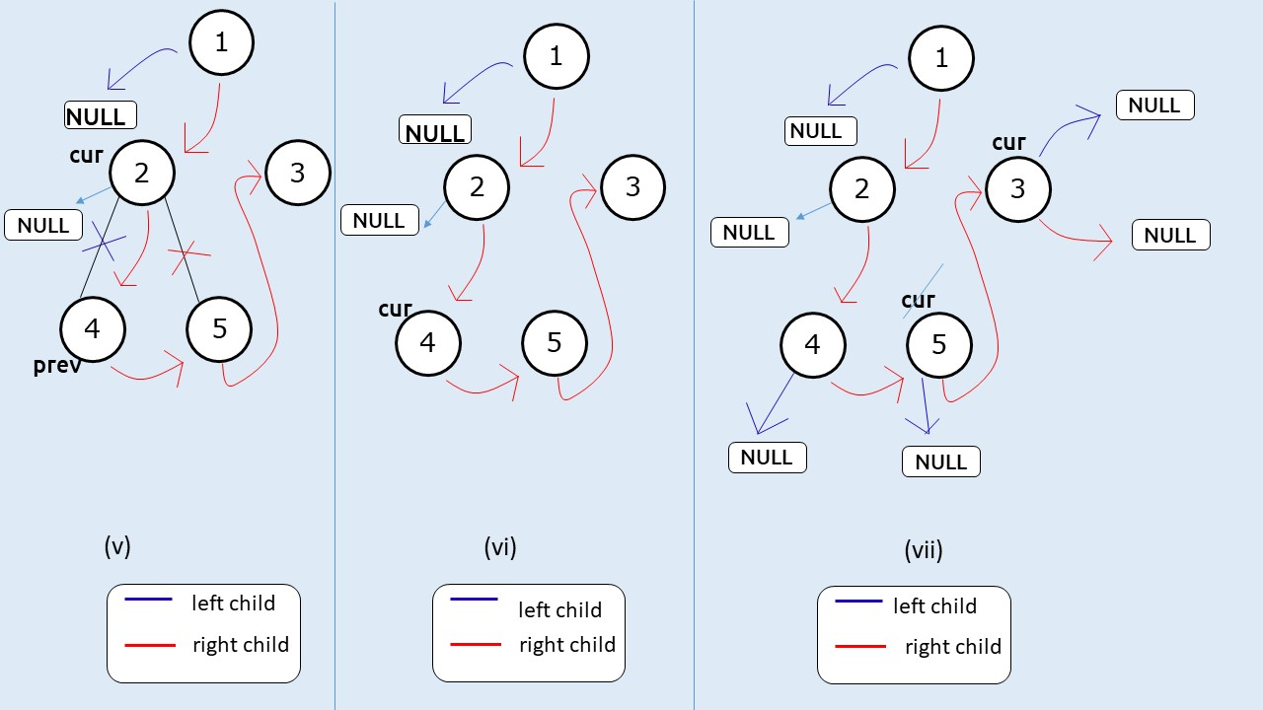

**Code:**

import java.util.*;

class Node {

int data;

Node left, right;

Node(int data)

{

this.data=data;

left=null;

right=null;

}

}

public class Solution {

static Node prev = null;

static void flatten(Node root) {

Node cur = root;

while (cur!=null)

{

if(cur.left!=null)

{

Node pre = cur.left;

while(pre.right!=null)

{

pre = pre.right;

}

pre.right = cur.right;

cur.right = cur.left;

cur.left = null;

}

cur = cur.right;

}

}

public static void main(String args[]) {

Node root = new Node(1);

root . left = new Node(2);

root . left . left = new Node(3);

root . left . right = new Node(4);

root . right = new Node(5);

root . right . right = new Node(6);

root . right . right . left = new Node(7);

flatten(root);

while(root.right!=null)

{

System.out.print(root.data+"->");

root=root.right;

}

System.out.print(root.data);

}

}

**Output:**

1->2->3->4->5->6->7

**Time Complexity: O(N)**

Reason: Time complexity will be the same as that of a morris traversal

**Space Complexity: O(1)**

Reason: We are not using any extra space.

# Introduction to Binary Search Tree

[Binary Search Tree](https://www.geeksforgeeks.org/binary-search-tree-set-1-search-and-insertion/) is a node-based binary tree data structure that has the following properties:

* The left subtree of a node contains only nodes with keys lesser than the node’s key.
* The right subtree of a node contains only nodes with keys greater than the node’s key.
* This means everything to the left of the root is less than the value of the root and everything to the right of the root is greater than the value of the root. Due to this performing, a binary search is very easy.
* The left and right subtree each must also be a binary search tree.    
  There must be no duplicate nodes(BST may have duplicate values with different handling approaches)
* 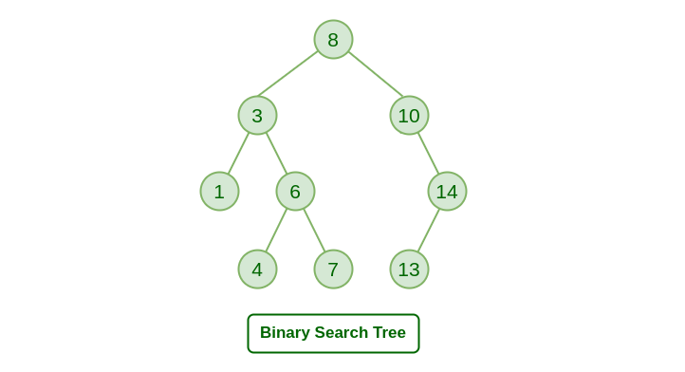

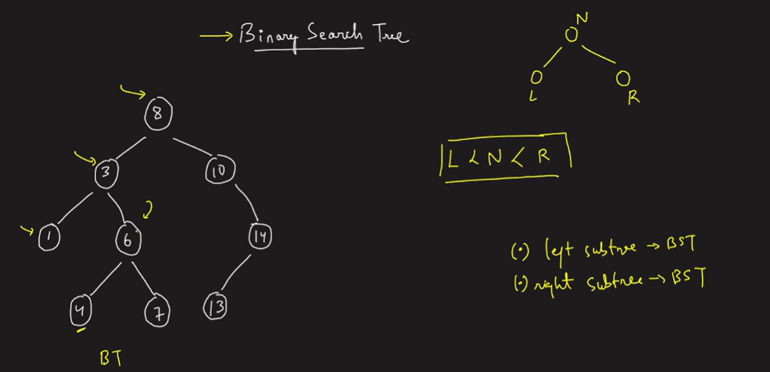

**Applications of Binary Search tree:**

* BSTs are used for indexing.
* It is also used to implement various searching algorithms.
* IT can be used to implement various data structures.
* BSTs can be used in decision support systems to store and quickly retrieve data.
* BSTs can be used to store and quickly retrieve data in computer simulations.
* BSTs can be used to implement fast autocomplete systems.

**Real-time Application of Binary Search tree:**

* BSTs are used for indexing in databases.
* It is used to implement searching algorithms.
* BSTs are used to implement Huffman coding algorithm.
* It is also used to implement dictionaries.
* Used for data caching.
* Used in Priority queues.
* Used in spell checkers.

**Advantages of Binary Search Tree:**

* BST is fast in insertion and deletion when balanced. It is fast with a time complexity of O(log n).
* BST is also for fast searching, with a time complexity of O(log n) for most operations.
* BST is efficient. It is efficient because they only store the elements and do not require additional memory for pointers or other data structures.
* We can also do range queries – find keys between N and M (N <= M).
* BST code is simple as compared to other data structures.
* BST can automatically sort elements as they are inserted, so the elements are always stored in a sorted order.
* BST can be easily modified to store additional data or to support other operations. This makes it flexible.

**Disadvantages of Binary Search Tree:**

* The main disadvantage is that we should always implement a balanced binary search tree. Otherwise the cost of operations may not be logarithmic and degenerate into a linear search on an array.
* They are not well-suited for data structures that need to be accessed randomly, since the time complexity for search, insert, and delete operations is O(log n), which is good for large data sets, but not as fast as some other data structures such as arrays or hash tables.
* A BST can be imbalanced or degenerated which can increase the complexity.
* Do not support some operations that are possible with ordered data structures.
* They are not guaranteed to be balanced, which means that in the worst case, the height of the tree could be O(n) and the time complexity for operations could degrade to O(n).

# Kth largest/smallest element in Binary Search Tree

**Problem statement:** Given a binary search tree find the kth largest and smallest element in Binary Search Tree.

**Examples:**

**Input**: N=6

Arr=[5,3,6,2,4,1]

K=3

**Output:** Kth largest element is 4

Kth smallest element is 3

**Input:** N=7

Arr=[10,40,45,20,25,30,50]

k=3

**Output:** Kth largest element is 40

Kth smallest element is 25

**Solution:**

**Disclaimer**: Don’t jump directly to the solution, try it out yourself first.

**Approach**:

Here first, we take the input array and we insert all elements of the array into a BST.

And after that, we take a variable K.

Then I have to find the Kth largest and smallest element in BST.

So, I created two functions one is kthlargest and the other is kthsmallest.

The first function gives us the Kth largest element of that BST and the second function gives us the Kth smallest element of that BST.

Both functions have two arguments one is root and another is K. In Kthlargest element function I call that function in reverse inorder traversal that means first right subtree after that root and last left subtree if I decrement k by 1 in each function because the maximum value of that BST is the right-most subtree value that’s why we decrement K by 1 each function if any instances we found K is equal to 0 then simply return the root(which is our desired value). The question is why we reduce  K by 1 because we traverse like reverse inorder traversal so if we construct an array by traversal the 0 indexed value will be the rightmost value and the and the next value will be the next function which terminated after that.

Now, comes to the kthsmallest element same as the kthlargest element just one change that is we follow inorder traversal here because we will get the element in a sorted order that’s why we call the left subtree first and after that root and after that, we call right subtree and we decrement K by 1 in each function. If any instance we found k is equal to 0 then we return the root. If any function we found that root is equal to NULL then return NULL.

In this program we have one corner case if we found NULL after executing the function then the K is greater than N in that case we simply print Invalid input.

**Code:**

import java.util.*;

class Node{

int data;

Node left,right;

Node(int val)

{

data=val;

left=null;

right=null;

}

}

public class TUF{

static Node insertBST(Node root,int val)

{

if(root==null)

{

return new Node(val);

}

if(val<root.data)

{

root.left=insertBST(root.left,val);

}

else

{

root.right=insertBST(root.right,val);

}

return root;

}

static Node kthlargest(Node root,int k[])

{

if(root==null)

return null;

Node right=kthlargest(root.right,k);

if(right!=null)

return right;

k[0]--;

if(k[0]==0)

return root;

return kthlargest(root.left,k);

}

static Node kthsmallest(Node root,int k[])

{

if(root==null)

return null;

Node left=kthsmallest(root.left,k);

if(left!=null)

return left;

k[0]--;

if(k[0]==0)

return root;

return kthsmallest(root.right,k);

}

public static void main(String args[])

{

int arr[]={10,40,45,20,25,30,50},i;

int k=3;

Node root=null;

for(i=0;i<7;i++)

{

root=insertBST(root,arr[i]);

}

System.out.println();

int p=k;

Node large=kthlargest(root,new int[]{k});

k=p;

Node small=kthsmallest(root,new int[]{k});

if(large==null)

{

System.out.println("Invalid input");

}

else

System.out.println("kth largest element is "+large.data);

if(small==null)

{

System.out.println("Invalid input");

}

else

{

System.out.println("kth smallest element is "+small.data);

}

}

}

**Output:**

kth largest element is 40  
kth smallest element is 25

**Time Complexity:** O(min(K,N))

**Space Complexity:** O(min(K,N))

# Check if a node is valid BST or BT

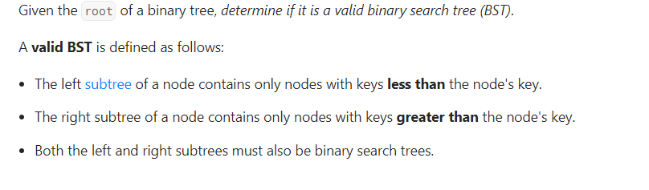

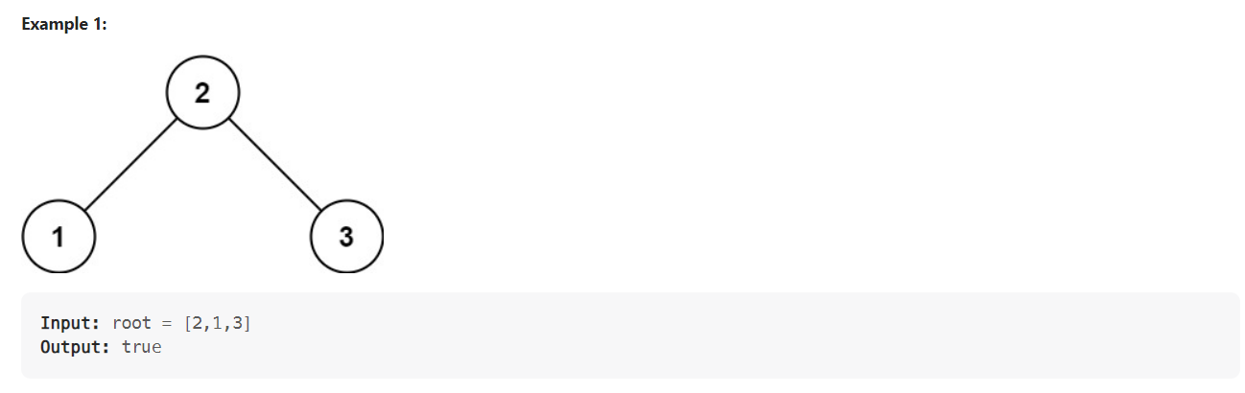

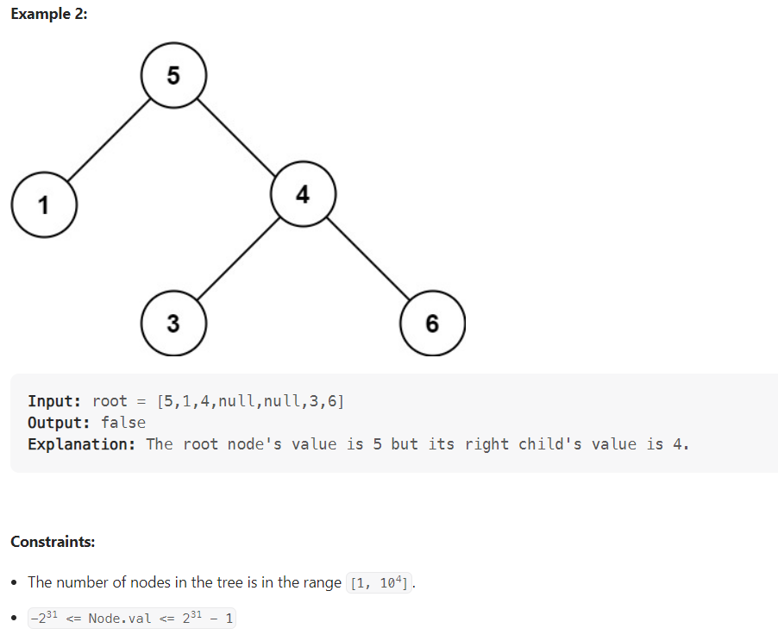

public class ValidBST {  
 public static boolean isValidBST(TreeNode root){  
 return *isValidBST*(root, Long.*MIN_VALUE*, Long.*MAX_VALUE*);  
 }  
  
 private static boolean isValidBST(TreeNode root, long minValue, long maxValue) {  
 if(root == null) return true;  
 if(root.val >= maxValue || root.val <= minValue) return false;  
 return *isValidBST*(root.left, minValue, root.val) && *isValidBST*(root.right, root.val, maxValue);  
 }  
}

# Lowest Common Ancestor in BST

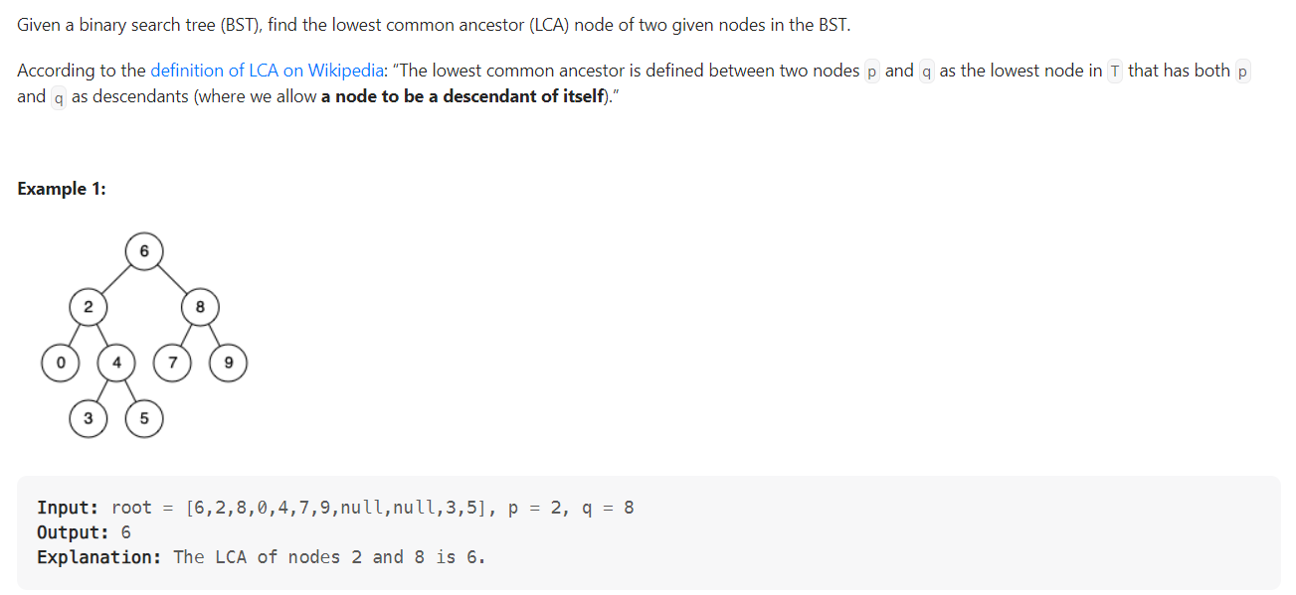

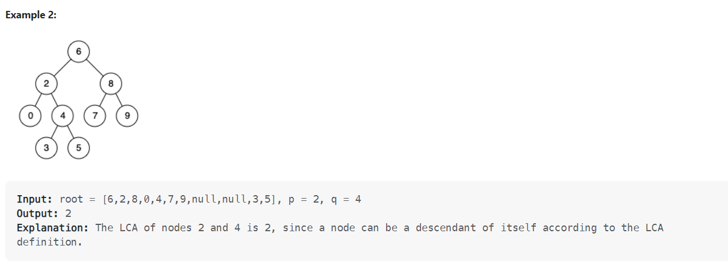

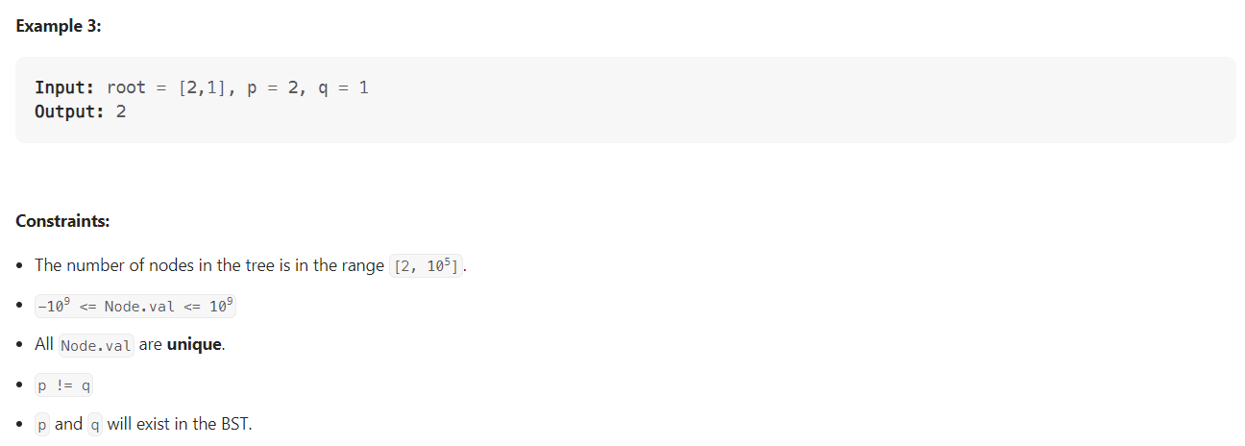

public class LowestCommonAncestorInBST {  
 public static TreeNode lca(TreeNode root, TreeNode p, TreeNode q){  
 if(root == null) return null;  
 int cur = root.val;  
 if(cur < p.val && cur < q.val) return *lca*(root.right, p, q);  
 if(cur > p.val && cur > q.val) return *lca*(root.left, p , q);  
 return root;  
 }  
}

# Construct a BST from a preorder traversal

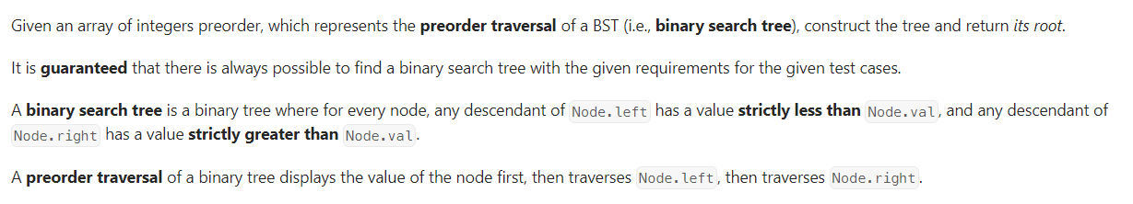

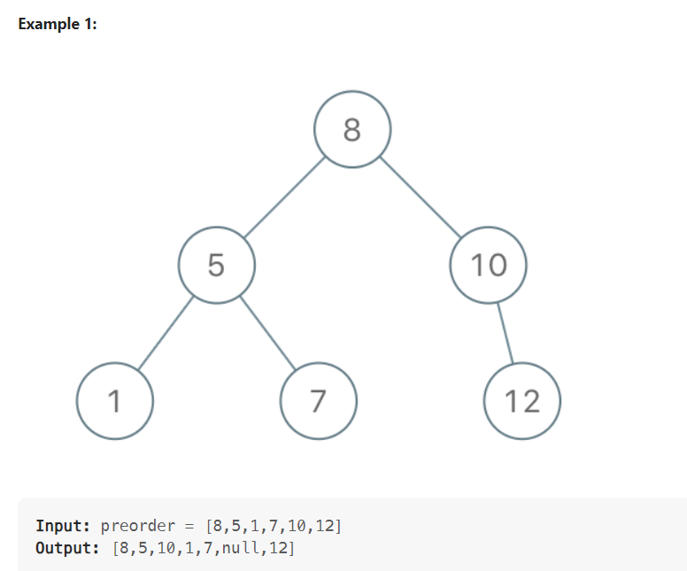

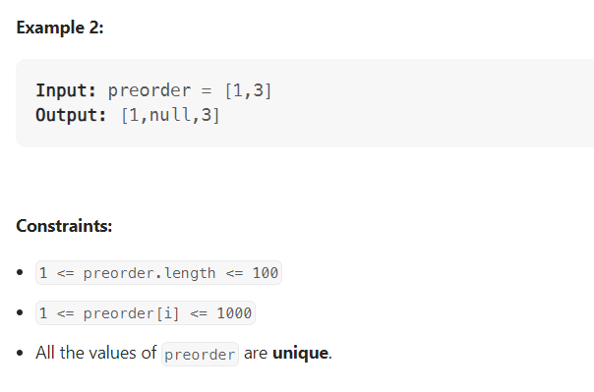

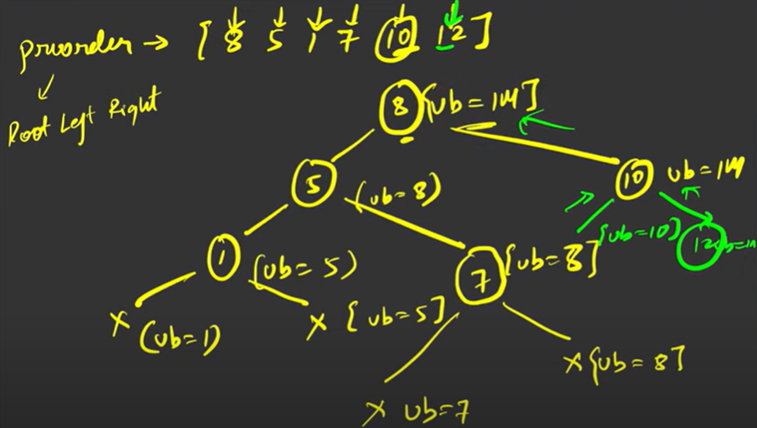

public class ConstructBSTFromPreOrder {  
  
 public static TreeNode bstFromPreorder(int[] arr) {  
 return *bstFromPreorder*(arr, Integer.*MAX_VALUE*, new int[]{0});  
 }  
  
 public static TreeNode bstFromPreorder(int[] arr, int bound, int[] i) {  
 if (i[0] == arr.length || arr[i[0]] > bound) return null;  
 TreeNode root = new TreeNode(arr[i[0]++]);  
 root.left = *bstFromPreorder*(arr, root.val, i);  
 root.right = *bstFromPreorder*(arr, bound, i);  
 return root;  
 }  
  
 public static void main(String[] args) {  
 System.*out*.println(*bstFromPreorder*(new int[]{8,5,1,7,10,12}));  
 }  
}

TC: O(N)

# Inorder Successor/Predecessor in BST

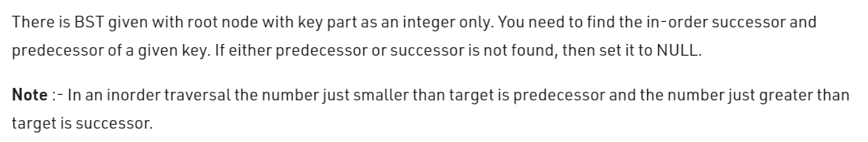

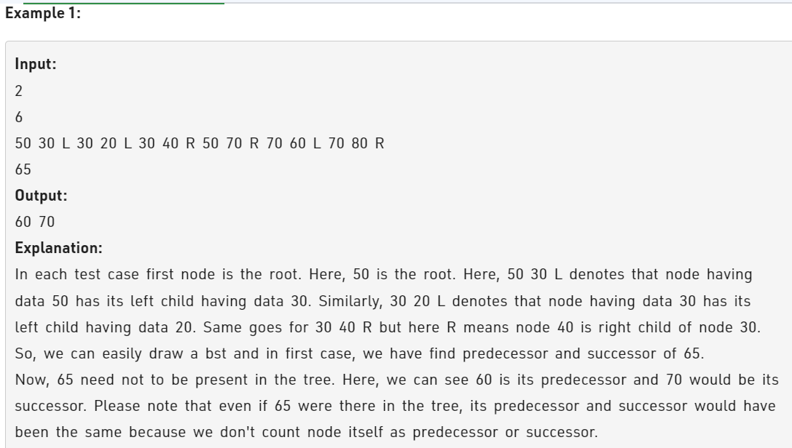

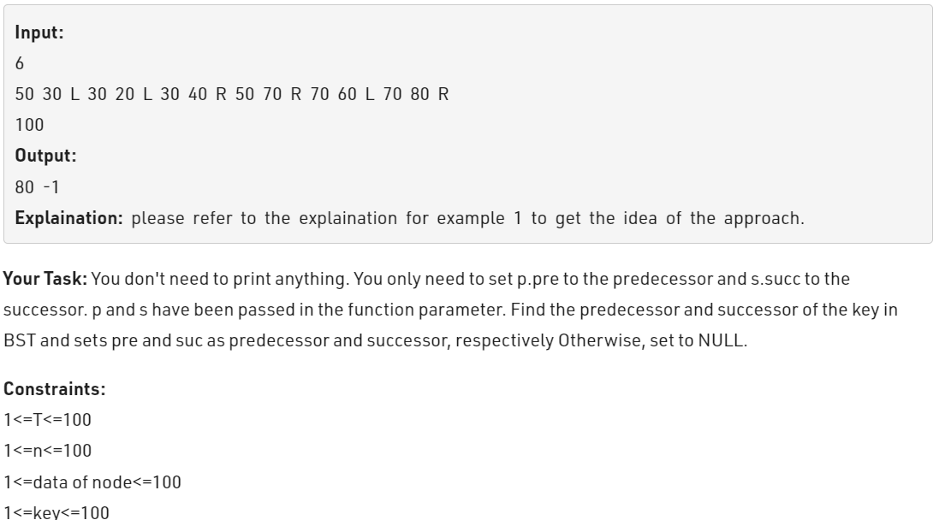

public class InOrderSuccessor {  
 public static TreeNode inOrderSuccessor(TreeNode root, TreeNode p){  
 TreeNode successor = null;  
 while(root != null){  
 if(root.val > p.val){  
 successor = root;  
 root = root.left;  
 }else{  
 root = root.right;  
 }  
 }  
 return successor;  
 }  
  
 public static TreeNode inOrderPredecessor(TreeNode root, TreeNode p){  
 TreeNode successor = null;  
 while(root != null){  
 if(root.val >= p.val){  
 root = root.left;  
 }else{  
 successor = root;  
 root = root.right;  
 }  
 }  
 return successor;  
 }  
  
 public static void main(String[] args) {  
 TreeNode root = new TreeNode(5);  
 root.left = new TreeNode(2);  
 root.right = new TreeNode(7);  
 root.left.left = new TreeNode(1);  
 root.left.right = new TreeNode(4);  
 root.left.right.left = new TreeNode(3);  
 root.right.left = new TreeNode(6);  
 root.right.right = new TreeNode(9);  
 root.right.right.left = new TreeNode(8);  
 root.right.right.right = new TreeNode(10);  
 System.*out*.println(*inOrderSuccessor*(root, root.left.right.left));  
 System.*out*.println(*inOrderSuccessor*(root, root.right.right.right));  
 System.*out*.println(*inOrderPredecessor*(root, root.left.right.left));  
 }

# Binary Search Tree Iterator

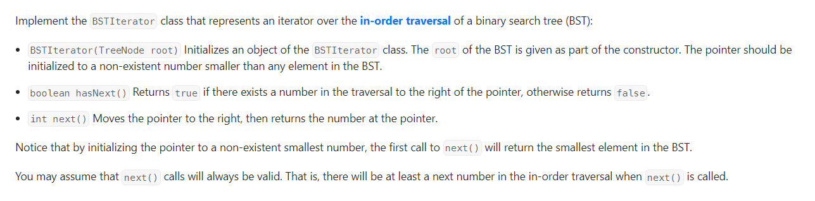

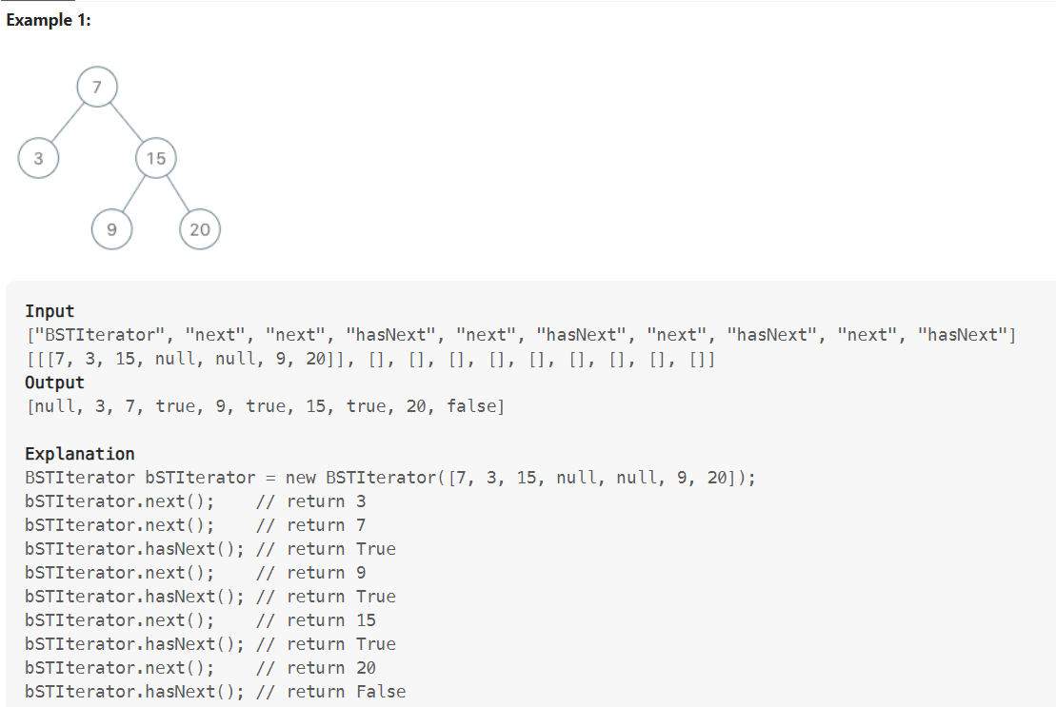

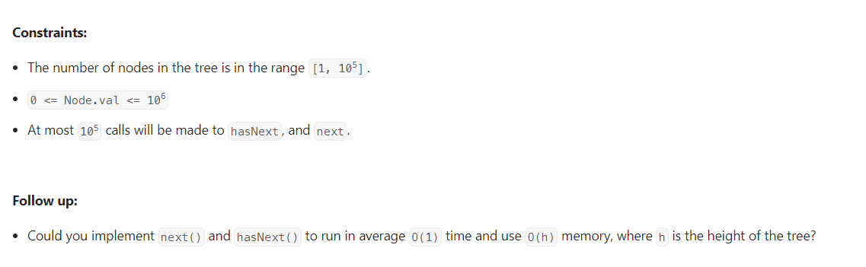

Code

|  |
| --- |
| class BSTIterator {      private Stack<TreeNode> stack = new Stack<>();      public BSTIterator(TreeNode root){          pushAll(root);      }        public int next() {          TreeNode treeNode = stack.pop();          pushAll(treeNode.right);          return treeNode.val;      }        public boolean hasNext() {          return !stack.isEmpty();      }      private void pushAll(TreeNode root) {          while(root != null){              stack.push(root);              root = root.left;          }      }  } |

# Two Sum IV - Input is a BST

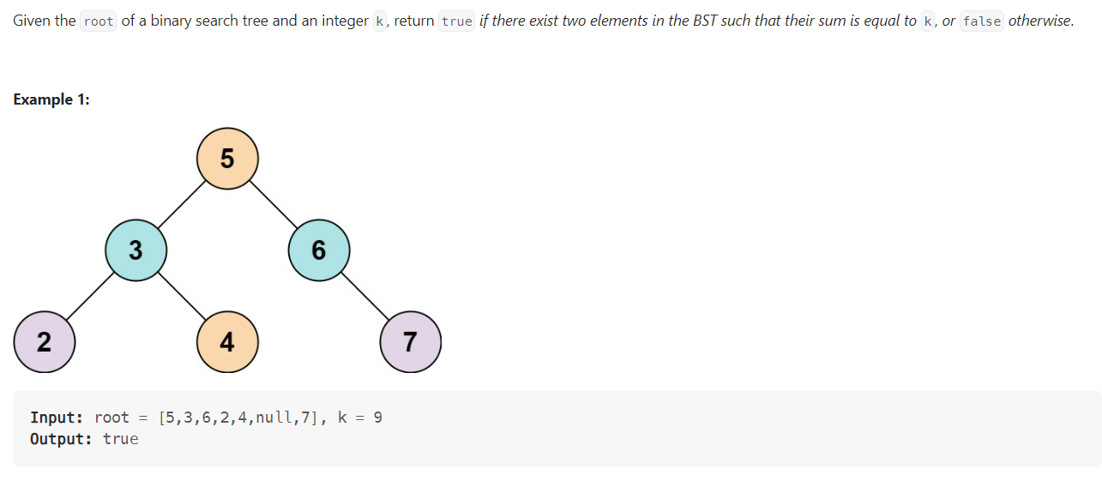

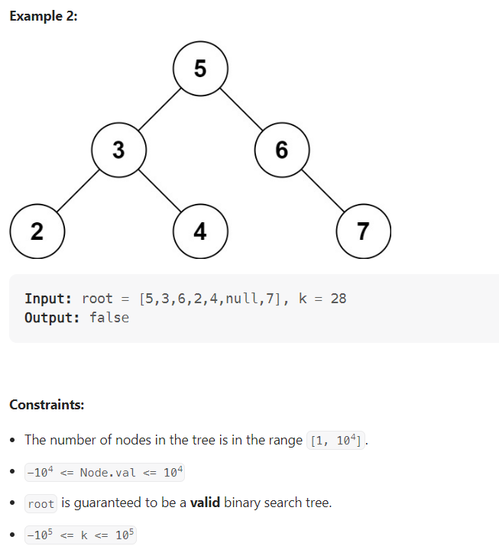

## Solution 1

class Solution {  
 Set<Integer> set=new HashSet<>();  
 int sum=0;  
 public boolean findTarget(TreeNode root, int k) {  
 return helper(root,k,set);  
 }  
 private boolean helper(TreeNode root,int k,Set<Integer> set)  
 {  
 if(root==null)  
 return false;  
 if(set.contains(k-root.val))  
 return true;  
 set.add(root.val);  
 return helper(root.left,k,set) || helper(root.right,k,set);  
  
 }  
}

## Solution 2

class BSTIterator {  
 private Stack<TreeNode> stack = new Stack<>();  
 boolean reverse = true;  
  
 public BSTIterator(TreeNode root, boolean isReverse) {  
 reverse = isReverse;  
 pushAll(root);  
 }  
  
 public boolean hasNext() {  
 return !stack.isEmpty();  
 }  
  
 public int next() {  
 TreeNode tmpNode = stack.pop();  
 if(!reverse) pushAll(tmpNode.right);  
 else pushAll(tmpNode.left);  
 return tmpNode.val;  
 }  
  
 private void pushAll(TreeNode node) {  
 while(node != null) {  
 stack.push(node);  
 if(reverse) {  
 node = node.right;  
 } else {  
 node = node.left;  
 }  
 }  
 }  
}

public class TwoSumBST {  
  
 public boolean findTarget(TreeNode root, int k) {  
 if(root == null) return false;  
 V1BSTIterator l = new V1BSTIterator(root, false);  
 V1BSTIterator r = new V1BSTIterator(root, true);  
  
 int i = l.next();  
 int j = r.next();  
 while(i<j) {  
 if(i + j == k) return true;  
 else if(i + j < k) i = l.next();  
 else j = r.next();  
 }  
 return false;  
 }

}

# Recover BST | Correct BST with two nodes swapped

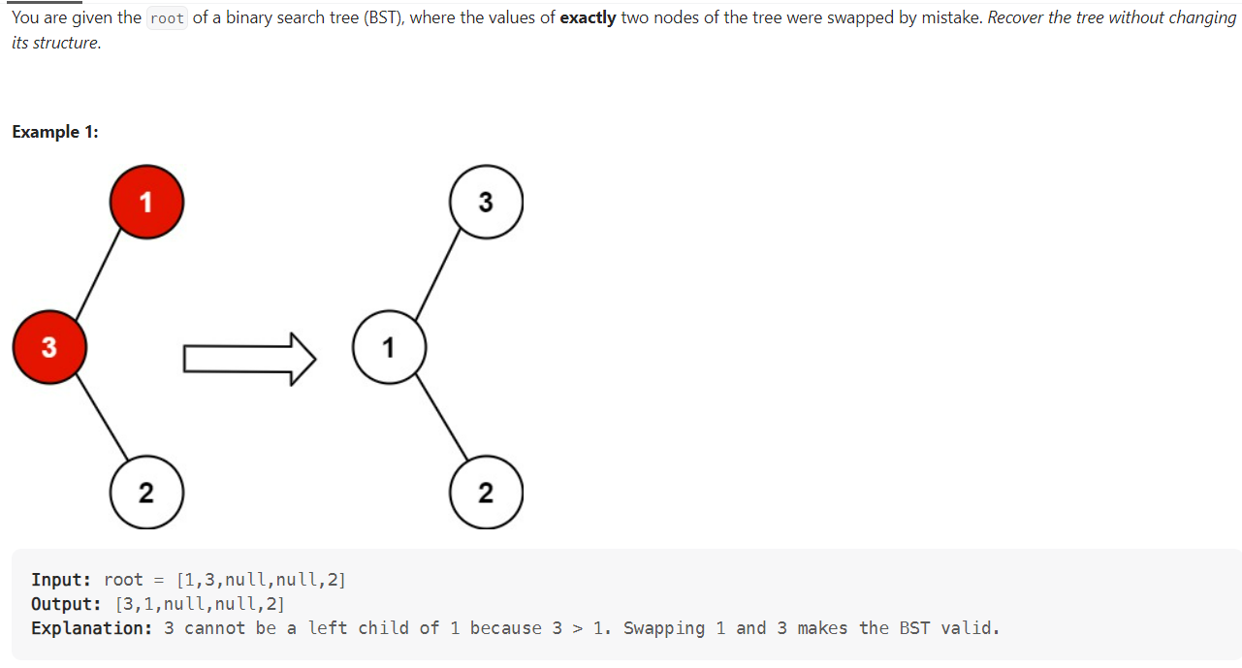

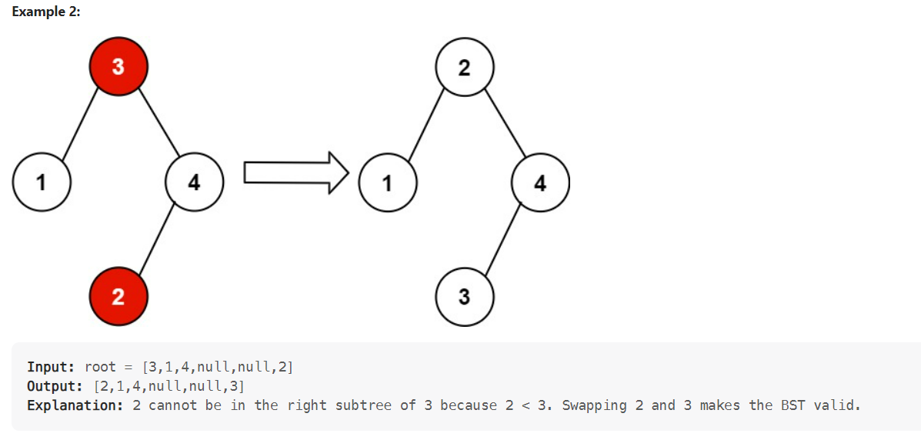

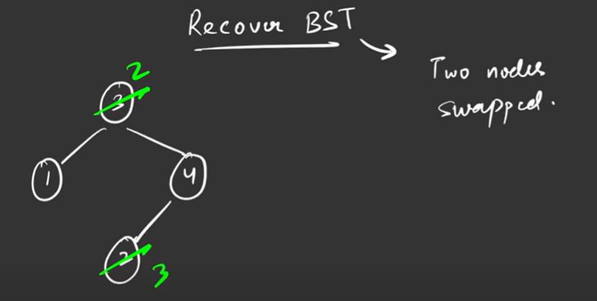

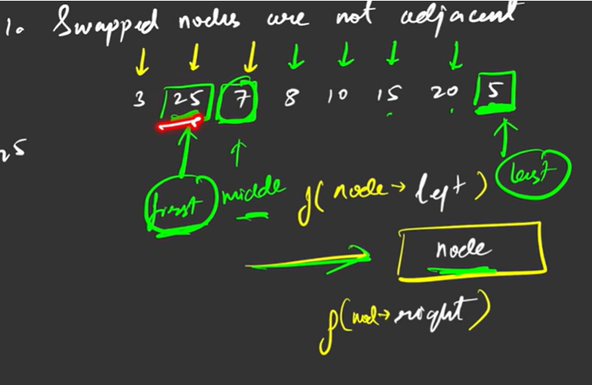

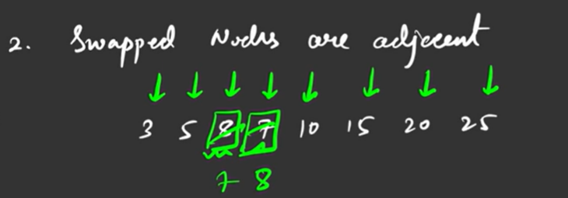

Time Complexity O(N)

Space O(1) excluding stack space for recursion

public class RecoverBST {  
  
 private TreeNode first;  
 private TreeNode prev;  
 private TreeNode middle;  
 private TreeNode last;  
 private void inorder(TreeNode root) {  
 if(root == null) return;  
  
 inorder(root.left);  
  
 if (prev != null && (root.val < prev.val))  
 {  
  
 // If this is first violation, mark these two nodes as  
 // 'first' and 'middle'  
 if ( first == null )  
 {  
 first = prev;  
 middle = root;  
 }  
  
 // If this is second violation, mark this node as last  
 else  
 last = root;  
 }  
  
 // Mark this node as previous  
 prev = root;  
 inorder(root.right);  
 }  
 public void recoverTree(TreeNode root) {  
 first = middle = last = null;  
 prev = new TreeNode(Integer.*MIN_VALUE*);  
 inorder(root);  
 if(first!=null && last!=null) {  
 int t = first.val;  
 first.val = last.val;  
 last.val = t;  
 }  
 else if(first!=null && middle!=null) {  
 int t = first.val;  
 first.val = middle.val;  
 middle.val = t;  
 }  
 }  
}

# Largest BST in Binary Tree

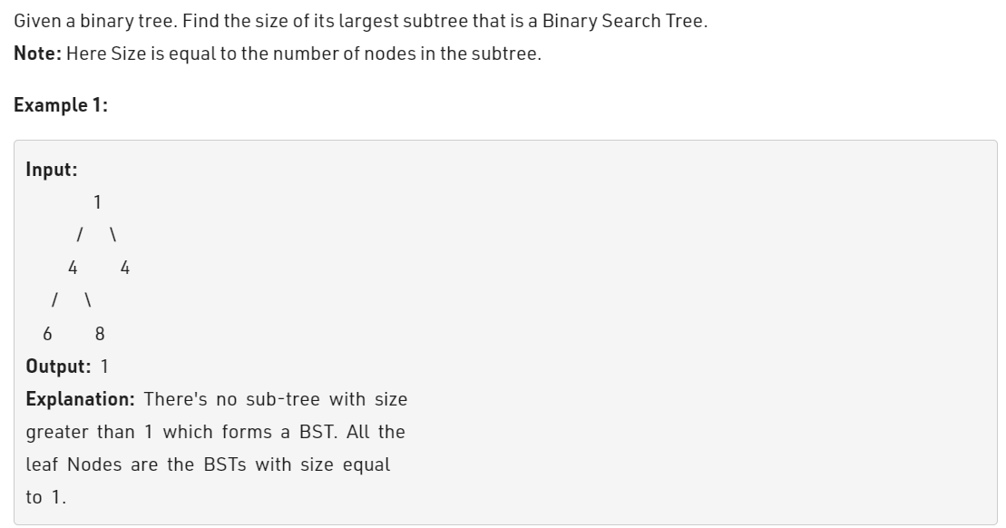

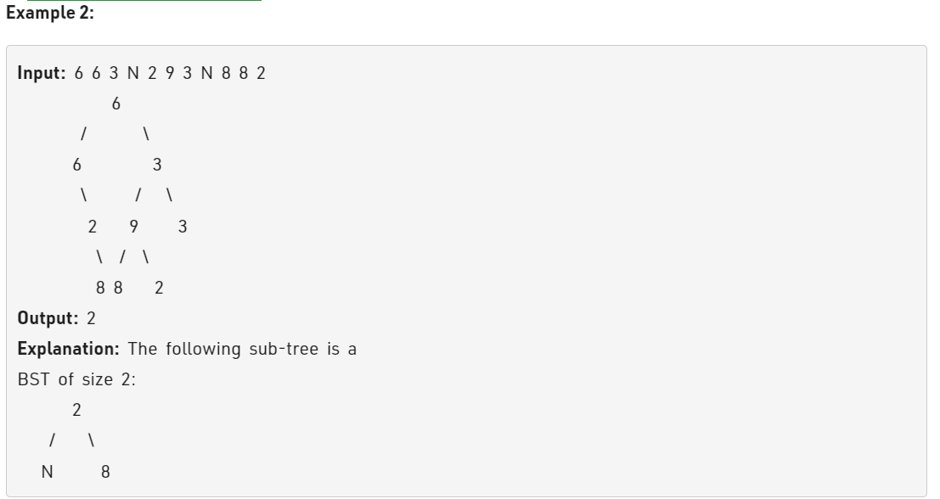

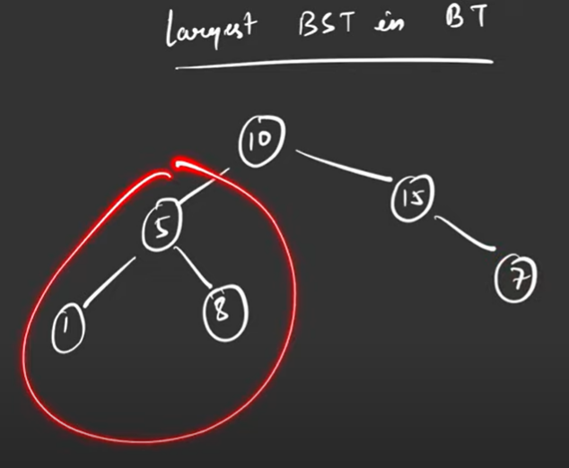

class NodeValue {  
 public int maxNode, minNode, maxSize;  
  
 NodeValue(int minNode, int maxNode, int maxSize) {  
 this.maxNode = maxNode;  
 this.minNode = minNode;  
 this.maxSize = maxSize;  
 }  
};  
public class LargestBST {  
  
 private NodeValue largestBSTSubtreeHelper(TreeNode root) {  
 // An empty tree is a BST of size 0.  
 if (root == null) {  
 return new NodeValue(Integer.*MAX_VALUE*, Integer.*MIN_VALUE*, 0);  
 }  
  
 // Get values from left and right subtree of current tree.  
 NodeValue left = largestBSTSubtreeHelper(root.left);  
 NodeValue right = largestBSTSubtreeHelper(root.right);  
  
 // Current node is greater than max in left AND smaller than min in right, it is a BST.  
 if (left.maxNode < root.val && root.val < right.minNode) {  
 // It is a BST.  
 return new NodeValue(Math.*min*(root.val, left.minNode), Math.*max*(root.val, right.maxNode),  
 left.maxSize + right.maxSize + 1);  
 }  
  
 // Otherwise, return [-inf, inf] so that parent can't be valid BST  
 return new NodeValue(Integer.*MIN_VALUE*, Integer.*MAX_VALUE*,  
 Math.*max*(left.maxSize, right.maxSize));  
 }  
  
 public int largestBSTSubtree(TreeNode root) {  
 return largestBSTSubtreeHelper(root).maxSize;  
 }  
}

TC: O(N)

SC: O(1)

# Implement Trie – 1

**Problem Statement:** Implementing insertion, search, and startWith operations in a trie or prefix-tree.

**Implementation:**

Type 1: To insert a string “word” in Trie.

Type 2: To check if the string “word” is present in Trie or not.

Type 3: To check if there is any string in the Trie that starts with the given prefix string “word”.

**Example:**

**Input:** type = {1, 1, 2, 3, 2};

value = {"hello", "help", "help", "hel", "hel"};

**Output**:

true

true

false

**Explanation:**

Trie object initialized

“hello” inserted in the trie.

“help” insertedin the trie

“help” searched in the trie //returns true

Checked if any previously inserted word has the prefix “hel” //return true

“hel” searches in the trie //returns true

### ****Solution****

**Disclaimer**: Don’t jump directly to the solution, try it out yourself first.

**Approach**: Trie struct has 2 variables Node *links[26] (for storing characters); assuming all words have lowercase letters and a bool flag. The flag is always false except when the word ends.

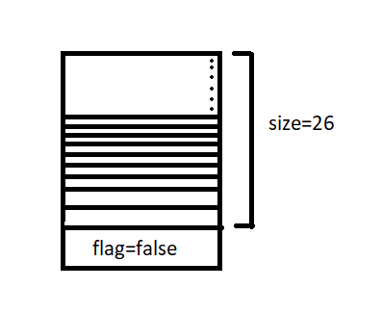

**Insert:**The last reference trie’s flag has to be to true since the word is completed. The diagram shows the insertion of the word “apple”.

The basic idea of insertion is that if the reference trie does not exist create a new trie and if it does simply traverse to it.

**Search: Search if the word is present in the trie or not**,

Start from the root and traverse through the word. while traversing through the word check if the reference trie for that character exists or not. If it exists move to the reference trie, else return false. Once the word is traversed character by character **return the flag** at that particular trie.

**startsWith: Check if the word inserted previously has the prefix “prefix” or not.**

It is similar to a search operation. Start from the root of the trie and traverse through the “prefix”.If the reference trie for a character is not present return false else transverse to the reference trie.Once the “prefix’ is traversed completely character by character **return true**.

**Code:**

class Node {

Node links[] = new Node[26];

boolean flag = false;

public Node() {

}

boolean containsKey(char ch) {

return (links[ch - 'a'] != null);

}

Node get(char ch) {

return links[ch-'a'];

}

void put(char ch, Node node) {

links[ch-'a'] = node;

}

void setEnd() {

flag = true;

}

boolean isEnd() {

return flag;

}

};

public class Trie {

private static Node root;

//Initialize your data structure here

Trie() {

root = new Node();

}

//Inserts a word into the trie

public static void insert(String word) {

Node node = root;

for(int i = 0;i<word.length();i++) {

if(!node.containsKey(word.charAt(i))) {

node.put(word.charAt(i), new Node());

}

node = node.get(word.charAt(i));

}

node.setEnd();

}

//Returns if the word is in the trie

public static boolean search(String word) {

Node node = root;

for(int i = 0;i<word.length();i++) {

if(!node.containsKey(word.charAt(i))) {

return false;

}

node = node.get(word.charAt(i));

}

if(node.isEnd()) {

return true;

}

return false;

}

//Returns if there is any word in the trie that starts with the given prefix

public static boolean startsWith(String prefix) {

Node node = root;

for(int i = 0;i<prefix.length();i++) {

if(!node.containsKey(prefix.charAt(i))) {

return false;

}

node = node.get(prefix.charAt(i));

}

return true;

}

public static void main(String args[])

{

int n = 5;

int type[] = {1, 1, 2, 3, 2};

String value[] = {"hello", "help", "help", "hel", "hel"};

Trie trie=new Trie();

for (int i = 0; i < n; i++) {

if (type[i] == 1) {

trie.insert(value[i]);

}

else if (type[i] == 2) {

if (trie.search(value[i])) {

System.out.println( "true" );

}

else {

System.out.println("false");

}

}

else {

if (trie.startsWith(value[i])) {

System.out.println("true" );

}

else {

System.out.println("false");

}

}

}

}

}

**Output:**

true  
true  
false

**Implement Trie – II**

**Problem Statement:**  Implement a data structure ”TRIE” from scratch. Complete some functions.

1) Trie(): Initialize the object of this “TRIE” data structure.

2) insert(“WORD”): Insert the string “WORD”  into this “TRIE” data structure.

3) countWordsEqualTo(“WORD”): Return how many times this “WORD” is present in this “TRIE”.

4) countWordsStartingWith(“PREFIX”): Return how many words are there in this “TRIE” that have the string “PREFIX” as a prefix.

5) erase(“WORD”): Delete this string “WORD” from the “TRIE”.

**Note:**

1. If erase(“WORD”) function is called then it is guaranteed that the “WORD” is present in the “TRIE”.

2. If you are going to use variables with dynamic memory allocation then you need to release the memory associated with them at the end of your solution.

**Example:**

**Input:**

1

6

insert samsung

insert samsung

insert vivo

erase vivo

countWordsEqualTo samsung

countWordsStartingWith vi

**Output:**

2

0

**Explanation:**

Insert “samsung”: we are going to insert the word “samsung” into the “TRIE”.

Insert “samsung”: we are going to insert the word “samsung” again into the “TRIE”.

Insert “vivo”: we are going to insert the word “vivo” into the “TRIE”.

Erase “vivo”: we are going to delete the word “vivo” from the “TRIE”.

countWordsEqualTo “samsung”: There are two instances of “samsung” is present in “TRIE”.

countWordsStartWith “vi”:There is not a single word in the “TRIE” that starts from the prefix “vi”.

**Solution**

***Disclaimer***: *Don’t jump directly to the solution, try it out yourself first.*

**Approach**:

1. **Insert**

Here we will maintain **ew** -> end with  and  **cp** -> count prefix,  
We will insert letter by letter by creating a new track every time. Starting from the root, fill letters of the word one by one and subsequently increase cp. At the end of every word, increase ew which denotes that word finished here. At the time a different prefix is found, we will create a new track by increasing cp.



**2. countwordsEqualTo()** – This function will count complete words which are present in the Trie. Starting from the root, we will check for the given letter of the word to be found, if we find that cp >0 every time and at the end if (ew>0) this means word ends here means the complete word is present here.



**3. countWordsStartWith()** – This function will count words starting with given string. Similarly, here also we begin from the root and check for the given letter one by one and check for cp>0. If it is, this means the given words are present here.



**4.** **Erase() –**It will delete the string given from the Trie.

Note- **In Erase() function**, it is assumed that the **given letter to be erased is present in the trie.**

Starting from the root, cp for the given prefix element is greater than 0, reduce cp by 1 and move on to a new track, and at last, reduce ew by 1  to mark that. word is fully deleted.



**Code:**

* C++ Code
* Java Code

import java.util.*;

class Node {

Node links[] = new Node[26];

int cntEndWith = 0;

int cntPrefix = 0;

public Node() {

}

boolean containsKey(char ch) {

return (links[ch - 'a'] != null);

}

Node get(char ch) {

return links[ch-'a'];

}

void put(char ch, Node node) {

links[ch-'a'] = node;

}

void increaseEnd() {

cntEndWith++;

}

void increasePrefix() {

cntPrefix++;

}

void deleteEnd() {

cntEndWith--;

}

void reducePrefix() {

cntPrefix--;

}

int getEnd() {

return cntEndWith;

}

int getPrefix() {

return cntPrefix;

}

}

public class Trie {

private Node root;

//Initialize your data structure here

Trie() {

root = new Node();

}

//Inserts a word into the trie

public void insert(String word) {

Node node = root;

for(int i = 0;i<word.length();i++) {

if(!node.containsKey(word.charAt(i))) {

node.put(word.charAt(i), new Node());

}

node = node.get(word.charAt(i));

node.increasePrefix();

}

node.increaseEnd();

}

public int countWordsEqualTo(String word) {

Node node = root;

for(int i = 0;i<word.length();i++) {

if(node.containsKey(word.charAt(i))) {

node = node.get(word.charAt(i));

}

else {

return 0;

}

}

return node.getEnd();

}

public int countWordsStartingWith(String word) {

Node node = root;

for(int i = 0;i<word.length();i++) {

if(node.containsKey(word.charAt(i))) {

node = node.get(word.charAt(i));

}

else {

return 0;

}

}

return node.getPrefix();

}

public void erase(String word) {

Node node = root;

for(int i = 0;i<word.length();i++) {

if(node.containsKey(word.charAt(i))) {

node = node.get(word.charAt(i));

node.reducePrefix();

}

else {

return;

}

}

node.deleteEnd();

}

public static void main(String args[]) {

Trie T=new Trie();

T.insert("apple");

T.insert("apple");

T.insert("apps");

T.insert("apps");

String word1 = "apps";

System.out.println("Count Words Equal to "+word1+" "+T.countWordsEqualTo(word1));

String word2 = "abc";

System.out.println("Count Words Equal to "+word2+" "+T.countWordsEqualTo(word2));

String word3 = "ap";

System.out.println("Count Words Starting With "+word3+" "+T.countWordsStartingWith

(word3));

String word4 = "appl";

System.out.println("Count Words Starting With "+word4+" "+T.countWordsStartingWith

(word4));

T.erase(word1);

System.out.println("Count Words equal to "+word1+" "+T.countWordsEqualTo(word1));

}

}

**Output:**

Count Words Ending With apps 2  
Count Words Ending With abc 0  
Count Words Starting With ap 4  
Count Words Starting With appl 2  
Count Words Ending With apps 1

**Time Complexity:**O(N), where n denotes the length of the longest string that we are inserting.

**Space Complexity:**O(1), since constant size array created for links.